Non-profit joint stock Company
Karaganda University named after Academician E.A.Buketov

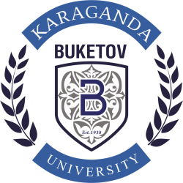

REPORT
BASED ON THE RESULTS OF SELF-ASSESSMENT
EDUCATIONAL PROGRAMS
WITHIN THE FRAMEWORK OF SPECIALIZED ACCREDITATION

6B01406 – VISUAL ART, ARTISTIC WORK,
GRAPHICS AND DESIGN

Karaganda, 2022

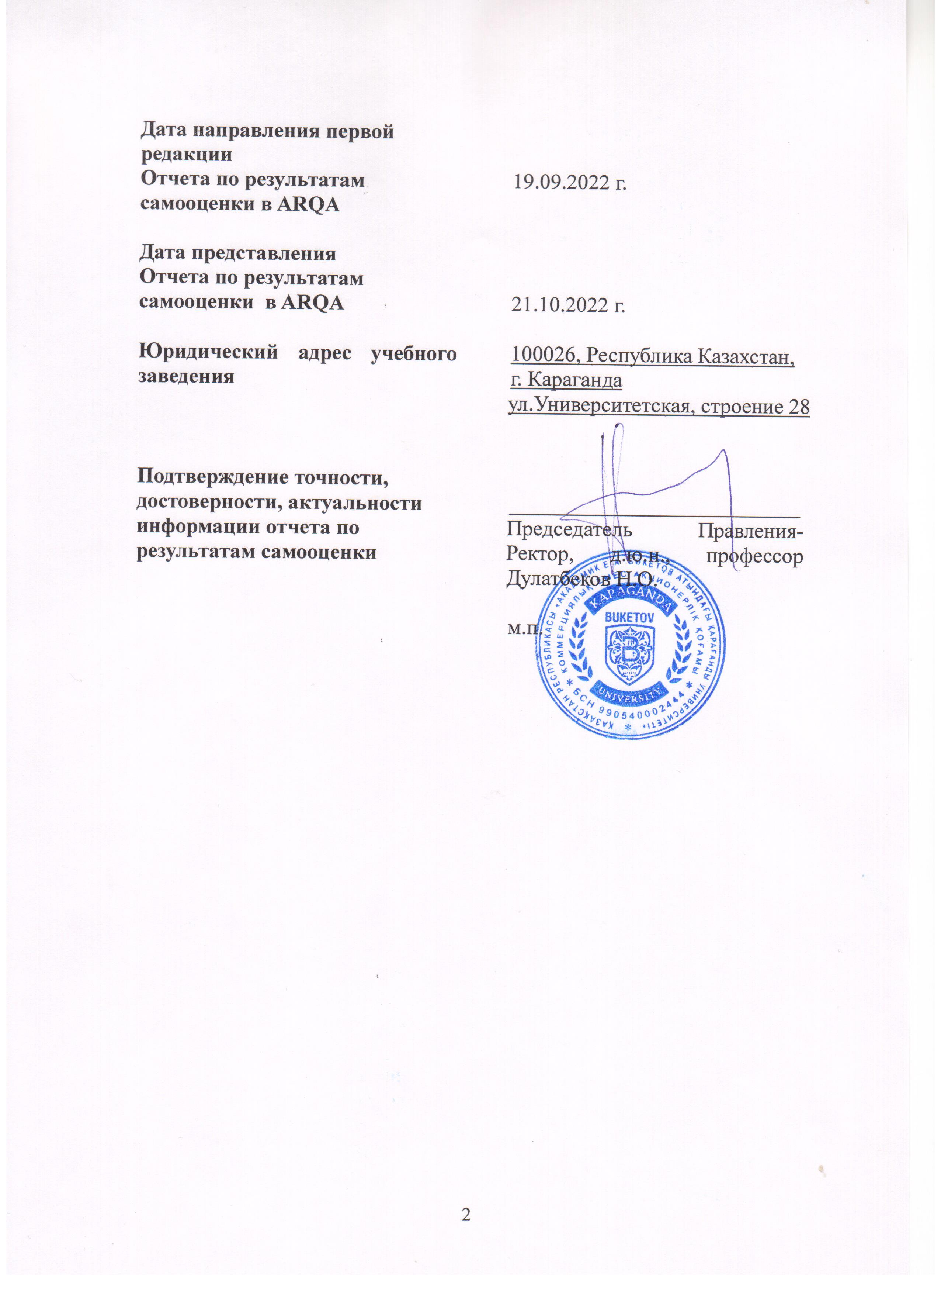
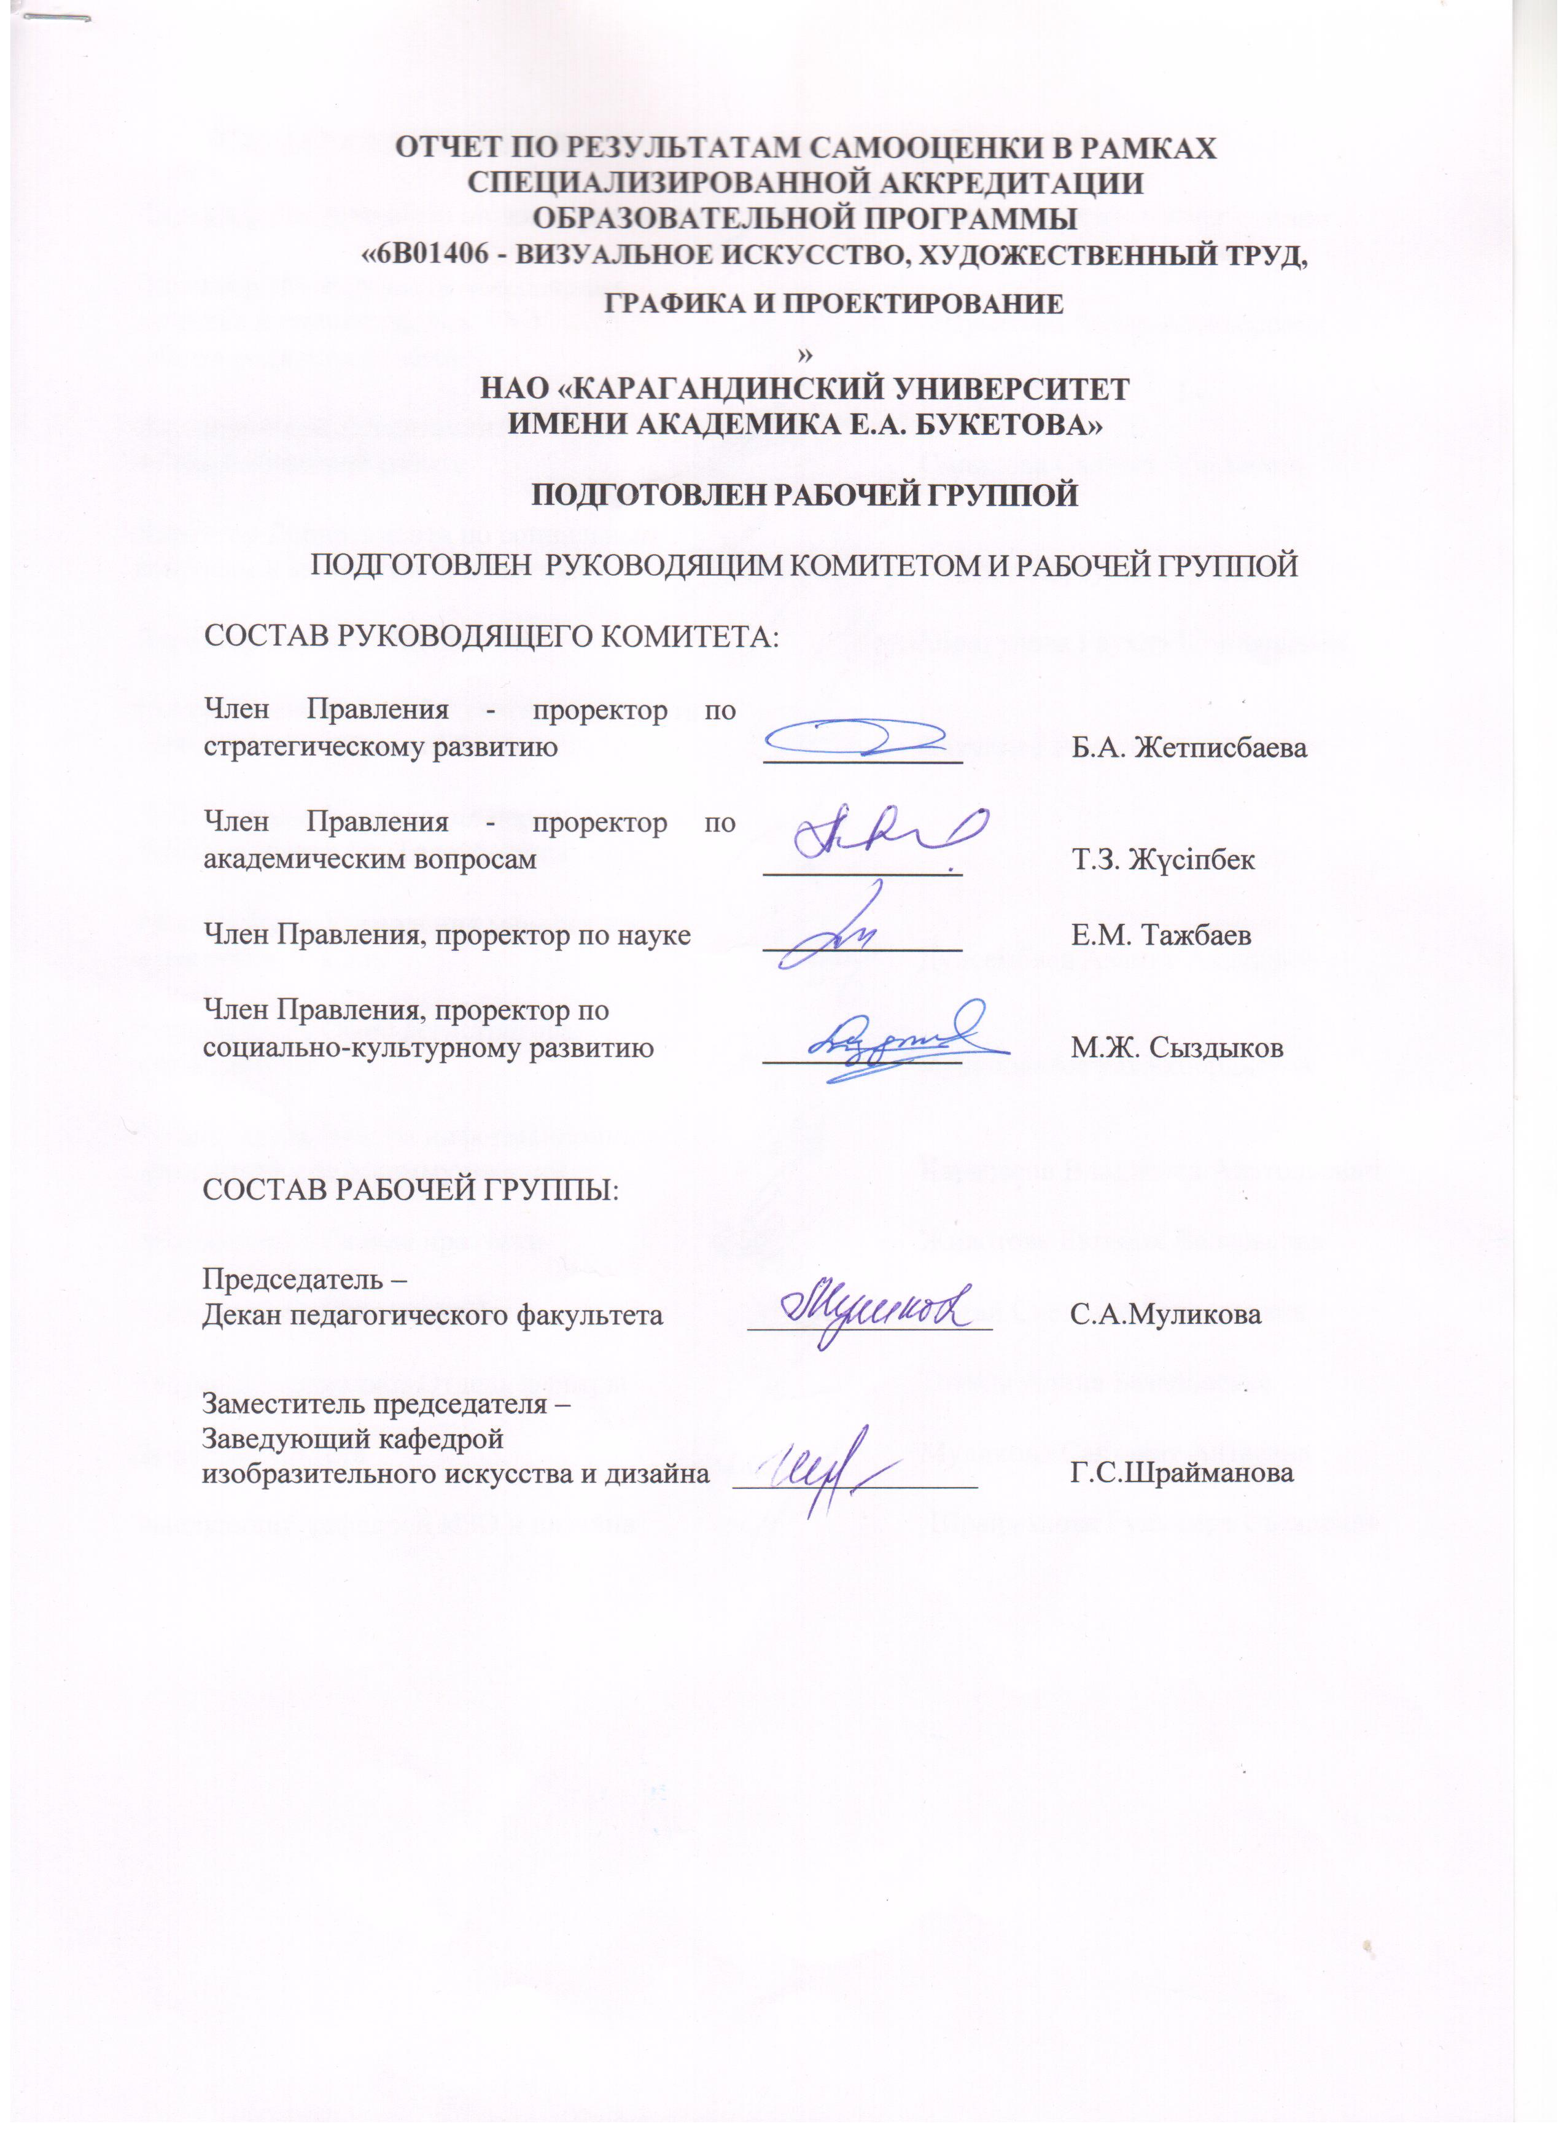
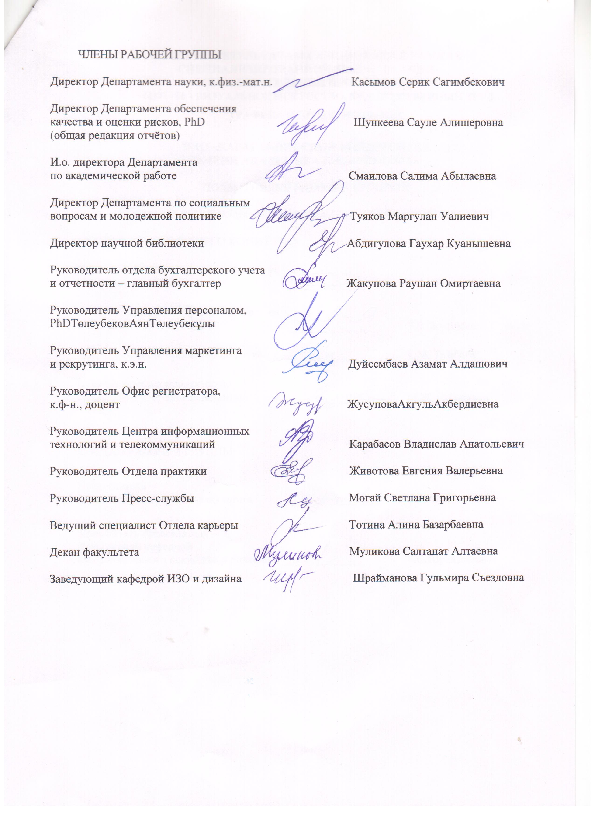
CONTENT

Designations and abbreviations | 5
General information about the organization of education | 6
Introduction | 7
Chapter 1. Implementation of the quality assurance policy | 8
Chapter 2. Educational programs: development and approval | 17
Chapter 3. Student-centered learning, teaching and performance assessment | 25
Chapter 4. Students: admission, support of academic achievements, certification | 34
Chapter 5. Teaching staff | 41
Chapter 6. Creative and personal development of students | 49
Chapter 7. Continuous monitoring and periodic evaluation of educational programs | 56
Chapter 8-1. Specifics of the educational program for the bachelor's degree level | 59
Conclusions | 62

Обозначения и сокращения

ECTS | Европейскаясистемапереносаинакоплениякредитов
ЕПВО | Европейскоепространствовысшегообразования
ESG | СтандартыируководствадляобеспечениякачествавЕПВО
GPA | Среднийбаллуспеваемости(GradePointAverage)
АИС | Автоматизированная информационная система
AК  АОО | Академический календарь  Автономная организация образования
БД | Базовые дисциплины
ВУЗ | Высшее учебное заведение
ВШ | Высшая школа
ВШИиС | Высшая школа искусства и спорта
ГАК | Государственная аттестационная комиссия
ГОСО | Государственный общеобязательный стандарт образования
ДО | Дистанционное обучение
ДОТ | Дистанционные образовательные технологии
ЕНТ | Единое национальное тестирование
ИКТ | Информационно-коммуникационные технологии
ИУП | Индивидуальный учебный план
КТО | Кредитная технология обучения
КЭД | Каталог элективных дисциплин
НАО | Некоммерческое акционерное общество
НИР | Научно-исследовательская работа
НИРС | Научно-исследовательская работа студентов
НПЦПК | Научно-практический центр повышения квалификации
НТС | Научно-технический совет
ОВПО | Организация высшего и (или) послевузовского образования
ООД | Общеобразовательные дисциплины
ОП | Образовательная программа
KBU | KaragandaBuketovUniversity
ПД | Профилирующие дисциплины
ППС | Профессорско-преподавательский состав
РУП | Рабочий учебный план
СРО | Самостоятельная работа обучающегося
СРОП | Самостоятельная работа обучающегося под руководством преподавателя
СЭД | Система электронного документооборота
УМКД | Учебно-методический комплекс дисциплины
УП | Учебный план
ЦОС | Центр обслуживания студентов
ЭУМКД | Электронный учебно-методический комплекс дисциплины

General information about the organization of education

Full name of the educational organization | Non-profit Joint Stock Company "Karaganda University named after Academician E.A.Buketov"
Form of ownership of an educational organization | Non-profit joint stock Company
Affiliation of the institution | Ministry of Science and Higher Education of the Republic of Kazakhstan
The list of educational programs (specialties) implemented at the university in accordance with the state licensein the right to conduct educational activities | 72 areas of training
Locationorganizations of education | 100028, Karaganda, Universitetskaya str., 28
Year of creation of the educational organization | 1972
Contingent of students: | Bachelor's degree: 12610  Master's degree: 801  Doctoral degree: 174  Total: 13585
Responsible person for communication with the accreditation agency, contact details | Shunkeeva S.A. – Director of the Department of Quality Assurance and Risk Assessment, PhD

Introduction

NAO Karaganda University named after Academician E.A.Buketov is a non-profit joint-stock company with one hundred percent participation of the state in the authorized capital. The university is managed by the Sole Shareholder (MES RK), the Board of Directors, the Management Board. The Chairman of the Board-Rector of the University is Doctor of Law, Professor Dulatbekov Nurlan Orynbasarovich.
The quality policy of the Karaganda University named after Academician E.A. Buketov was approved by the Chairman of the Board-Rector of the University on 15.01.2021. When forming a Quality Policy, Karaganda State University named after Academician E.A. Buketova was guided by the state policy in the field of education and science, the mission and Strategic Plan of the University for 2020-2025, the strategic goal of which is to promote the brand "Karaganda Buketov University" as a world-class university. These documents are posted on the website of the NAO Karaganda University named after academician E.A. Buketov, in the section "About us" (http://buketov.edu.kz
Focusing on improving the quality of training, focusing on the changing needs of the market, the university has defined its mission, which is to preserve spiritual values, disseminate knowledge, and introduce innovative approaches to training based on the best educational practices and research programs.
The quality policy of the NAO of the Karaganda University named after Academician E.A. Buketov is an integral element of the management of the university and the basis for planning its educational activities.
The mission of the University is to preserve values, disseminate knowledge, and introduce innovative approaches for training based on the best educational practices and research programs.
Training of personnel under the educational program of the OP "6B01406 - Visual art, artistic work, graphics and design" is conducted in the direction 6B014 "Training of teachers with a subject specialization of general development" in accordance with the license for educational activities of Appendix No. 016 KZ83LAA00018495 dated 07/28/2020, issued by the State University "Committee for Quality Assurance in Education and Science MES RK" (Appendix A1).
OP "6B01406 - Visual art, artistic work, graphics and design" was developed in 2019, included in the register of ESUVO as new on 15.06.2019.
The educational program was developed in accordance with the Law of the Republic of Kazakhstan "On Education" dated July 27, 2007, the State Educational System of the Republic of Kazakhstan, the Standard Rules for the activities of educational organizations of the relevant types, the Order of the Minister of Education and Science of the Republic of Kazakhstan dated December 24, 2020 No. 539, the Law on Professional Standards of a teacher from January 1, 2020, the National Qualifications Framework, and agreed with Dublin descriptors and the European Qualifications Framework, it is formed on the basis of a competence-based approach to design and has a modular format.
For the reporting period, the training of future specialists in the OP "6B01406 - Visual art, artistic work, graphics and design" is carried out on the basis of general secondary education and higher education in full–time (full-time, full-time distance) form of education - 4, 3, 2 years in Kazakh and Russian with a contingent of 54 students.
Chapter 1. IMPLEMENTATION OF THE QUALITY ASSURANCE POLICY

The quality policy of the Karaganda University named after Academician E.A. Buketov was approved by the Chairman of the Board-Rector of the University on 15.01.2021. When forming a Quality Policy, Karaganda State University named after Academician E.A. Buketova was guided by the state policy in the field of education and science, the mission and Strategic Development Plan of the University for 2020-2025, the strategic goal of which is to promote the brand "KaragandaBuketovUniversity" (hereinafter KBU) as a world-class university. These documents are posted on the website of Karaganda State University. academician E.A. Buketov, in the section "About us" (http://buketov.edu.kz
Focusing on improving the quality of training, focusing on the changing needs of the market, the university has defined its mission, which is to preserve spiritual values, disseminate knowledge, and introduce innovative approaches to training based on the best educational practices and research programs.
The quality policy of the Karaganda University named after Academician E.A. Buketov is an integral element of the university's management and the basis for planning its educational activities.
The University staff is involved in the development, discussion and adoption of the Quality Policy through its representatives in the University Board. The quality policy is periodically reviewed on the basis of the following documents: State programs for the development of education and programs for the development of various sectors of the Republic of Kazakhstan; amendments and additions made to the current laws "On Education", "On Science", etc.; current results of the analysis of satisfaction of consumers of educational services and other interested parties; ENQA standards and directives; information on the results of the functioning of the University's QMS for previous periods.
The main principles of management are: the development of strategic planning, the use of modern management methods, multilateral internal quality assessment, corporate training and continuous improvement.
Internal quality assurance system of NAO "Karaganda University named after Academician E.A. Buketova" is reviewed and approved by the collegial body of the University – the Academic Council (approved on 26.08.2021). The internal quality assurance system is based on international standards and guidelines for quality assurance of higher and postgraduate education in the European Higher Education Area (ESG); reflects common approaches, policies, principles, standards and basic mechanisms established by in the NAO "Karaganda University named after Academician E.A. Buketova" on improving the quality of education and developing a culture of continuous improvement of quality; is an integral part of the strategic management of the university.
The policy and standards of internal quality assurance are the basis of a logically structured and consistent system of internal quality assurance in the NAO "Karaganda University named after academician E.A. Buketov".
The University is responsible for the quality of education provided and its provision, takes into account the needs and expectations of students and all other stakeholders of society. The university management ensures the unity of strategy, policy and procedures; involvement of all employees and students, external stakeholders in quality assurance activities; creates conditions for continuous improvement of the quality assurance system and the development of a quality culture, according to which each employee is aware of his obligations and responsibility for ensuring and developing quality.
The internal quality assurance system provides for a clear separation of powers and responsibilities for processes, quality and standards, and ensures the adoption of important management decisions based on a comprehensive analysis of data and information.
Quality assurance is the common responsibility of the university management, all structural units, employees and students.
For example, the rector is responsible for the compliance of the university's activities with legislative and regulatory requirements; the Vice-Rector for Strategic Development is responsible for the development of a Strategic Plan for the Development of the University, the development and operation of an internal Quality Assurance System, for ensuring a systematic approach to quality assurance; the Vice-rector for Academic Affairs ensures the planning, organization and control of the educational and methodological work of the university, determines and develops university-wide measures aimed at improving the quality of the development of educational programs and monitoring the quality of methodological and methodological support of the educational process; The Vice-rector for Science and Innovation is responsible for ensuring a systematic approach to the organization of research work of the university, ensures monitoring of the results of scientific activity and a stable link between research, innovation, teaching and learning; the Vice-rector for Socio-cultural Development is responsible for ensuring the quality of social conditions for students.
The teaching staff is responsible for the quality of teaching activities, educational and methodological documentation, compliance of the educational process with the goals and educational results of the relevant educational programs. The heads of all structural divisions are responsible for ensuring the quality of compliance of the activities of the divisions with the goals, objectives and functions in accordance with the Regulations on Structural Divisions and job descriptions.
The activities of all structural divisions of the university are planned and organized on the basis of the mission, strategic goals and objectives of the university.
The department and the faculty carry out their activities in direct cooperation with the supporting services of the university – the departments responsible for ensuring constant quality control in the implementation of educational programs of the departments.
For example, the Department of Academic Work together with the department ensures the involvement of employers in the implementation of the educational program through the coordination of the list of elective disciplines, the management of professional practice, the review of theses and methodological developments of teachers, the organization of the work of the State Attestation Commission. Among the areas of work of the department is the organization of the work of departments on planning the educational process and educational and methodological support in accordance with the state mandatory standards of education, based on the normative documents of education: to ensure control over the implementation of plans of educational and methodological work at departments and faculties, carrying out activities to generalize and disseminate advanced pedagogical experience, the introduction of modern; educational technologies, organization and development of working curricula for bachelor's, master's and doctoral degree programs in all forms of education, development of an academic calendar, scheduling of classes and exams, development of catalogs of elective disciplines, development of syllabuses, educational and methodological complexes of disciplines.
The office of the Registrar of the University, which is part of the Department for Academic Work, provides the organization, management and control of accounting of mastered credits of students, registers students for academic disciplines, formation of academic groups and streams, registration of individual curricula of students, organizes and conducts intermediate and final attestation of students, keeps records of mastered credits of students throughout the period for the entire period of training, forms transcripts of students, test tasks for the control of students' knowledge, carries out information and technical support of the educational process on credit technology and distance learning technology, keeps records of the implementation of individual plans within the framework of academic mobility, organizes the summer semester, ensures the creation of databases of information educational resources.
The Department of Academic Work includes a Student and Staff Service Center (CES), which, along with the university's services, also provides public services provided by the portal "Electronic Government e.gov.kz ". Students can apply for a place in a university dormitory, request various documents and certificates, and register an electronic pass to the university buildings in the Central Educational Center.
Organizational and methodological support of the learning process in the distance format is provided by the Distance Education Center, which is a structural subdivision of the Department for Academic Affairs. The CDO ensures the functioning of an automated distance learning system, the operation of the portal idl.ksu.kz , provides technical support for the creation of electronic educational publications.
Career Department is a division of the Academic Work Department (https://buketov.edu.kz/ru/page/service ) – advises graduates of the OP on employment issues, organizes psychological trainings for interviews with an employer, Career weeks – Career Week, intensive courses, presentations of employers; monitors vacancies in organizations in the region, as well as monitoring the employment of graduates.
The tasks of the Department of Quality Assurance and Risk Assessment include providing an institutional analysis of academic indicators of students, assessing the satisfaction of participants in the educational process with the quality of educational services (Appendices G-1 and G-2). This department analyzes the OP, monitors the work on attracting external and internal stakeholders, determines the compliance of the OP with the needs of the labor market, monitors the timely updating of the content of the OP according to global, republican and regional trends in education, monitors the implementation of the OP, assists in strengthening external relations with employers and education authorities.
This department carries out the general management of the scientific and methodological content of the educational program in accordance with modern trends in the development of education and science, economics, technology, technology, social sphere and labor market, is responsible for the quality of educational services provided in accordance with the Charter, the University Development Program, internal documents of the university.
Also, together with the teaching staff, it is developing a plan for the development of the educational program in accordance with the Development Strategy of the Karaganda University named after E.A.Buketov for 2020-2025. Thus, in the development plan of OP 6B01406 "Visual art, artistic work, graphics and design" for 2021-2025, the main activities are:
- external assessment of the quality of the university's activities and the satisfaction of consumers of educational services;
- updating of the educational program with the involvement of employers, teaching staff, students;
- making changes to the QED taking into account the needs of the market;
- improvement of educational and methodological documents;
- development of information and educational resources of the OP;
- professional development of teaching staff;
- strengthening of human resources;
- activation of scientific activity of teaching staff, students of OP;
- increasing the civic activity of young people and fostering Kazakhstani patriotism in the context of the national idea "Mangilik el";
- development of the material and technical base for the implementation of the OP.
The Department of Social Affairs ensures the implementation of the state youth policy, promotes the solution of social problems of university students, provides psychological support to students, oversees issues of leisure and living in students' Homes. This department determines the main directions of educational work in accordance with the University's Work Plan, organizes and conducts events of a cultural, sports, creative, intellectual, civil-patriotic nature of work at the university, provides leisure for students, organizes clubs, sections, clubs of interest, coordinates the work of teachers, curators, elders of academic groups, bodies student self-government for the development and improvement of the educational process, the implementation of youth policy, forms an asset of students and Student Houses, organizes self-government of students, coordinates and monitors its work, organizes the participation of students and teachers in university and interuniversity level events, conducts activities to assist the university in performing household chores.
The work of scientific centers and laboratories is supervised by the Department of Science, contributing, in general, to the development of the scientific infrastructure of the university. The Department of Science searches for partners for collaboration of scientific research, implementation of joint projects, commercialization of scientific products and their promotion on the market. Departments can apply to the Department of Science for participation in scientific projects, registration of patents, state registration of intellectual property objects.
The Department of Science informs teaching staff and young scientists about scientific programs, conferences and other events held by scientific institutions and universities of the Republic of Kazakhstan, coordinates the work on scientific seminars, conferences, round tables for teaching staff and students, coordinates research, hears reports of the chairmen of committees on the areas of internationalization, research and entrepreneurship, makes appropriate decisions on them, recommends the best research projects for national and international competitions, monitors scientific achievements of teaching staff and students, coordinates the work on summarizing the research activities of the department and identifying the best scientific results of the year, coordinates the research work of undergraduates and doctoral students.
The Department of International Cooperation provides organizational support to participants of academic mobility programs, faculties in concluding cooperation agreements, inviting guest lecturers, visa support issues; promotes the participation of students and university staff in international programs and projects.
The departments cooperate with the Center for Information Technology and Telecommunications (CITiT) on the development of software modules within the digital ecosystem of the university, the functioning of computer technology and multimedia equipment, Internet access. In addition, CITiT develops software, implements information systems, supports network and server infrastructure; accompanies the work of multimedia equipment, Wi-Fi network, website and portals of the university.
The Marketing and Recruiting Department is engaged in attracting applicants and other stakeholders, promotes the image of the university in the internal and external environment, ensures cooperation with domestic and foreign recruiting agencies in the field of education.
An important structural unit in the organizational system of the university is the Press Service, which informs the public, provides communication with it, and thereby forms the image of the university. The departments cooperate with the Press Service on the placement of information on the university's website, social networks, in the university newspaper "Zhastar Alemi. The World of Youth"; organization of briefings, press conferences.
The quality assurance policy is implemented at the university at all stages of the development of educational programs and with the participation of not only the structural divisions of the university, but also external stakeholders.
Thus, planning according to the practice adopted at the university is carried out with the participation of managers at all levels within the framework of responsibility and involvement in the main processes. The management of the university approves the developed plans and approves the criteria for evaluating the effectiveness. The plans are drawn up in the context of the Quality Policy of the NAO "Karaganda University named after Academician E.A. Buketova", annual Goals in the field of university quality, annual work plans of the Board, Board of Directors, Academic, Academic and Scientific-Technical Councils, annual work plans of faculties, departments and departments. All plans are focused on the implementation of the goals, objectives, indicators of the medium-term Development Strategy of the university for 2020-2025. The rector, vice-rectors, teachers, heads of departments, deans, heads of departments, external stakeholders are involved in the periodic evaluation of the results and comparative analysis of the achieved performance indicators through consideration of planned issues at meetings of collegial bodies of the university and faculties (by management levels).
The high results in the implementation of the stated policy in the field of quality of the University named after E.A. Buketov are evidenced by the university's positions in the world and national rankings of the reporting years.
The interaction between teaching, research and training in the quality assurance policy of the OP is reflected in the individual plans of the teaching staff. The University creates conditions and stimulates not only the quality of the organization of the educational process and the services provided, but also the quality of research and systematic professional development of teaching staff, which is reflected both in the university Policy of quality of education, and in the Personnel Policy and Qualification professional standards of the teaching staff of the NAO "Karaganda University. Academician E.A. Buketova", the procedure for forming the load of teaching staff and accounting for their employment.
The implementation of the OP is facilitated by the research work of not only teaching staff, but also students. Students of the OP have the opportunity to engage in science, participate in conferences of various levels and competitions under the guidance of teaching staff, publish scientific research in domestic and foreign publications, engage in scientific circles and clubs.
Official website of the university http://buketov.edu.kz provides the public with complete, reliable and timely, socially significant information about the services provided and areas of activity. On the official website of the NAO of the Karaganda University. Academician E.A. Buketov provides general information about the university; study programs, science, life on campus. In the "Entrant" section, materials on the order of admission to the university, on the organization of the educational process, etc. are presented. All materials and advertisements published on the official website of the university are developed taking into account the principles of honesty and objectivity.
An important element of the policy in the field of quality assurance of programs is the anti-corruption policy at the university, including anti-corruption measures, accessibility of the university management for teachers and students, flexibility to respond to requests; as well as strict compliance with the requirements of the Teaching staff and students of the Code of Corporate Ethics of the NAO "Karaganda University named after Academician E.A. Buketov" (approved by the decision of the Board of Directors, Protocol No. 1 of June 10, 2021).
The University has developed an Anti-Corruption Strategy of the Academician E.A. Buketov KarU for 2015-2025, a Plan of anti-corruption measures for the 2020-2022 academic year, a Work plan of the SANALYURPAQ project office. The anti-corruption strategy is based on the main ideas of strategic documents reflecting Kazakhstan's principled position on this issue, including the "Anti-Corruption Strategy of the Republic of Kazakhstan for 2015-2025", approved by Decree of the President of the Republic of Kazakhstan dated December 26, 2014 No. 986; The Law of the Republic of Kazakhstan "On Combating Corruption" dated November 18, 2015 No. 410-V; The Anti-corruption Program of the Nur Otan Party for 2015-2025, approved by the Resolution of the Political Council of the Nur Otan Party dated November 11, 2014 No. 001; The corruption risk map developed by the Anti-Corruption Project Office "Adalbilim".
In order to introduce democratic principles of governance and prevent corruption, the work of the student self-government of the Karaganda University named after Academician E.A. Buketova is built on social partnership, which allows students to be involved as social subjects in the management, control and evaluation of the university's activities. For example, students are included in the faculty Council, Academic Council.
The university management, teaching staff and students take an active part in the planning, implementation and monitoring of all processes carried out at the university. Teaching staff and employees have the opportunity to participate and make suggestions for improving activities at meetings of the labor collective, meetings with the Chairman of the Board - Rector, vice-rectors, deans of faculties, at meetings of the Academic Council, other collegial bodies of the university.
The accessibility of the university management and feedback from the lecturers and students is provided through the blogs of the Chairman of the Board-Rector, Vice-Rectors of the university, Personal pages of teachers and students on the Educational Portal of the University, helplines.
The key task of the university is to ensure the quality of training of future teachers. Strategic goal: training of professionals who broadcast innovative pedagogical ideas. The mission of the Karaganda University named after Academician E.A. Buketov: the formation of the pedagogical elite of the Republic of Kazakhstan, ensuring the development of the intellectual potential of the nation. Vision: Karaganda University named after Academician E.A.Buketov is a leader in the training of teaching staff in the educational services market in the Republic of Kazakhstan.
The mission, goals and objectives of the Karaganda University named after Academician E.A.Buketov are accepted and approved (or re-approved) by the Chairman of the Board - the rector of the university on the basis of the procedure of open voting of members of the Academic Council. The mission of the University is to preserve values, disseminate knowledge, and introduce innovative approaches for training based on the best educational practices and research programs.
Control over the implementation of the mission, goals and objectives is carried out at several managerial levels – heads of the OP, deans of higher schools, directors of departments, heads of departments, vice-rectors in the field of activity, chairman of the board - rector of the university.
The mission is an integrating link in the work of the university. On its basis, priorities, strategic goals and objectives are determined, the activities of all structural divisions of the university are planned and organized, prospects for further development are developed, reflected in the «Development Strategy of the Non-Profit Joint Stock Company «Karaganda University named after E.A. Buketov» for 2020-2025».
In accordance with the Standard Rules for the Activities of Educational Organizations of the relevant Types (Order of the Minister of Education and Science of the Republic of Kazakhstan dated October 30, 2018 No. 595), the educational activities of the OVPO are carried out on the basis of its academic policy, which is a system of measures, rules and procedures for planning and managing educational activities and effective organization of the educational process aimed at implementing student-oriented learning and improving the quality of education.
Academic policy of the university (http://buketov.edu.kz ) is a system of measures, rules and procedures of the academic integrity policy, admission policy, planning and management of the educational process aimed at the implementation of student-oriented learning and improving the quality of education. It determines the order of organization of education at the university according to the credit system of education and programs of higher and postgraduate education. The document includes the procedure for registering students to attend training sessions; conducting current, intermediate and final controls; the organization of the passage of students of all types of practices; evaluation of educational achievements, students; the procedure for awarding state scholarships to students; rules for transfer, restoration, expulsion of students; final certification, etc.
The policy and standards of internal quality assurance of the Karaganda University named after Academician E.A. Buketov reflect common approaches, policies, key principles, standards and basic mechanisms for improving the quality of education and developing a culture of quality improvement. They are an integral part of strategic management, and are considered together with other documents: The university's development strategy, Academic policy.
The Department for Academic Work on the quality of education analyzes the educational and methodological support of the educational process, monitors the implementation of the academic load of the university teaching staff, the quality of training sessions, professional practice through visits by a working group of these forms of educational activity, analyzes the topics of theses, master's and doctoral dissertations, organizes the discussion of theses, master's and doctoral theses dissertations, discusses the results of intermediate and final certification of students, supervises the issues of professional development of teachers of higher education.
The Career Department positions graduates of higher education in the labor market and promotes their employment, monitors the employment of graduates, coordinates work with educational organizations for the employment of graduates, analyzes the career growth of graduates, collects and analyzes information on the needs of the region for graduates of higher education, attracts specialized employers to organize and conduct practices.
In accordance with the Academic Policy of Karaganda University, the responsibility for the management, development and continuous improvement of the educational program is borne by the graduating department.
The head of the department analyzes the results of the periodic evaluation of the OP, which provides for:
- changing the needs of society and the professional environment;
- analysis of students' progress;
- graduation and employment;
- employers' satisfaction with the quality of graduate training;
- compliance of the educational environment and the student support service with the goals of the OP;
- satisfaction of students with the content of training on OP.
The dean and the head of the department monitor the OP in accordance with the standards and criteria for quality assurance. Based on the results of monitoring and evaluation of the educational program, he submits proposals for changing and supplementing the OP for consideration by the faculty council.
The selection of qualified personnel of teaching staff and other employees is regulated by internal documents: Qualification characteristics of positions of teaching staff of the Karaganda University named after Academician E.A.Buketov, the Rules of competitive replacement of positions of administrative and managerial personnel of the NAO Karaganda University named after Academician E.A.Buketov, the Personnel Policy of the NAO Karaganda University named after Academician E.A.Buketov for 2021-2025 (http://buketov.edu.kz ).
The personnel policy of the University is aimed at preserving and developing human resources, a competent and highly qualified team capable of responding promptly to changes in the external environment, taking into account the mission and strategy of the Karaganda University named after Academician E.A.Buketov. The personnel policy is reflected in the Charter, collective agreement, internal labor regulations and employment contracts.
The classification of University teaching staff positions is developed on the basis of international experience in the classification of teaching staff positions and successful practices of domestic education and is aimed at stimulating the professional growth of teaching staff, increasing motivation in personal and professional development.
Recruitment is carried out on the basis of an analysis of the needs of the educational program, according to the results of which a competition is announced to fill vacant positions. A system of hiring teachers and working with staff has been developed and approved in accordance with the Rules of competitive replacement of positions of teaching staff and researchers of higher educational institutions approved by the Ministry of Education and Science of the Republic of Kazakhstan. According to them, a competition commission has been created at the university. The existing mechanism allows you to get a holistic view of the professional competence of the teacher, to determine his compliance with the desired position.
The interaction between teaching, research and learning is one of the principles of the university's activities. The quality assurance policy of the OP is regularly analyzed for suitability by receiving feedback from students, teaching staff and employers, as well as by analyzing the educational achievements of students. The teaching of disciplines is based on modern achievements in the field of science and practice, modern educational technologies in accordance with the competence approach and the introduction of active teaching methods.
The University's quality assurance policy takes into account the national and intra-university context. The activity of the university in the context of national policy is reflected in the Academic Policy of the university, the Code of Academic Integrity and the Code of Honor of the student.
The conceptual foundations of education, spiritual development, the formation of national identity are realized through the study of the discipline "Modern history of Kazakhstan", "History of Arts of Kazakhstan" and "Artistic culture of Kazakhstan", value attitude to pedagogical activity – "Aspects of the updated content of school education", intolerance to various types of antisocial phenomena, such as corruption, etc.
The students' mastering of the discipline "Decorative and applied art" OP 6B01406 "Visual art, artistic work, graphics and design" is aimed at introducing them to the historical and national cultural values of Kazakhstan.
Due to the need to prepare future teachers for professional activity in the field of inclusive education, the discipline "Inclusive Education" was introduced in the OP, which is aimed at the formation of professional knowledge, content, forms and methods of working with children with disabilities.
An important element of the Program Quality Assurance Policy is the Anti-Corruption Policy at the University. On the official website of the university, in the "Anti-Corruption Policy" tab, there is an Anti-corruption standard, an anti-corruption action plan at KBU, a memo on anti-corruption, etc.
To provide feedback, the rector's blog is available on the university's website, through which students and teachers can address their opinions, wishes and claims on educational programs and other problems. The incoming information is analyzed and the university management takes appropriate measures.
The main ways to inform stakeholders about the results of the implementation of the quality assurance policy for the development of the OP are the materials posted on the information website of the university http://buketov.edu.kz , the results of the students' professional practices, the participation of stakeholders in the final certification of students (reviewing theses, participation in the certification commissions), the employment of graduates and their demand in the labor market (Appendix B3, Partnership with schools and universities).
In 2022, this educational program participated in the rating of educational programs implemented by the NCE RK "Atameken".
Interaction with stakeholders is carried out through meetings, including online (Appendix D14).
SWOT- analysis

S (strength) – strengths (potentially positive internal factors) | W (weakness) – weaknesses (potentially negative internal factors)
- attractive image of the university, its competitive advantages;  - participation of teachers, students and employers in the formation of the OP | - insufficient development of the regulatory framework and mechanisms of interaction with stakeholders

Chapter 2. EDUCATIONAL PROGRAMS: DEVELOPMENT AND APPROVAL

The design and development of higher professional education is regulated by regulatory legal acts of the Republic of Kazakhstan, internal documents of the university:
- The Law of the Republic of Kazakhstan "On Education";
- "Standard rules for the activities of educational organizations of appropriate types", approved by Order of the Minister of Education and Science of the Republic of Kazakhstan dated October 30, 2018 No. 595;
- "State mandatory standard of Higher Education", "State mandatory standard of postgraduate education", approved by the Order of the Minister of Education and Science of the Republic of Kazakhstan dated October 31, 2018 No. 604;
- "Rules for the organization of the educational process on credit technology of education", approved by the Order of the Minister of Education and Science of the Republic of Kazakhstan dated 28.01.2016 No. 90;
- KBU Academic Policy;
- Guidelines for the design and design of the educational program of the NAO KarU named after E.A.Buketov.
When designing the OP, its main goals, content and scope of knowledge, strategies and approaches to the implementation of the educational process, the sequence and timing of the development of courses, modules, expected learning outcomes, monitoring and evaluation of learning outcomes, including the formation of competencies, are determined.
The development and approval of the OP at the university are carried out by the Academic Board of the Board of the E.A. Buketov KarU. OP 6B01406 "Visual art, artistic work, graphics and design" was developed in accordance with the State Mandatory Standard of Higher Education (Annex 7 to the Order of the Minister of Education and Science of the Republic of Kazakhstan dated October 31, 2018 No. 604).
The purpose of the OP: to prepare a competitive teacher with fundamental and applied knowledge, research skills for the implementation of scientific and pedagogical, professional and practical activities in the conditions of the updated content of secondary education, having in-depth skills in the application of IT in the field of education.
OP tasks:
- formation of high-quality knowledge, skills and competencies in the subject area necessary in professional activity;
- formation of research and entrepreneurial skills;
- development of creative abilities, critical thinking and leadership skills;
- education in the spirit of patriotism, tolerance, empathy.
The object of professional activity of the Bachelor of Education in the OP "6B01406 - Visual art, artistic work, graphics and design" is the pedagogical process in educational organizations of all types and types, regardless of ownership and departmental subordination: primary, basic and general secondary education, additional education of children, cultural and art organizations.
Bachelor of Education in the OP "6B01406 – Visual art, artistic work, graphics and design" can perform the following types of professional activities: educational (pedagogical); educational and educational; educational and technological; socio-pedagogical; experimental research; information and communication; organizational and managerial; artistic and creative; cultural- educational.
The functions of the professional activity of the Bachelor of Education in the OP "6B01406 - Visual art, artistic work, graphics and design" are: teaching; educating; methodical; research; social and communicative.
In accordance with the structure of the educational program of higher education (Appendix to the state mandatory standard of higher education), the content of the OP includes three cycles of disciplines: general education, basic and profiling. The university component and (or) the elective component ensures the electability of disciplines, determines the possibility of individual training of the student, taking into account the specifics of socio-economic development and the needs of the region, the established scientific school and the interests of the student.
The content of the OP is presented in modules, with an indication in the context of each module of the competencies being formed. The volume of the module in ECTS credits, the period of study, the module components consisting of the code and the names of the disciplines that make up the module, the cycles of disciplines (OOD, DB, PD), belonging to the mandatory component, the university component or the component of choice, the number of credits and the form of control relative to each discipline are indicated. The volume of the OOD cycle is 56 academic credits, of which 51 academic credits are allocated to the disciplines of the mandatory component. The DB cycle includes the study of academic disciplines and the passage of professional practice and amounts to at least 112 academic credits. The PD cycle includes academic disciplines and types of professional practices, the volume of which is at least 60 academic credits in the total volume of the educational program.
The search for optimal ways to train a future teacher of art work is due to the updating of the content of school education, based on the analysis of the content of the type curriculum for art work and the inclusion of disciplines in the university component and the component of choice.
Table 2 - Correspondence of elective disciplines of OP 6B01406 "Visual art, art work, graphics and design" to sections/topics of the standard curriculum "Art work" for grades 5-9 of secondary school

Sections/ topics on artistic work in the Secondary School | Elective disciplines OP 6B01406 "Visual art, artistic work, graphics and design"
Visual art/themes "Graphics", "Painting", "Sculpture", "Composition", "Animation" | Visual art, Academic Drawing, Academic Painting
Design and Technology (option for girls) / Design and technology (option for boys) | Design and Technology (for girls) / Design and Technology (for boys)
Decorative and applied art | Decorative and applied art
Culture at home. Food culture | Home and Food culture

Integration of various technical and technological disciplines previously studied separately, namely "Materials science of sewing production", "Equipment of sewing production", "Design and modeling of clothing", "Technology of manufacturing of sewing products", into one discipline "Design and technology", analysis of the content of standard curricula of the school "Artistic Labor" and "Graphics and design", the balance between the technical, technological and artistic part of the subject training of future teachers reflect the uniqueness of the OP. An important aspect of the OP "Visual art, art work, graphics and design" is the focus on the updated content of secondary education, which contributes to the successful professional activity of graduates of the OP in the academic subjects "Art work" and "Graphics and design" in secondary schools.
The content of the OP is regularly updated taking into account the level of development of science, education, culture, technology and the social sphere. The discussion of the OP is carried out annually at a meeting of the Department for Academic Work with the participation of stakeholders.
Updating of the OP is carried out on an ongoing basis, taking into account the opinions of internal and external stakeholders; taking into account the needs of the labor market and state policy in the field of higher education development; the need for personal development of students; activation of research activities of teaching staff and students.
Thus, in the discipline "History and theory of visual Art" OP 6B01406 "Visual art, artistic work, graphics and design", the previously studied disciplines "Composition" and "History and Theory of Fine Art" were integrated separately.
In order to ensure the effective implementation of the OP and create a favorable learning environment, KBU constantly monitors, periodically evaluates and updates educational programs. Internal Quality Policy and standards have been developed for this purpose. The quality assurance policy attracts external stakeholders and partners of the university interested in the success of development projects in the processes aimed at improving and developing the quality of education.
The external evaluation of the OP is carried out through participation in the national ratings of the OP, the examination of the OP by independent agencies for assessing the quality of education, receiving feedback, reviews of theses, opinions and suggestions from students and employers based on the results of professional practices, proposals of the chairmen of the SAC, stakeholders.
The employer in modern conditions acts as a full participant in the educational process. The interaction of the university and employers becomes an important indicator of the quality and reliability of the university's activities, one of the most important criteria for its competitiveness in the education and labor market.
Along with the results of internal monitoring of academic indicators and sociological surveys of students, the official reviews of practitioners and employers supervising professional practice, presiding over the process of final certification of graduates, reviewing theses, etc. are analyzed in detail.
The university's requirement for the quality of the OP includes the requirement to ensure a logical sequence of disciplines using a system of pre- and post requisites in the curriculum. Ensuring a clear logical sequence contributes to the formation of students' general and professional competencies.
The module "Fundamentals of pedagogical training" includes the discipline "Inclusive Education", which is aimed at mastering by students the theoretical foundations of psychodiagnostics of developmental disorders of children, various approaches and ways of studying children with developmental disabilities that will be necessary to solve practice-oriented tasks in professional activity.
The module "Project activity" includes the disciplines "Graphics and design", "Perspective in art", "Fundamentals of descriptive geometry", "Computer design", "Computer drawing". This module is intended for the future implementation by students of the content of the subject "Graphics and design" in grades 10-11 of secondary school, the section "Visual Art" of the curriculum "Artistic work" in grades 5-9 of secondary school.
The module "Applied Creativity and Technology" includes the disciplines "Decorative and applied art", "Workshop on materials processing technology (boys)", "Fundamentals of product design and construction (girls)", "Materials processing (boys)", "Artistic design of products (girls)". This module is designed for students to implement the content of the sections "Design and Technology" and "Decorative and Applied Arts" (options for girls and boys) of the curriculum "Artistic Work" in grades 5-9 of secondary school.
Within the framework of the program of modernization of pedagogical education, taking into account regional needs, new trends are being formed, reflecting, on the one hand, the patterns of the world pedagogical process, on the other hand, the peculiarities caused by historical, demographic, economic and other factors. In the context of the national idea "Mangilik el", the disciplines "Art History of Kazakhstan" and "Art Culture of Kazakhstan" were introduced in OP 6B01406 "Visual art, artistic work, graphics and design" with a volume of 4 credits.
As part of the implementation of digitalization tasks in the field of education, the module "Distance Learning Technologies" introduced the disciplines "Distance learning platforms and services" and "Organization of distance learning in the school education system" with a volume of 4 credits each.
The goals of OP 6B01406 "Visual art, artistic work, graphics and design" correspond to the KBU development strategy. In order to achieve goals in all strategic directions and development priorities, KBU directs the efforts of the team to form a high academic culture and a positive image at the regional and national levels. The main principle of KBU's activity is continuous development. In connection with the set goals, the university's efforts are aimed at developing and strengthening the values of educational activities. The purpose of the accredited OP is to prepare a competitive teacher with fundamental and applied knowledge, research skills for the implementation of artistic and pedagogical, professional and practical activities in educational institutions, to form the ability to realize themselves in the process of creative activity in the conditions of modernization of Kazakhstan education.
The strategy, the system of current and future actions are defined in the Development Plan 6B01406 "Visual art, artistic work, graphics and design" for 2021-2025.
The expected learning outcomes are formulated in accordance with the Dublin descriptors of the first cycle of education (for bachelor's degree) and based on the requirements of the 6th qualification level of the NRK.
Global trends and related innovation processes have a significant impact on the Kazakh education system, which, along with the national, socio-economic and political realities of the republic, takes into account the development strategy of KBU. This approach provides conditions for the formation of key competencies among university students: fundamental professional skills that ensure the ability to act in any conditions in the future (hard skills); universal social, strong-willed skills and qualities that ensure the ability to act in a communication environment (soft skills).
The effectiveness of the organization of the educational process is reflected in the implementation of the expected learning outcomes. The learning outcomes of educational programs are formulated on the basis of the graduate model using Bloom's taxonomy and in accordance with the Dublin descriptors of the European Higher Education Qualifications Framework. The qualification characteristic of a bachelor in OP covers all types of professional activity, describes the requirements for the competencies and the level of education of the graduate.
The graduate's competence model is represented by a system of:
a) universal competencies;
b) professional competencies in the performance of teaching, educating, methodological, research, social and communicative work functions.
The planned results of training in the OP are achieved as a result of mastering the modules and disciplines of the educational program. The results of training in the OP are described in the form of knowledge, skills and abilities that the student should be able to demonstrate at the end of the module (discipline). For example, when studying the disciplines "Methods of teaching artistic work" and "Methods of teaching graphics and design" of the module "Private methods", professional competencies of the future teacher on the application of innovative educational technologies in the educational process are formed.
The module "Fundamentals of pedagogical training" form universal competencies, which include the development of spirituality, moral consciousness, humanitarian culture of the future teacher, form professional competencies, including diagnostics of development, communication, activities of students of different ages through qualitative and quantitative methods of psychological and pedagogical research.
The implementation of all aspects of the OP is connected with the personality of the student, with the need to constantly improve it and increase the level of professionalism. The experience of professional activity students acquire during the passage of professional practices. OP6B01406 "Visual art, artistic work, graphics and design" provides the following types of practices: educational – introductory, museum, open-air; pedagogical - psychological-pedagogical, educational, industrial; pre-graduate.. All types of practices are planned and conducted in accordance with the academic calendar and work curricula. "Rules for the organization and conduct of professional practice, the definition of organizations as bases of practice of the Karaganda University named after Academician E.A. Buketov", approved on 27.01.2022 (Appendix 6 to the Academic Policy) are guidelines for the organization and conduct of professional practice. General information on the organization of professional practices is available to students and teaching staff on the page https://idl.ksu.kz / in the "Practice" section. The internship programs developed at the department contain requirements for internship and reporting documentation, a list of tasks for students, samples of paperwork, etc.
The direction of students for all types of practices is issued by the order of the rector of KBU with an indication of the terms of internship, the practice base and the head(s) of the practice.
In the first year, students undergo an educational (introductory) practice, which has an excursion format. Students get acquainted with different types of educational institutions, with the objects of their future professional activity, with regulatory documents defining the activities of teachers of art work, fine art, drawing and labor training, observe the work of school teachers and perform tasks of the internship program.
In the second year, students are involved in psychological and pedagogical practice, which is carried out in the conditions of a temporary children's team of different ages on the basis of educational organizations during summer school camps, in children's health centers, etc. Trainees conduct psychological observations using the methods of interaction of the teacher with the subjects of the pedagogical process; conduct a psychological and pedagogical study of the collective and individual students, including children with special educational needs; analyze and plan the educational process in didactic, psychological aspects; organize and carry out educational work in the classroom as an assistant to the class teacher, evaluate its results, carry out its reflection; make up the psychological and pedagogical characteristics of the personality of the student and the team.
In the third year, after studying private methods during pedagogical practice, students gradually begin to conduct training sessions, organize work as a substitute class teacher.
In the fourth year, students continue to improve their professional level. In the process of production (pedagogical) practice, students are comprehensively immersed in practical pedagogical activities within the framework of the updated content of education; the formation of practical skills for independent conduct, analysis and evaluation / self-evaluation and mutual evaluation of training sessions; the practical application of modern learning strategies (critical thinking, functional literacy, criteria-based assessment), innovative educational and distance technologies. They conduct a pedagogical experiment as part of a thesis, analyze their professional activities at school, which will allow them to critically evaluate their own practice.
Degree awarded: Bachelor of Education in the educational program 6B01406 "Visual art, artistic work, graphics and design"
The possibility of further continuing education is a master's degree in OP 7M01406 "Visual art, artistic work, graphics and design".
The academic load of students is measured by the time required for a student to study an academic discipline (module) necessary to achieve the established learning outcomes in the OP. The load of students is determined on the basis of Annex 7 to the Order of the Minister of Education and Science of the Republic of Kazakhstan dated October 31, 2018 No. 604 "State mandatory standard of Higher Education", as well as on the basis of the order of the Minister of Education and Science of the Republic of Kazakhstan dated January 28, 2016 No. 90 "On approval of the Rules of the educational process on credit technology of education" and is reflected in Academic policy of KBU.
The student's academic load includes all educational activities - classroom and extracurricular classes, including classes in distance technology, professional practice, thesis, independent work, including under the guidance of a teacher. The full academic load of one academic year is 60 credits, which corresponds to 1800 academic hours, while during one semester a student masters 30 credits. Coursework is performed within the hours or credits allocated for the development of the discipline program. At the same time, consultations on writing term papers (projects) are provided at the expense of the SRSP. The main criterion for the completion of training in the OP is the development of at least 240 academic credits for the entire period of study, including all types of educational activities of the student.
In accordance with the Academic Policy of KBU, a catalog of elective disciplines is being developed for each OP. QED provides students with the opportunity to choose elective academic disciplines for the formation of an individual student curriculum. RUPS are approved by the KBU Academic Council. Using the data from the catalog of elective disciplines, the student builds a working curriculum that serves to compile the student's curriculum, which is formed for each academic year with the help of an adviser. Advisors are appointed by order of the Dean of the faculty. Students have access to view the catalog of elective disciplines located in the student's personal account.
As part of the interdisciplinary integration in OP 6B01406 "Visual art, artistic work, graphics and design", disciplines are provided that focus on the integration of theoretical positions of design, engineering, technology and provide subject training at the junction of a number of fields of knowledge. Thus, the content of the discipline "Design and technology (for girls)" provides for the development of students who previously studied separately disciplines: materials science, sewing production equipment, designing and modeling of clothing, sewing technology, design.
The formation and development of students' personal and professional qualities that ensure competitiveness in the labor market, as well as the development of a creative personality that can adapt to modern conditions, are realized during the study of the disciplines of the modules "Fundamentals of Pedagogical training", "Project activity" and during the passage of professional practices.
KBU has the necessary amount of multimedia and other technical means of receiving and transmitting educational information. All categories of users are provided with access to the electronic catalog of the University library and the resources of electronic library systems from anywhere where the Internet is available.
The formation and development of professionally important qualities, skills and abilities that ensure the personal readiness of students to participate in the work of an inclusive educational institution is carried out through the involvement of students in organizing and conducting charity events, performing educational research and projects on inclusive education.
If necessary, students with special educational needs can study according to an individual schedule of the educational process using electronic educational resources, advisory assistance, with the use of DOT.
The use of distance learning technologies in the educational process is carried out in accordance with the Requirements for educational organizations to provide distance learning and the rules for organizing the educational process for distance learning (Order No. 137 of the Minister of Education and Science of the Republic of Kazakhstan dated 09.04.2020).The educational process at KBU using distance learning technologies is organized in accordance with the academic calendar.
The university has created and operates a modern information and educational environment that combines buildings and information resources into a single educational space of the university.
KBU information and educational environment provides:
- provision of educational services to various categories of the population of the region and the republic;
- permanent access to training courses for students from anywhere in the world via the Internet;
- access to information resources of the KBU scientific library;
- interaction of the student and the teacher.
The educational process of DOT in KBU is organized on the basis of the use of websites and portals:
- KBU official website: http://buketov.edu.kz/ru/;
- scientific library. The main office of the scientific library is located at ul . University, 28, office No. 308; https://library.ksu.kz/;
- distance learning portal (SDO Moodle): https://idl.buketov.edu.kz/;
- AIS Plato: https://platonus.ksu.edu.kz /.
To conduct training sessions in the "on-line" mode, and the interaction of the student and the teacher can be carried out on the basis of the use of various "Zoom" platforms.
The educational process in DOT is provided by syllabuses in all disciplines of RUP. Syllabuses are prepared by the course developer according to the approved RUP.
The syllabus of each discipline includes mandatory and, if necessary, additional sets. The mandatory set consists of a syllabus, an electronic course of lectures, materials of practical and seminar classes, a laboratory workshop (tasks, examples, methodological guidelines), tasks for SRO and SROP, materials on the organization of boundary control (control works, test tasks, individual tasks, etc.). An additional set may include guidelines for the performance of control work; computer programs of a training nature (reference and methodological materials, multimedia versions of educational and teaching aids) and other materials that help the assimilation of the discipline's educational material.
The uniqueness and individuality of OP 6B01406 "Visual art, artistic work, graphics and design" is characterized by its competitive advantages, because it reflects the features of bachelor's degree preparation, having innovative thinking, possessing subject knowledge and modern methods, learning strategies, teaching skills at the level of primary, basic and general secondary education. It allows you to solve the problems of staffing with teaching staff of secondary schools.

SWOT- analysis
S(strength) – strengths (potentially positive internal factors) | W(weakness) –weaknesses (potentially negative internal factors)
- compliance of the subject training of students with the content of school subjects in accordance with the updating of the content of secondary education;  - interdisciplinary integration of the disciplines of the OP is developed taking into account current scientific achievements, the logic of training and formation of professional competence and a systematic understanding of the subject;  - conditions are provided for inclusive education of persons with special educational needs | - insufficiency of basic educational and methodological resources in connection with the integration of the school subjects "Technology" and "Fine Art" into the new academic subject "Artistic Work", with the change of the school subject "Drawing" in grade 9 and the introduction of a new academic subject "Graphics and design" in grades 10-11

Chapter 3. STUDENT-CENTERED LEARNING, TEACHING AND PERFORMANCE ASSESSMENT

The process of implementing student-centered learning at the department is carried out by shifting the emphasis from the teacher to the student, who is provided with the necessary teaching materials in the disciplines, individual training and the creation of comfortable conditions.
Student self-government as one of the forms of work that have developed at the university is based on the principle of prioritizing the interests and needs of students. 12 student self-government bodies are actively involved in the implementation of the state youth policy at KBU.
Student-centered learning requires the introduction of elements of an active learning environment into the educational process, which involve a reduction in classroom classes, an increase in the amount of independent work of students and the need for active management and control of learning, evaluation of the quality of independent work of students.
The academic policy of KBU named after E.A.Buketov is aimed at meeting the needs of the labor market in the field of education, through the implementation of the principles of student-centered learning with the provision of flexible learning trajectories, various forms and methods of teaching. The development of the OP by students is carried out with the help of an adviser who introduces the content of the program and forms an IUP, which includes disciplines aimed at acquiring the professional competence of the future teacher, taking into account their interests and individual characteristics, which is adjusted taking into account changing conditions.
According to the decision of the Board meeting of the NAO "Karaganda University named after Academician E.A. Buketov" under the item "On the contribution of the Resource Center for Inclusive and Special Education of KarU to the development of the inclusive environment of the University dated 07.02.2022 The university has developed methodological recommendations for the organization of the educational process by students with special educational needs. Taking into account accessibility for low-mobility groups of the population, educational buildings have been brought into compliance with the norms of sanitary nodes, entrance ramps, tactile paths, etc. At the moment, there is a ramp in the educational building No. 11.
Students of the OP "6B01406-Visual art, artistic work, graphics and design" participated in the development of the content of the educational program, a 3rd-year student D. Shankbaeva took part as a developer (Appendix A-2).
The quality assessment of the OP is annually conducted by the Department of Quality Assurance and Risk Assessment of the E.A. Buketov KarU, the results which are presented in Appendix G-1.
Consideration of appeals / appeals of students is carried out in accordance with the provisions of the "Rules for the organization of the educational process on credit technology of education at the University and "Organizational and technological instructions for conducting appeals" approved by the Academic Council of the University.
Within the framework of student-centered learning and teaching, assessment quality assurance procedures should include and/or include:
A unified system of information and library services has been formed at the university, in the process of teaching students, information support is provided through the provision of computer classes in free access, through classroom classes in classrooms (6 computer classes, 1 language lab, 8 multimedia classrooms of building No. 11) equipped with the necessary equipment and software. The hall of electronic resources provides opportunities for students to use OP full-text databases Web of Science, Springer. E-Library, RMEB, open access resources that allow you to prepare for academic classes, to search for scientific research. The library is working on the creation of electronic library collections, within the framework of the Republican Interuniversity Electronic Library program.
Every year, within the framework of the contest "Student of the Year of E.A. Buketov KBU", the best students are determined in the nominations "Student of the Year", "Talent of the Year", etc.
Students of the educational program "6B01406-Visual art, artistic work, graphics and design" are active participants in events organized for students, such as providing duty and holding events in student dormitories, as a rule, students of the OP live in dormitories No. 5 and No. 3. The Department organized and conducted 11.11.19 in the dormitory No.5 poster contest on the theme: "Alashorda–100 zhyl" among students of KBU dormitories; 19.03.2019, a contest of creative projects "Design of my room" was held; 12.02.2020 a competition-exhibition of posters "Bukar zhyrau-350" was organized in the categories "Graphics", "Painting"; 12.02.2021. The faculty of the department organized a festive event "Department Day" in the House of Students, etc.
Students also took an active part in various promotions and events: the "Clean Session" campaign (annually), in the round table "I am a patriot of my country!", etc. Students of the OP participate in creative events of the university: the Zhas Talap contest, the Youth against Violence drawing contest, the Leader's Way exhibition contest dedicated to the 25th anniversary of Independence of the Republic of Kazakhstan, the poster contest "A World without Extremism and Terrorism" within the framework of the International project "Peer to Peer: Facebook Global Digital Challenge (P2P)" etc.
The interests of the student, his individual abilities and capabilities are fundamental in ensuring the educational process. In the course of mastering the OP, students independently determine an individual learning trajectory. In this regard, there is a practice at the end of each academic year to choose elective subjects and teachers for the next academic year. When choosing elective disciplines, the student is guided by a standard curriculum, a catalog of elective disciplines, and the recommendations of an adviser. Based on the choice of disciplines and teachers by students, individual curricula (IUP) of students are formed, which are approved by the Dean of the faculty and stored in the Registrar's Office and at the student's. An example of a student's individual plan is given in the Appendix. Each 1st year student is guided by a guidebook.
To assess the academic achievements of students, various forms of control and certification are provided – ongoing monitoring of academic performance, intermediate and final certification of students, the frequency and duration of which is carried out in accordance with standard and working curricula, academic calendar and professional curricula developed on the basis of the SES of Higher Education and approved by the Academic Council of the University. Based on the results of monitoring the current academic performance, a decision is made to transfer students from one course to another. The academic performance of the students of the program for the reporting period was 100%. The transfer of students from course to course is carried out taking into account the GPA, which is set annually by the rector of the university. During the reporting period, the GPA level was 2.2 points for full–time students when transferring from 1st to 2nd year; 2.4 points from 2nd to 3rd year; 2.6 points from 3rd to 4th year.
In the KBU Electronic University system (e.ksu.kz ) each student can view the schedule of classes and exams, current and intermediate academic performance, get acquainted with the established transfer points from course to course, with the catalog of elective disciplines, as well as with the procedures for passing computer testing online and other information.
The volume of students' academic load is measured in credits mastered during 8 semesters. The volume of the module of general education disciplines (RUP 2022) is 25% of the total volume of theoretical training or 56 credits. The volume of the DB module is 50% of the total volume of theoretical training or 142 credits, of which 71 credits are allocated to the disciplines of OK and 71 to KV. The volume of the PD module is 25% of the total volume of theoretical training or 80 credits, of which 46 credits are allocated to the disciplines of OK and 44 to KV. For all types of practices – 29 credits. Final certification – 12 credits. The academic year consists of 2 semesters, and each semester consists of 15 weeks, training is carried out according to a block-modular credit system. Each period of theoretical training ends with a 2-week examination session.
The academic load is determined by the duration of the academic hour. One academic hour of classroom work is equal to 50 minutes. Academic hours of classroom work are supplemented by the corresponding number of hours of SRS. The main criterion for the completion of the educational process for the preparation of a bachelor is the student's mastering of at least 300 ECTS, as well as at least 6 credits of practice, at least 2 credits for writing and defending a thesis (project) and at least 1 credit for preparing and passing the state exam in the specialty. The graduate is awarded an academic degree – Bachelor of Education in the OP "6B01406-Visual art, artistic work, graphics and design".
Information on academic achievements of students, systematic data collection on students, monitoring and management of information on the progress of students of the educational institution, which is available to the Registrar's Office, is reflected in the system "Electronic University KBU" (pictogram "Credit system"). On the website of KBU named after E.A. Buketov (https://e.ksu.kz/ru /) the navigation section "Student-Academic Student Rating" displays information about students with a high GPA score.
Feedback from students is provided through a questionnaire, which is carried out in accordance with the annual Plan of conducting sociological surveys. To this end, various questionnaires have been developed to assess students' satisfaction with the quality of programs, disciplines, and availability of resources. Thus, during the reporting period, students' satisfaction with the quality of the program and the conditions of study amounted to 97%, which is a high indicator. Positive results were obtained for all parameters of the questionnaire.
Student-centered learning necessitates continuous professional development of teachers in order to effectively use student-centered learning technologies. During the reporting period, teachers of the Department of Art and Design continued to work on the creation of electronic textbooks, electronic lectures, presentation materials on the disciplines of the program (Appendix 11).
The university has created the necessary conditions for providing socio-psychological support to students, providing comprehensive psychological, pedagogical and social advisory assistance to all participants in the educational process. For this purpose, the University has a Department of Social Affairs, which, among other supporting services of the university, carries out continuous work with students, both during academic and extracurricular time. In addition, as part of the Faculty of Philosophy and Psychology at the Department of Psychology, there is a Center for psychological support of the educational process, which was established in 2014.
Being the main unit for ensuring the coordination of educational work, KDM KBU interacts with all structural divisions of the university, the independent trade union committee, as well as government agencies and other public, commercial, charitable organizations. Average student satisfaction indicators by faculty, measures to implement student proposals, a short version of the student rating of teachers are published on the website of the Department of Evaluation and Monitoring of the Quality of Education (http://ksu.kz/?page_id=214&lang=ru ).
The University has developed a "Regulation on the procedure for transferring loans by ECTS type" of the university. Adequate use of credit technology within the framework of the educational program allows us to successfully implement the principles of the Bologna process: academic mobility, the system of joint degrees and the characteristics of different positions on the student's educational trajectory, lifelong learning. As a transfer tool, this system promotes the exchange of students between countries and universities of Kazakhstan, and improves the quality of such exchanges in educational programs, which ultimately solves the problem of recognition of academic qualifications and documents. KBU named after E.A. Buketov has about 20 contracts with universities for academic mobility.
Information about the academic achievements of students, systematic data collection on students, monitoring and management of information on the progress of students of the educational program is reflected in the system "Electronic University KBU" (pictogram "Credit system"). For a student in the KBU Electronic University system, a "Student's Personal Account" is provided, access to the personal account is carried out only by a personal login and password. At the meetings of the department, test assignments in the disciplines are reviewed and approved, in due time, teachers embed prepared test files from their personal account into the university's test database. On the website of KBU named after E.A. Buketov (www.ksu.kz ) the navigation section "Student-Academic Student Rating" displays information about students with a high GPA score.
The system for assessing students' knowledge has been developed taking into account the generally accepted principles of objectivity and transparency. Each type of control has its own specific weight in the 100-point total assessment of knowledge in the discipline. The boundaries of the rating-admission to the exam (from 50 to 100), the final rating (from 50 to 100) are clearly defined. The final scores are correlated with a 4-point scale (from 0 to 4), letter equivalents (from "F" to "A"), traditional grades (from "unsatisfactory" to "excellent"). Calculations of the final assessment are carried out by an automated system in which the results of all types of controls of students' knowledge in each discipline are recorded. All points received by students in the course of studying the discipline are reflected in their personal accounts. The knowledge assessment policy is described in the "Regulations on the organization of the educational process at the E.A. Buketov KBU", which meets the requirements of regulatory documents of the Ministry of Education and Science of the Republic of Kazakhstan. The level of the passing GPA is approved at the meeting of the rector's office for each course separately. Students with a passing GPA are transferred to the next course, even if there are arrears in certain disciplines. Thus, the GPA level in the 2019-2020 academic year was 2.2 points when transferring from the first to the second year, 2.4 points from the second to the third year, 2.6 points from the third to the fourth year. The form of the exam is determined by the teacher in consultation with the Faculty Council, since 2017 – with the Academic Council of the University. According to statistics, 73.9% of disciplines are passed in the form of testing, 8.7% - by tickets, 17.4% - in writing according to the OP "6B01406-Visual art, artistic work, graphics and design".
In 2019, the practice of conducting exams at the university was revised: the transition from written exams to oral ones was ensured according to the representations of faculties (based on decisions of the Faculty Councils as collegial governing bodies) in order to implement a student-centered approach in terms of acquiring professional competencies, observing the principle of transparency and objectivity. The final certification of graduates is commission-based.
The European Diploma Supplement (Diploma Supplement) is a personal document and describes the nature, essence, level, context, content and status of the graduate to whom the main diploma to which the Application relates has been issued. Appendix 25 reflects the form of the European Diploma Supplement.
The academic performance of students in the OP "6B01406-Visual art, artistic work, graphics and design" during the analysis period remains at a fairly high level, so the success rate of the sessions in 2019-2020 academic year is 91.46% (average score - 6.05); in 2020-2021 academic year – 91.37% (average score – 3.06); in 2021-2022 academic year – 84.57% (average score – 7.2). Thus, the average academic performance is 70.34%, the average score is 5.43
At the final stage of training, the results of the state final certification of students are analyzed, which consists of the final exam and the defense of the diploma project. There was no graduation under this educational program.
The university applies the practice of appealing the results of complex testing and examination interviews. The rules provide for the creation of appeal commissions for all educational programs, which work during the period of the boundary, final controls and final exams. An appeal commission is formed for the university by order of the rector. The appeal is carried out the day after the exam on the basis of the student's application. The organization of the appeal is carried out in accordance with the following regulations:the student submits an application for appeal on the day of the announcement of the results, indicating the discipline and the number of the issue requiring commission consideration; the appeal commission considers the application and decides on the expediency of the appeal;the registrar's office issues an order on the composition of students admitted to the appeal; the registrar's office issues an order on the composition of the appeal commission, which includes the dean of the faculty, the head of the department, the lecturer;the results of the appeal are entered in the appeal sheet prepared by the registrar's office;the change of the student's pre-examination rating during the appeals are not allowed; the results of the appeal are entered in the student's record book.
At the Department of Fine Arts and Design, educational, informational and explanatory work is carried out among students of the OP "6B01406-Visual art, artistic work, graphics and design" to comply with the code of honor by students and "zero tolerance" to any kind of dishonest attitude to study, study, and grades. Each teacher, employee and student, fulfilling the norms of this Code and sharing corporate values, contributes to maintaining the internal culture of quality, corporate unity, academic reputation of the university. The "Code of Corporate Ethics" and the "Rules of Academic Integrity" establish uniform requirements for the behavior of teachers, staff and students, from the moment of enrollment of the latter until the completion of training. These documents are posted on the official website of the university (http://ksu.kz/?page_id=4007&lang=ru ), (http://pravo.ksu.kz/index.php?name =pages&option=view&id=12), are published annually in the Reference Guide for first-year students and in the university newspaper "Zhastar Alemi - The World of Youth".
In accordance with the curriculum, during the academic year, on the basis of the approved academic calendar, current, intermediate and final controls of students' knowledge in disciplines are conducted. KBU uses a 100-point scale for determining the student's rating. The current control is estimated from 50 to 100 points and is carried out by the lecturer's assistant in the framework of practical, laboratory classes. Intermediate control of students' knowledge is carried out by the teacher, according to the approved academic calendar, twice during the academic period. The form of border control is computer testing, oral exams and online testing. The boundary control of students' knowledge is estimated from 50 to 100 points and is conducted by the lecturer during the academic period at 6-7 weeks, as well as at 11-12 weeks. The final assessment of the discipline includes assessments of the current, boundary and final control and is reflected in the examination sheet. The average results of the current and boundary control of students of the OP for 2019-2022 range from 85-98% of academic performance.
The structure of the educational program allows students to participate in research work and master the culture of research. The training program requires the student to prepare research papers starting from the 3rd year. Alternative forms of student participation in research work are the preparation of scientific reports, participation in student conferences, publication of articles in collaboration with the supervisor.
As part of the annual plans, students participate in scientific research in priority areas of research of departments and faculties, prepare and present scientific innovative projects for participation in international and regional competitions, prepare speeches at conferences and scientific articles, etc. In 2019. Published 11 articles together with teachers in the collection of scientific papers. In 2020 - During the reporting period, students together with teachers published more than 76 scientific articles on topical issues of design and art. In total, more than 6 student works and projects were submitted to competitions of various levels, for which diplomas, diplomas, certificates were received.

Students of the OP actively participate in competitions of various levels both within Kazakhastan and abroad. At the faculty, students actively participate in the publication of scientific research in the collection of scientific articles. So, in 2019-2020, in the collection of scientific articles "Art education: problems, trends and prospects", 11 articles of students of the OP were published, the release of which is carried out by the Department of Fine Arts and Design once a year. In 2020-2021 in the collection of scientific articles "Innovative technologies in art education", the release of which is carried out by the Department of Fine Arts and Design once a year. On the faculty's website (http://www.ksu.kz ) the scientific achievements of students of the OP "6B01406-Visual art, artistic work, graphics and design" are presented.

To improve the educational and scientific achievements of students, the library fund is annually replenished with new educational, methodological and scientific literature. The activity of the scientific library of the Karaganda University named after Academician E.A. Buketova is aimed at improving the quality of information and library services for users, as well as replenishing the library fund with books and periodicals on paper and electronic media.

The activity of the scientific library of the Karaganda University named after Academician E.A. Buketova is aimed at timely provision of educational and scientific activities of the university with educational and scientific literature, as well as information about the latest achievements in the field of science, education, culture, improving the quality of information and library services to users.

The library's book collection consists of 1807,579 copies of scientific, educational, methodical and fiction literature. The fund includes monographs, materials of scientific conferences, collections of scientific articles, abstracts of dissertations, dictionaries, reference books, encyclopedias, scientific journals.The structure of the book fund is as follows:

Educational and methodical literature |  | % | Scientific literature | %
Educational | Including educational and methodical
991 367 ex. | 216 714 ex. | 70 | 530 906 ex. | 30

The book fund as a whole is updated annually by 4.5%-5%, which corresponds to the "Rules for the formation, use and preservation of the library fund of state educational organizations."Order of the Ministry of Education and Science of January 19, 2016 No. 44 (Item 29, amendments dated 05/13/2021 No. 211).
Annually more than 50 million tenge is allocated for the purchase of new books.The purchase of new books is carried out in accordance with the requests of departments and faculties, their quantities for the last five years have been 48824 copies, including by year:

2019-2020гг. | 2020-2021гг. | 2021-2022 гг.
4 352 ex. | 5186 ex. | 10 557 ex.

Over the past five years, more than 167 million tenge has been allocated for the purchase of new books. The mandatory literature recommended as the main one for the cycles of disciplines is presented in the library in full and meets the qualification requirements for educational activities. A sufficient number of publications recommended as additional literature are available and used in the educational process in the library fund.
Within the framework of the project "New humanitarian knowledge. 100 new textbooks in the Kazakh language"the library received 111 titles of books in the amount of 24072 copies by branches of science, including the best intellectual works of Great Britain, France, Russia, Switzerland, the USA.
Every year the library subscribes to periodicals in the amount of more than 24,091,889. These are almost 685 titles of modern scientific journals and newspapers of Kazakhstan and foreign countries, both in print and in electronic form.
Information and library services for library readers are organized in 10 reading rooms, 10 subscriptions, 8 halls of electronic resources. There are reading rooms in seven dormitories of the university. The organization of work on servicing readers corresponds to the main directions of educational training programs. The total number of seats is 1,078, including 380 seats equipped with personal computers with Internet access. RFID technologies (radio frequency identification of the fund) have been introduced in the reading room of the main building and in the educational library of the Faculty of Biology and Geography. The system allows you to automate the following processes in the library: acceptance of new receipts; return of the book; inventory of the fund; issuance of books to users; control of the removal of books from the library. There is a high-speed planetary scanner for digitizing the book collection.
The development of library and information technologies today is impossible without the formation of an electronic catalog, which reflects all information about library collections. The electronic catalog allows students and teachers to carry out a multidimensional and full-text search for books and other materials in preparation for academic classes, including as part of the independent work of students, undergraduates. The volume of the electronic catalog is more than 600 thousand bibliographic records. For effective methods of serving readers and organizing the information space, an automated system "Book publishing" has been introduced. ID card readers are installed at all service points for operational maintenance of readers.
The main directions of the library's work in the field of informatization is the complex automation of all library processes, namely the formation of an electronic library. The volume of the electronic library is about 70 thousand educational and scientific documents, these are lecture courses, teaching materials, educational presentations of the teaching staff, digitized educational publications and scientific articles, including the electronic version of the "Bulletin of Karaganda University", databases of its own generation: "Alma Mater KarU", "Academician E.A. Buketov", "Ecology of Central Kazakhstan".
Library information resources are available through the library's website at https://library.ksu.kz . The library's website performs informational and educational functions, where reference information is provided about new educational publications (Bulletin of New Arrivals), about periodicals being issued (Bulletin of Periodicals), about virtual book exhibitions, about events held for students, undergraduates and teaching staff. Each user has a login and password to access the full-text collections of the electronic library.
The formation of an open full-text database of scientific works of university staff is currently an urgent and priority task of every university and academic library. The repository provides a modern level of scientific communications, contributes to the formation and strengthening of the university's image, significantly improves the publicity and accessibility of research results, more quickly distributes new scientific knowledge, increases the coordination of scientific research. The institutional repository of the university reflects more than 12 thousand. intellectual developments of the teaching staff of the university. These are articles from all series of the "Bulletin of Karaganda University", materials of scientific conferences, separate collections of scientific papers, monographs, as well as publications of scientists in highly rated journals. Access to the repository is provided at (http://rep.ksu.kz ). The university's repository is registered in the OpenDOAR international catalog (http://www.opendoar.org ), through which users have access to the results of scientific research of universities around the world.
To support the research work of scientists, a collection of scientific resources of the Wiley publishing company was acquired (https://onlinelibrary.wiley.com ). The publishing house opens up opportunities for publishing the best achievements of scientists, increasing their recognition in the world of science and close cooperation in the international scientific community, and also publishes high-quality peer-reviewed scientific articles. The publication of the results of his research in such an authoritative journal opens up broad prospects for a young scientist.

Information about the availability of the fund of educational and scientific literature
Direction | Specialization | Number of educational literature |  |  |  | Number of educational, methodical, scientific literature
 |  | Total | Kaz | Rus | Eng | Total | Kaz | Rus | Eng
Training of teachers with a subject specialization of general development | 6B01406-Visual art, art work, graphics and design | 9546 | 2014 | 7320 | 212 | 5759 | 2298 | 3254 | 207
Thus, the information and library services of the university's educational programs meet the qualification requirements for educational activities.
The university has a computer network with Internet access, which covers all departments of the university, computer classes and an electronic reading room of the library. The bandwidth of the Internet connection is 500 Mbit/sec. Wi-Fi access points are available in all KBU buildings. The University has an official website (www.ksu.kz ) in Kazakh, Russian, English. The university has a unified corporate information system for teachers and students "Electronic University" (e.ksu.kz ), which includes modules such as "Electronic University System", "Curricula", etc. The module "Student's Personal Account" provides the student with authorized access to personal results of academic achievements throughout the entire period of study. The social network "Student World–Univer" functions within the site (student.ksu.kz ), which provides communication of students in the Internet space. Over the past years, the university's website has been taking a leading position - 4th place among the websites of universities in Kazakhstan in the world ranking of the best websites of the world's leading universities Webometrics. In addition, the page of the pedagogical faculty provides information about departments, teachers, international cooperation, etc.

SWOT- analysis
S (strength) – strengths (potentially positive internal factors) | W (weakness) – weaknesses (potentially negative internal factors)
1. High level of effectiveness of students' participation in scientific and creative competitions of various levels.  2. The availability of effective mechanisms for monitoring the quality of teaching disciplines and assessing the satisfaction of students and employers with the results of training graduates of the program.  3. Implementation of student-centered learning.  4. Flexibility of the educational program, which allows you to acquire professional competencies in your field and in related fields, as well as personal competencies.  5. Compliance with the Code of Corporate Ethics.  6. Availability of a Career Department | Low educational level of school graduates

Chapter 4. STUDENTS: ADMISSION, SUPPORT OF ACADEMIC ACHIEVEMENTS, CERTIFICATION

A special role in ensuring stable recruitment is played by career guidance work, which is planned in nature. The university has an Admissions Committee that forms an annual plan of career guidance work of the university and a schedule of field meetings with students. The University annually republishes the advertising and information booklet "The applicant's Compass", publishes thematic issues of the university newspaper "Zhastar Alemi. The World of Youth", a video clip has been prepared, image products with the KBU logo.
On the university's website (www.ksu.kz ) a virtual tour of the university in 3D format is posted, the faculty's website contains detailed information about the educational program "6B01406-Visual art, artistic work, graphics and design" with an indication of the professional field of future specialists. In addition, career guidance work is carried out through the activities of the University center of the Ministry of Education and Science of the Republic of Kazakhstan for the UNT and the Educational, Methodological and scientific-production complex KBU, which includes 43 schools of the city and region.
Teachers of the department in fixed educational institutions conduct career guidance talks: Karaganda Humanitarian College, KSU Lyceum School No. 57 named after S. Sattarov, Karaganda, KSU Lyceum school 101, 81, 16, 66, etc. As a result, a target group of applicants is formed, focused on admission to KBU, the questionnaire information of which is provided to faculties for targeted work. For those who want to enroll in KBU, paid preparatory courses are conducted.
Statistics of the reporting period show that the score of applicants enrolled in the program is on average 74 points out of 120, which indicates that the established requirements are met. At the same time, the average score of applicants who received state educational grants was 114 points out of 120.
Career guidance work in the NAO "Karaganda University named after Academician E.A.Buketov" is carried out in accordance with the following regulatory legal acts:The Law of the Republic of Kazakhstan "On Education" dated July 27, 2007 No. 319-III, the Law of the Republic of Kazakhstan "On the Rights of the Child in the Republic of Kazakhstan" dated August 8, 2002 No. 345-II; Methodological recommendations for the diagnosis and determination of professional orientation of students in secondary education organizations of the Republic of Kazakhstan, approved by the Order of the Minister of Education and Science of the Republic of Kazakhstan dated December 19, 2018 No. 692; Regulations on career guidance work of the NAO "Karaganda University named after Academician E.A. Buketov" dated October 28, 2020.
Attracting graduates to the university involves conducting comprehensive marketing activities using the following mechanisms and tools:
1. Online career guidance work includes:
conducting online meetings, seminars, online exhibitions on career guidance work with graduates of schools and colleges of the Karaganda region and other regions of the republic live on YouTube, Instagram;
conducting online presentations of videos and other informational materials about the brand "KaragandaBuketov University".
So, in the 2020-2021 academic year, the Marketing and Recruiting Department organized and conducted 20 online meetings with graduates of the Karaganda region, including jointly with the regional scientific and practical center "Saryarkadaryny" of the Department of Education of the Karaganda region; 5 online meetings live on YouTube with the participation of graduates of schools of Mangystau, Aktobe, West Kazakhstan, Turkestan, Atyrau regions and Shymkent. The coverage of these events amounted to more than 6,000 graduates of schools and colleges.
2. Offline career guidance work includes:
- formation of working groups from among the teaching staff of faculties, including heads of departments, deans of faculties, to conduct offline career guidance work among graduates of schools and colleges;
- development and updating of information materials about the university: handouts, Rollup banners, informational posters and other interesting materials for online mailing;
- organizing and conducting field career guidance work in coordination with the Regional Department of Education among graduates of schools in cities and district centers of the Karaganda region;
- organization and conduct of field career guidance work of a special working group of the university to attract graduates of schools in the western and southern regions of Kazakhstan entering the state educational program "Serpin".
3. Advertising and PR activities aimed at strengthening career guidance:
organization and holding of Olympiads, contests and other projects at the university that are attractive for school graduates;
conducting advertising events at the regional and national levels for school graduates and their parents in television, audio-informational media and social networks;
Instagram Facebook, Youtube, TikTok active targeting of the University's brand in Instagram, Facebook, TikTok;
organization and holding of cultural and sports image events with the participation of graduates of schools of the city of Karaganda and the Karaganda region;
placement of advertising banners with the logo and slogan of KaragandaBuketov University on billboards of the city of Karaganda and district centers;
holding events in the southern and western regions of Kazakhstan in order to attract school graduates enrolled under the state program "Serpin", such as: distribution of promotional video and audio materials about the university on local TV and radio channels; placement of advertising billboards promoting the Karaganda University brand in cities and district centers of the regions;
implementation of a system of encouragement and educational and methodological support from the university of classroom teachers, managers who actively promote Karaganda Buketov University when working with graduates of secondary schools and colleges in Karaganda and district centers of the Karaganda region;
production and release of image products with the brand Karaganda Buketov University in a wide range for distribution among school graduates who actively participate in university educational, scientific and other image events.
4. Recruiting work
conclusion of contracts and memoranda with reliable recruiting agencies of foreign countries and conducting advertising PR campaigns to attract graduates of foreign countries;
conducting online meetings and "round tables" with representatives of secondary education, recruiting organizations for career guidance among graduates of schools of foreign countries;
organization and conduct of field recruiting work among foreign applicants.
In the 2020-2021 academic year, for example, the Marketing and Recruiting Department conducted field recruiting work among graduates of schools and colleges of cities of Uzbekistan. Within the framework of the trip, about 500 applicants from the cities of Bukhara, Samarkand, Namangan, Khiva, etc. were covered.
The policy of forming a contingent of students consists of the regulatory requirements of the admission procedure, forms of career guidance, informing the public about the academic opportunities of the university, social support mechanisms, including tuition benefits, affordable rates for accommodation in dormitories, treatment in a dispensary, services of the student household complex. The procedure for admission of students to the university is determined by the regulatory documents of the Ministry of Education and Science of the Republic of Kazakhstan. According to the standard rules, the selection of applicants is carried out through a Unified national testing in 2 compulsory subjects and passing creative exams for the educational program "6B01406-Visual art, artistic work, graphics and design" for aptitude.
Creative exams are taken in 2 profile subjects "Painting", "Drawing", according to the program of the school subject "Artistic work". The maximum number of points is 45. Applicants who graduated from school with honors, who won the republican subject Olympiads, graduates of rural schools, representatives of the foreign Kazakh diaspora, orphans, the disabled have a preferential right to receive a grant. Applicants who have not received a grant, but have overcome the threshold level of testing (50 points), have the right to study at their own expense. Applicants can study under 5-year (school graduates), 3-year (college graduates), 2-year (persons with higher education) bachelor's degree programs. During the reporting period, 128 students were enrolled in various forms of education: in 2019-2020 academic year - 31; in 2020-2021 academic year -29: in 2021-2022 academic year - 25; in 2022-2023 academic year - 43.
After enrolling applicants in the educational program, the curator and teachers of the department carry out systematic and consistent work with students from the 1st year to graduation on the formation of professional and personal competencies, which contributes to the progress of students in their academic career. The university provides students enrolled in the 1st year with a reference guide, which reflects all the information necessary for a first-year student. Every year, during the introductory week with the university for 1st year students, meetings are held with the administration, representatives of other services, teaching staff of the department.
In the 2021-2022 academic year, students of the gr.VI-31 OP "6B01406-Visual art, artistic work, graphics and design" of the E.A. Buketov KBU studied online in academic mobility at the NAO Kyzylorda University.Korkyt Ata (01.09.2021-30.01.2022). As an exchange within the framework of the academic mobility program at the department in the 2021-2022 academic year (01.09.2021 to 31.12.2022) senior lecturer of the Department of Art and Design M.P.N., member of the Union of Designers of Kazakhstan A.K. Burtibaeva a course of lectures on the discipline "Candik-koldanbaly oner" (15 hours) was read, respectively – senior lecturer, M.P.N., member of the Union of Artisans of Kazakhstan Alaydarova A.A. a course of lectures in the amount of 15 hours on the discipline "Kadesy buyymdaryn designs" for OP "6B01406-Visual art, artistic work, graphics and design" (Appendix).
The university has an electronic database of students by type of educational programs and levels of education. In the KBU Electronic University system (e.ksu.kz ) the registrar office through the module "Credit Technology" has the opportunity to work with the electronic database of the contingent of students on educational programs. The policy and marketing of the university to attract the necessary contingent of students, admission conditions and special conditions for admission to educational programs are posted on the KBU website. Introductory presentations and individual conversations with them, media promotions and Open Days are also held for future students. To attract the necessary contingent, the university studies the market of educational services, contracts on cooperation with organizations and enterprises on the profile of the educational program are concluded, the university's advertising activities are being improved.
Students of the program have the opportunity to track personal academic achievements through the use of the Electronic University software package (e.ksu.kz ) – module "Student's Personal account". Access to this module is made through an authorized login by each student. The student can view the results of passing current and boundary controls, as well as examination sessions.
The results of the implementation of the educational program are evaluated through quantitative indicators. During the reporting period, 100% of students had excellent and good grades, the average student score was 3.84; the academic performance indicator was 96%. The level of practical training of students is evidenced by high rates of passing educational and professional practice. During the reporting period, 100% of students were rated "excellent" and "good" by the heads of the practices, the average score according to the results of the practices was 3.91.
As part of the final state certification, graduate students, according to the Working Curriculum, conduct scientific research and write theses, the topics of which are reviewed at the department, updated on average by 30-40%.
In 2019-2020 academic years, the GPA level for the specialty did not change, remained at a high level in order to improve the quality of training. The transfer of a student from course to course is carried out taking into account his transfer score (GPA). The graduation of the OP "6B01406-Visual art, artistic work, graphics and design" will be carried out in the 2022-2023 academic year.
The University has developed procedures for transfer, restoration and granting of academic leave, which are reflected in the "Academic Policy of the Karaganda University named after E.A. Buketov". The restoration and transfer of students is carried out during the vacation period, academic leave is granted for medical reasons in connection with the birth of a child, conscription for military service. When transferring or restoring students, an academic difference is determined (no more than 30 credits), for the elimination of which the student enrolls in academic disciplines, studies them during the academic period, passes all types of control.
The procedure for recognition and transfer of the disbursed loans is carried out according to the internal "Rules for recognition of the results of formal and informal education" approved by the Academic Council (minutes of the meeting No. 08 of 28.01.2021) and approved by the Chairman of the Board-Rector of the University. The following types of formal education results are recognized at the university:
the results of the previous level of formal education - when enrolling university graduates in reduced training programs and master's and doctoral programs;
the results of the current level of formal education - when transferring students from one university to another, restoring students, returning from academic leave;
the results of formal education in other universities – with the participation of students in academic mobility programs, including distance learning, joint educational programs, double degree programs.
The decision to transfer the results of training is made by the commission. The transfer of learning outcomes received by students within the framework of academic mobility is carried out on the basis of a transcript issued by a partner university.
A sociological survey of the reporting period (2019-2022), in which 4 organizations took part, showed that all surveyed employers positively assessed the level of training of graduates of the program "6B01406-Visual art, artistic work, graphics and design". According to the surveyed employers, all the students of the program who have completed the internship have sufficient knowledge of the necessary competencies. The website of the university "Employer" contains information about the best graduate students and an internal link to the website section "Student" is made to familiarize with the current GPA of students. The average indicators of employer satisfaction, measures to implement the proposals of employers who participated in the survey are published on the KBU website (the page of the Department of Evaluation and Monitoring of the Quality of Education).
Admission of applicants to the university is carried out according to the Standard Rules for admission to educational organizations implementing professional training programs of higher education, approved by the Decree of the Government of the Republic of Kazakhstan dated January 19, 2012 No. 111 (taking into account the amendments of April 19, 2012 No. 487 and dated 04/06/2017) and the Rules for awarding an educational grant for payment higher education approved by the Resolution of the Government of the Republic of Kazakhstan dated January 23, 2008 No. 58. The competition for awarding educational grants is conducted by a Commission established by the authorized body in the field of education.
On the university's website, in the "Entrant" navigation, there is information for applicants about standard admission rules, a list of documents for entering the university, a list of specialties in the areas of training, about the state educational order and semi-pass points in the context of specialties of the KBU named after Academician E.A. Buketov.
To facilitate the employment of graduates, Career Week is held at the university – Career weeks, introductory meetings with employers, psychological trainings on the formation of self-presentation skills, consulting on resume compilation. On the website https://buketov.edu.kz/ru/page/ckt information is posted on state programs to assist in the employment of young professionals, information about the need for personnel in the region, statistics on the employment of graduates in the context of training areas, in the context of OP. The demand for graduates of the OP in the labor market is evidenced by the data on the need for teachers on the subject of "Artistic work". In addition, the Career Department has an electronic database of graduates' resumes, which will simplify and speed up the recruitment process and allow establishing professional contacts with potential employers.
Graduates have the opportunity to work in organizations of various forms of ownership. As the survey of the 2019-2022 academic year shows, all the surveyed employers (KSU Lyceum School No. 101, Gymnasium No. 39 named after M.Zhumabayev, Gymnasium School No. 66, Secondary School No. 16, 81, etc.) highly appreciate the level of acquired professional competencies and their compliance with the requirements of the modern labor market. The average indicators of employer satisfaction, measures to implement the proposals of employers who participated in the survey are published on the KBU website (https://buketov.edu.kz/ru/page/report ).
The data on students' academic performance are in an electronic database, which allows you to generate various statistical reports and monitor the academic progress of students for the entire period of study. The electronic database contains information about the results of the current, milestone, final controls and final certification. The functionality of the database allows you to form a student's transcript as they master the educational program, as well as to rank the academic rating of students by GPA. The electronic database is technically linked to the electronic journal of teachers and the online testing module for students.
The university keeps records of the employment results of graduates of each year. All the actual information about this is accumulated in the Career Department, which carries out institutional monitoring of employment. The electronic database of graduates includes the name of the qualification obtained, contact information, place of employment, position held, supporting documents, information of the State Pension Fund on pension contributions. This database allows you to generate various statistical reports and use them for analytical purposes (https://buketov.edu.kz/ru/page/ckt ).
Upon completion of training, students who have passed the final certification, and who have confirmed the assimilation of the relevant professional curriculum of higher education, are awarded the academic degree "Bachelor of Education" according to the educational program "6B01406-Visual art, artistic work, graphics and design" by the decision of the SAC and a state diploma with an appendix is issued. The issuance of a state-issued diploma with an appendix is carried out on the basis of the order of the rector of the university on graduation. The diploma supplement is filled out on the basis of a certificate on the implementation of an individual curriculum for students (students) in accordance with the grades they received in all disciplines to the extent provided for by the state mandatory standard of education and the working curriculum, types of practices and the results of the final certification. The results of the defense of graduate theses in full-time distance learning amounted to 100%. In the appendix to the diploma, the latest grades for each academic discipline are recorded according to the point-rating letter system of knowledge assessments, indicating its volume in credits on the national scale and on the ECTS scale. A student who has passed exams and differentiated tests with grades "A", "A-", "B+", "B", "B-" and has an average academic achievement score (GPA) for the entire period of study of at least 3.5, as well as who has passed all state exams and defended a thesis with grades "A", "A-", a diploma with honors is issued in the absence of repeated exams during the entire period of study.
The European Diploma Supplement (Diploma Supplement) is a personal document and describes the nature, essence, level, context, content and status of the graduate to whom the main diploma to which the Application relates has been issued. The application does not replace the main diploma and does not give any rights to formal recognition of the original diploma by the academic authorities of other countries. Diploma Supplement is designed to provide a description of the nature, level, context, content and status of the training completed and successfully completed by the person named in the original qualification to which the document is attached. The Appendix reflects the diploma issued by KBU at the request of the graduate of the accredited OP.
The university constantly monitors the quality of the implementation of educational programs. According to the results of the questionnaire "Teacher through the eyes of students", a student rating of teachers is compiled according to 17 parameters. The questionnaire is freely available on the website of the KBU Education Quality Assessment and Monitoring Department (www.ksu.kz ). The analysis of the questionnaires of the departments showed that 94% of students are satisfied with the quality of teaching a particular discipline on average.
In order to control the degree of independence of the written work, the university uses a system for checking text documents for the presence of illegal borrowings - the online system "Anti-Plagiarism". Simultaneously with the submission of theses to the supervisor, the graduate provides a report on self-examination in the "Anti-Plagiarism" system with an indication of the author, title, and also fills out an application for verification of theses in the "Anti-Plagiarism" system. Graduates can carry out self-examination of written works on the website http://www.antiplagiat.ru . Within the walls of the university, graduates are given the opportunity to self-test in computer classes.
The university practices "postgraduate support", which manifests itself in various forms of interaction with graduates and employers. The faculty's cooperation with employers is systemic in nature: there is a practice of coordinating the content of the educational program with employers in the region; involving employers in the management of practices, etc. A feedback mechanism with employers has been established.
For the recognition of higher education qualifications, coordination of study periods and previous studies, including the recognition of informal and informal education, international cooperation is carried out at the university, which is based on the main directions of development of the higher education system arising from the Concept of Education Development in the Republic of Kazakhstan, and providing for the implementation of the Bologna Declaration.
Teachers of the Department of Fine Arts and Design have the opportunity to receive advice on their scientific topics from leading foreign researchers (Doctor of the Academy of Fine Arts and Design Ivan Lezin, Professor N. Mazacheva, Professor Ya. Danek et al.).
SWOT- analysis
S (strength) – strengths (potentially positive internal factors) | W (weakness) – weaknesses (potentially negative internal factors)
1. The optimal level of practical training of students of the educational program.  2. High level of student satisfaction with the quality of educational services.  3. The combination of a high level of educational and methodological support of classes and the quality of the teaching staff. | Insufficient level of external academic mobility of students.

Chapter 5. TEACHING STAFF

The staff of the teaching staff of the educational program is staffed in accordance with the Labor Code of the Republic of Kazakhstan, regulatory legal acts in the field of higher and postgraduate education, the Rules of competitive replacement of positions of teaching staff and researchers of higher educational institutions.
When applying for a job, a prerequisite is that the applicant for the vacant position has a basic higher professional education, an academic degree of candidate or doctor of sciences, an academic master's degree, a PhD, etc. When appointing to positions, compliance with the Qualification requirements for the positions of teaching staff and persons equated to them, competence in the field of the intended field of activity, work experience are taken into account.
Employment contracts are concluded with the teaching staff, which reflect the subject of the employment contract, the validity period, the rights and obligations of the employer and employee, working conditions and payment. For the organization of labor activity and compliance with the requirements of the Labor Code of the Republic of Kazakhstan, the University has developed and approved regulations on structural divisions and job descriptions of university employees.
The personnel policy of the University of the NAO "Karaganda University named after Academician E.A. Buketov" (approved by the Chairman of the Board-Rector on 08.12.2020) is aimed at preserving and developing human resources, a competent and highly qualified team capable of responding promptly to changes in the external environment, taking into account the mission and strategy of the university.
The staff of the teaching staff of the educational program is staffed according to the staffing table in accordance with the Qualification professional standards of the teaching staff approved by the decision of the Board of 02.04.2021. (hereinafter referred to as the Standard), and the Rules of competitive replacement of positions of teaching staff and Researchers, approved by the Decision of the Board of Directors on 07.10.2020. (hereinafter - the Rules). All documents are posted on the website of the KarU named after Academician E.A. Buketova, in the "About us" section (http://buketov.edu.kz ) and are available to faculty and university staff.
The staff of the faculty of the university is determined annually. The teaching staff is formed based on the needs for the effective implementation of educational programs, as well as on the basis of the total academic load.
The recruitment of teachers is carried out through a competition to fill vacant positions, the procedure for which is regulated by the Rules. According to the Rules of competitive replacement of positions of the teaching staff and researchers of the university, a competition commission is created by order of the rector. Competitive selection of candidates for vacant positions is carried out in accordance with the Standard. Information about the competition of positions of teaching staff and researchers is published in regional periodicals and on the official website of the University.
The developed mechanism of personnel selection in the recruitment process allows you to conduct the necessary analysis of the professional activity of the teacher and determine his compliance with the desired position at the department. Based on the decision of the competition commission, an employment contract is concluded with the teaching staff.
The personnel policy of the university is focused on the development of "human capital" through continuous training and professional development. The traditional mechanism in this regard is intra-university training (on-the-job training, mentoring institute, training at the Faculty of Additional Education), as well as internships, participation in seminars, trainings, etc.
Staff optimization involves the implementation of rotation of employees, both internal (job movements of employees within the university) and external (in cases of non-compliance with the requirements of a particular position on professional competencies). At the same time, the assessment of the professional level and quality of the performance of functional duties of employees is carried out in accordance with the approved procedure of periodic certification.
The term of tenure in a managerial position (head of the department, dean, head of the department) should not exceed three years with the possibility of re-election no more than 1 time, taking into account the effectiveness of the work performed (KPI).
The main criterion for compliance with the position is the principle of meritocracy and performance (KPI). When optimizing the personnel composition of the university, along with this principle, the principle of functional efficiency is implemented, following which allows you to determine the necessary and sufficient quantitative composition of departments.
The university has a stable incentive system for teaching staff and employees. Motivation and stimulation of teaching staff and university employees is carried out in accordance with the Regulations on the conditions of remuneration, bonuses and other remuneration of employees of the NAO "Karaganda University named after Academician E.A. Buketova", approved by the Chairman of the Board-Rector on 08.09.2021, as well as through the improvement of the remuneration system, the introduction of economically attractive methods of stimulating graduates of the Bolashak program, the implementation of social protection measures and the implementation of social programs of the university.
Termination of an employment contract with university employees is carried out in accordance with the procedure regulated by the labor legislation of the Republic of Kazakhstan.
The university has developed job descriptions for all positions that are fixed in the current staffing table.
The staff of the Department of Fine Arts and Design is determined based on the normative academic load calculated on the basis of the approved working curricula of the OP, and the requirements for the procedure for planning the academic load of the teaching staff.
Currently, the OP is provided with a highly qualified staff of teaching staff with a basic education. The total number of full-time scientific and pedagogical workers implementing the educational program for the current academic year is 25 people, the degree is 52% (3 doctors of sciences, 10 candidates of sciences, 7 masters, 5 senior teachers). The share of teaching staff with academic degrees is 52%. Among the teachers of the department – 3 holders of the title "The best teacher of the University of the Republic of Kazakhstan" (Zolotareva L.R. (2009), Manabaeva A.Sh. (2010), Kipshakov S.A. (2016)); 1 Academician of the Academy of Arts of the Republic of Kazakhstan (Zolotareva L.R. (2020); 2 Corresponding members of the Academy of Arts of the Republic of Kazakhstan (Zolotareva L.R., Kalmakhanov M.S.), etc., which is also evidence of external recognition of the qualitative level of the teaching staff of the department.
For creative and pedagogical achievements, teachers are regularly rewarded with awards and diplomas:
2019 - Kurmet gramotasy of the Ministry of Education and Science of the Republic of Kazakhstan (Associate Professor S.A. Kipshakov);
2020 - diplomas for creative achievements in the field of design (Eurasian Union of Designers) (senior teachers Bodikov S.Zh., Burtibaeva A.K., Kenzhebekov G.B., Kipshakov S.A., Manabaeva A.Sh., Rezin Zh.Sh.);
2020 - badge "Alimkhanov Ermekov" for special achievements in the field of education of the city Karaganda (senior lecturer Balabekov K.A.);
2020 - badge "Madeniyet salasyn uzdigi" by the Ministry of Culture and Sports of the Republic of Kazakhstan (senior lecturer Bodikov S.Zh.).
2020 - bronze medal named after A.Baitursynov "Elimizdin zhogary bilim beru zhuyesinin damuyna koskan zor ulesi zhane zhogary bilikti mamandar dayindaudagi eren enbegi ushin" (senior lecturer Bodikov S.Zh.).
2021 - jubilee medal "30 years of Independence of Kazakhstan" senior lecturer Koshkumbaev K.T.).
Teachers, those involved in the implementation of the OP annually increase qualification through seminars, advanced training courses.
Professional development of teachers is carried out in various directions in order to strengthen the scientific and pedagogical, educational and methodological levels of training of teaching staff:
- advanced training course "Preparation of a university teacher for training using distance learning technologies" (36 hours) Certificate of KarSU. 2019 passed Zolotareva L.R., Balabekov K.A., Bodikov S.Zh., Burtibaeva A.K., Zhuchenko I.A., Manabaeva A.Sh., Kipshakov S.A., Rezin Zh.Sh., etc.
- advanced training seminar on the topic "Developing inclusion, equitoy and access in higher education". Nazarbayev University. Certificate. 17.10.2019. listened to Kipshakov S.A., Rezin Zh.Sh.
- advanced training course "Administrative management. Management in education" 72h. 05.01.2020-18.01.2020 Karaganda, Kargu. Kipshakov S.A., Zhuchenko I.A. Appendix 5-2.
- Republican online seminar on the topic: "Ways for students to independently perform creative works in distance learning" Aktobe Regional University named after Zhubanova, Aktobe. Certificate. 2020. Kipshakov S.A.
- advanced training course "Innovative integration processes in design and art education", National Academy of Design, (72 hours), Nur-Sultan, 2021. passed Balabekov K.A., Bodikov S.Zh. Burtibayeva A.K., Zhuchenko I.A., Zolotareva L.R., Kalmakhanov M.S., Karipbayev Zh.B., Kenzhebekov G.B., Kipshakov S.A., Komutov Zh.K., Koshkumbaev K.T., Manabayeva A.Sh., Salkimbayeva S.A., Suindikov E.T.
- advanced training course "Basic approaches to updating the content of secondary education" (72h.). Certificate of KarSU. 2020. passed Balabekov K.A., Burtibaeva A.K., Manabaeva A.Sh.
- a course of guest lectures by Ph.D., associate professor of the Belarusian State Pedagogical University.Maxim Tank I.V.Shestiko "Intensive training: technologies of the educational process organization" (72h.) Certificate No.095021. 2021 was passed by S.A. Kipshakov
- Ministry of Education and Science of the Republic of Kazakhstan, JSC "National Center for Advanced Training "Orleu". "Kazak tili alipbiin latyn grafikasyna koshiru zhagdayynda zhogary oku oryndary professor-okytushylar kuramynyn kuzyretterin arttyru" (240 hours). 28.10-06.12.2019, Reg. No. 00262. Suindikov E.T.
Member of the Union of Artists of the Republic of Kazakhstan, corresponding member of the Academy of Arts of the Republic of Kazakhstan, senior lecturer of Karaganda University named after E.A.Buketov, Master of Pedagogical Sciences Kalmakhanov M.S. participant of many foreign, republican, regional exhibitions, his works are kept in the collections of museums and private collections of Kazakhstan, Russia, CIS countries, Germany, France.Appendix 5-6.
In July 2019, M.S. Kalmakhanov participated in the International Symposium of Artists of the Turkic Peoples in Cyprus.
In April-May 2019, he participated in the group exhibition "Nomads", which was held in Berlin at the ARS PRO DONO gallery.
In October-November 2021, his Personal exhibition dedicated to the 30th anniversary of Independence of the Republic of Kazakhstan was held in Berlin at the ARS PRO DONO gallery.
And in April - May 2022, his Personal exhibition was held, dedicated to the day of the 50th anniversary of the Karaganda University named after E.A. Buketov in the city of Karaganda, in the gallery "Altyn-Gasyr".
Also in June-July 2022 Kalmakhanov M.S. participated in the Republican Symposium of artists-painters, "Babanyn kozi, Dananyn sozi – dombra", held in Atyrau.
Senior lecturer of the department Suindikov E.T. is the author of textbooks such as "Fundamentals of designing design objects" – Moscow; Vologda: Infra-Engineering, 2019. – 264 p.; "Landscape sauleti". – Karaganda: Publishing house of KarSTU, 2019. -134 b.; "Designing a secondary school" – Karaganda: Publishing house of KarSTU, 2020. - 85 b., "Interior designs" – Karaganda: Publishing house of KarSTU, 2020. – 81 p.
Zolotareva Larisa Romanovna is a leading specialist in the field of art and pedagogical education and fine arts of Central Kazakhstan. Honored Professor of the Department of Fine Arts and Design. She is a participant of the largest international scientific congresses and conferences of the near and far abroad on the problems of art education and fine arts of Central Kazakhstan (Russia, Belarus, Great Britain, Germany, Czech Republic, Poland, Bulgaria, Slovakia, Turkey, etc.). She has published a monograph "The Heritage of the Great Silk Road in the context of World culture". – Karaganda: Medet Group LLP. 2020. -185c. She also made a report at the V International Scientific and Practical Conference "Actual problems of art: history, theory, methodology" with a report on Modern guidelines in teaching the history of art of Kazakhstan: "artistic picture of the world" by nomads, which was held on November 11, 2020 at the Belarusian State University named after Maxim Tank. And also has creative projects:
1. The Kazakh heroic epic in the visual arts and music. Karaganda: KarSU Publishing House, 2019. – 35 p., ill.
2. The image of Kurmangazy in painting, graphics, plastic. Karaganda: KarSU Publishing House, 2019. – 19 p., ill.
3. Creative horizons of "Abai themes". The image of Abai in graphics and painting. Karaganda: Publishing House of KarSU, 2019. - 26 p., ill.
4. The ethno–artistic heritage of Chokan Valikhanov. Karaganda: KarSU Publishing House, 2019. – 32 p., ill.
On the website of the Karaganda University named after E.A.Buketov (https://buketov.edu.kz/ru/page/faculty/faculty-ped/izo ) (Section Faculties: Pedagogical Faculty, Department of Fine Arts and Design) there is general information about the teachers of the department serving the educational program.
The number of teaching staff at the department is controlled by the university management and is 100% in accordance with the norms of the Law of the Republic of Kazakhstan "On Education" (dated July 27, 2007 No. 319-III (with amendments and additions as of 11.01.2020).
Teaching staff is the main resource for the implementation of the tasks and mission of the university. In this regard, the university pays special attention to the selection, training and retraining of personnel. The formation of the teaching staff is carried out in strict accordance with the qualification requirements. The share of full-time teaching staff in the OP "6B01406-Visual art, artistic work, graphics and design" in the reporting period is 100%, which meets the established qualification requirements for licensing educational activities of the university.
The University has developed and operates internal regulatory documents, according to which the evaluation of employees' activities is carried out: Regulations on the evaluation of the activities of the Board of Directors, the Management Board, the Internal Audit Service and the Corporate Secretary; Regulations on the KPI of the Dean; Criteria for evaluating the work of deans.
At the same time, the assessment of the activities of the teaching staff and administrative staff is carried out in accordance with the Regulations on the certification of the teaching staff and the Regulations on the Procedure for the certification of Administrative and Educational Support staff.
Along with Personnel Management, the Department of Quality Assurance and Risk Assessment participates in the certification procedure of the teaching staff, whose tasks include assessing the professional competencies of teaching staff directly in the classroom. For this purpose, the Department creates an expert commission from among the highly qualified faculty members of the faculties to attend classes of certified university staff. The composition of the expert commission is approved by the order of the Chairman of the Board – Rector. The results of each visit are drawn up by experts in the form of evaluation sheets and stored in the Department of Quality Assurance and Risk Assessment.
The quality of teaching is also assessed through sociological surveys of students and other interested stakeholders about the quality of teaching at the university. The Department of Quality Assurance and Risk Assessment is responsible for conducting sociological surveys.
Thus, in the 2021-2022 academic year, the Department of Quality Assurance and Risk Assessment organized and conducted 6 planned sociological surveys, including
- "Teacher through the eyes of students" (2 times a year), period: October 2021, April 2022;
- "Satisfaction of employers with the quality of practical training of KarU students (questionnaire survey of employers of non-pedagogical specialties)", period: 11/16/2021;
- "Assessment by students of the anti-corruption climate at the University", period: 02/21/2022 - 04/03/2022;
- "Satisfaction of teaching staff with management at the University", period: 11/16/2021;
- "Assessment by students of the quality passing of professional practice", period: 16.05.2022 – 31.05.2022;
- "Satisfaction of doctoral students with the work of domestic and foreign scientific consultants", period: 07.06.2022 - 17.06.2022.
The results of the surveys in the form of analytical reports were brought to the attention of the management and faculties, as well as briefly posted on the official website of the E.A. Buketov KarU in the section "About us", hereinafter "Reports".
Automation of social surveys "Teacher through the eyes of students", "Course effectiveness", carried out and tested by the Department of Quality Assurance and Risk Assessment in the 2021-2022 academic year, will allow on an ongoing basis 2 times a year to receive up-to-date data on the quality of teaching teaching staff of the University in order to further analyze them, develop recommendations and take preventive and/ or corrective measures.
The university has a permanent commission for assessing the quality of education, which during the academic year attends academic classes of the University faculty and reports on the results of work at meetings of the Academic Council of the University. The purpose of this commission is to provide methodological assistance to university teaching staff. Similar commissions – quality assurance commissions - work at faculties.
The material, technical and personnel potential of ensuring the implementation of the educational program corresponds to the stated mission, is regularly updated through modernization and strengthening, allows you to use bachelors, undergraduates, doctoral students in the process of training, research and practice. Information and communication resources are combined into a single information system, have high-speed communication and correspond to this educational program. In general, it can be noted that the OP has sufficient and adequate resources for the development plan, including: human resources, material and technical base, information and financial resources.
As part of the training sessions, the teaching staff of the KARA are focused on the use of innovative learning technologies that take into account the modern requirements of the development of society and the interests of employers, forms students' knowledge and readiness to organize the learning process, self-learning skills, self-regulation. The updated content of school education requires professional training of the future teacher to use effective techniques, methods and strategies that increase the cognitive activity of students. For example, critical thinking is the ability to reason, analyze, draw conclusions, compare, generalize, evaluate and explain using various methods: brainstorming, insert, "Six Hats", "Thin and thick questions and others. The use of ICT in the classroom allows you to fully implement the basic principles of enhancing cognitive activity. The teaching staff of the department actively uses learning and teaching based on dialogue, in which the dialogue between students, between a student and a teacher, helps to independently form and develop their own thinking.
The academic load is formed in accordance with the working curricula and SES No. 895 dated December 27, 2018 "Academic work and pedagogical load. The main provisions", taking into account the staffing table. During the reporting period, the annual teaching load of the teaching staff of the Department of Fine Arts and Design amounted to 680 hours.
The workload of teachers is reflected in the journals "Individual teacher plan" and "Accounting of pedagogical load", which include a list of activities, deadlines and a report on implementation. Individual plans are approved before the beginning of the academic year by the head of the department, dean, supervising vice-rectors. The analysis of the implementation and evaluation of the activities of teachers is carried out at the end of the academic year, and are reflected in the minutes of the meetings of the departments. The educational-methodical and organizational-methodical load includes the development of educational-methodical literature; participation in the work of the department and the methodological commission of the university, etc. During the reporting period, the teaching staff of the department published 1 textbook of the Ministry of Education and 7 textbooks, 3 teaching aids, 14 electronic textbooks with information in the state register of rights to an object protected by copyright, 153 educational and methodological complexes in disciplines, 38 sets of electronic lectures in the disciplines of the curriculum, 35 multimedia presentations.
The research load of teachers includes the preparation of scientific articles, monographs; participation in the work of the Scientific and Technical Council, scientific management of theses. During the reporting period, the faculty of the department participated in 3 search and initiative scientific topics; 5 monographs, 220 scientific articles were published, including: in journals with a high impact factor: Scopus - 3, RSCI - 25, in publications of COXON MES RK – 11; in journals of far and near abroad – 35; in collections of international conferences – 146; 9 certificates of state registration of an intellectual property object. The educational load includes curatorial work, participation in university student events, city and regional social events, organization of extracurricular leisure of students, the Council of Curators of the university. The activity of teachers is planned in nature, which provides the necessary balance of educational, methodical, research and educational work.
The Faculty of Additional Education/FDO functioning at the university contributes to the improvement of the methodological level of teachers. During the reporting period, 18 teachers of the department (100% of the full-time staff of the department) have improved their qualifications. All members of the department in 2019 completed a refresher course "Methods of teaching fine art and design in modern education" (Karaganda). 32% of the teachers of the department have been trained at the National Center for Advanced Training "Orleu".
A set of social support measures contributes to the creation of conditions for the personal development of teachers, including benefits for medical care in the university's dispensary, for visiting university recreation areas, the right to free use of the gym, Internet channels in all academic buildings and student homes. The system of incentives for teachers is supported by the "Regulations on allowances for the teaching staff and staff of KBU", "Regulations on the provision of benefits for student tuition fees", "Regulations on the procedure for awarding the title "Honored Worker of Karaganda University named after E.A. Buketov", "Regulations on the procedure for awarding annual university awards to the best teachers and students of Karaganda University named after E.A. Buketov", decisions of the Rector's Office, Academic Council. Forms of incentives are also extra-budgetary allowances to the official salary; remuneration for publishing articles in scientific journals with a high impact factor and for obtaining a patent, etc.
Confirmation of the level of competence of teachers is the effectiveness and quality of teaching, assessed at the university by conducting open training sessions, mutual visits to classes, conducting a questionnaire "Teacher - through the eyes of a student".
According to the program of guest lectures, in March 2019, teachers of Shiheqing University (China) held a master class on painting, drawing and decorative arts for students of the OP "6B01406-Visual art, artistic work, graphics and design".
On October 14, 2019, on the basis of KarSU, the US Embassy in Kazakhstan jointly with Nazarbayev University implemented the "TECH CENTRAL ASIA" program for startup projects, in which students participated.In December 2019, Ivan Lezin, Doctor of the Academy of Fine Arts and Design, held a master class on "New European trends in graphic Design" (Italy, Milan).
International cooperation activities are carried out within the framework of activities aimed at facilitating the participation of students, teaching staff and staff in international programs, and are carried out in partnership with organizations such as Charles University (Czech Republic, Prague), Eurasian Academy (Bratislava, Slovak Republic), Higher Technical University (Porto, Portugal), Institute of International and Public Relations (Czech Republic, Prague), Gazi University (Ankara, Turkey), art Gallery "GRUZINYAK" (Berlin, Germany), and other leading universities of the near and far abroad.

SWOT- analysis
S (strength) – strengths (potentially positive internal factors) | W (weakness) – weaknesses (potentially negative internal factors)
- highly qualified personnel of the faculty of the University;  - rating assessment  of the activity of the teaching staff | - low activity of teachers' participation in funded grant projects;  - insufficient commercialization and implementation of research results
Chapter 6. CREATIVE AND PERSONAL DEVELOPMENT OF STUDENTS

The University named after E.A. Buketov has various service services to support students. Teachers and students of the university have access to such university resources as a scientific library with halls of electronic resources, a publishing house, a Palace of students, a house of students, a student household complex, a health center with 5 medical offices, canteens and buffets in each academic building, gyms. In order to meet personal and cultural needs, the Students' Palace functions, in which creative student collectives successfully work, which participate in the organization and conduct of cultural events.
The university has a number of structural divisions, student support services that assist students in mastering educational programs, namely the Registrar's Office service. Students and teachers use an ID-kard electronic ticket. The scientific library, which introduced an electronic service system. In addition, students have access through the university's website to the educational portal, where methodological materials on disciplines and an electronic journal of academic performance are posted. At the graduating department, students are provided with methodological assistance by advisors who advise students on issues related to studying at the university, the choice of elective disciplines, and help solve emerging problems. The curator of the student group oversees the educational work, the adviser oversees the student's educational part. The advisors and the curator work individually and in a group with each student.
At the E.A.Buketov Karaganda University, the Department of International Cooperation is engaged in the organization of internal and external academic mobility of students and teachers, together with the Office of the Registrar of the University. The Department of International Cooperation does a lot of work on finding and concluding international cooperation agreements with other universities. The Registrar's office coordinates work with Kazakhstani universities. The basis for academic mobility is an official invitation from a foreign or Kazakh university or research center and the results of a competitive selection. The full list of documents can be found on the website https://buketov.edu.kz /. The mechanism of implementation of academic mobility is reflected in the guidebook for students of the Karaganda University named after Academician E.A. Buketov. The implementation of academic mobility complies with the basic principles of the Bologna Declaration. The term for the implementation of academic mobility is one academic period.
The Students' House includes 6 residential buildings of nine floors with 2,400 seats.
All buildings are divided into several zones: residential sections, utility rooms, laundries, showers, leisure rooms. The living section includes double or triple rooms, a small toilet room, a shower cabin and a common corridor. Each room has two or three beds with a mattress, a table, two or three chairs, a wardrobe, bedding, curtains, a floor mat. In the toilet room there is a toilet and a sink for washing. The living section includes 2 or 3 rooms. The area of a double room is 11 sq.m., a triple room is 16.4 sq.m., a toilet room is 1.2 sq.m., a common corridor is 8.6 sq.m.
Household rooms are located on each floor and are intended for cooking. They have two electric stoves, a sink for washing dishes, a table.
The laundry rooms are equipped with automatic washing machines. Laundry drying rooms contain special drying racks, ironing boards and irons. The shower room is equipped with shower cabins. In the leisure rooms you can play board games, read books.
Students can visit the gym "Ayuli" and the leisure center "Zhastar ortalygy", which are located on the territory of the Students' House.
In each House of students there are video surveillance cameras, there is a pass system, there is a security guard and an administrator. The university polyclinic is located on the campus.
One of the priorities is the promotion and development of a healthy lifestyle, as well as the involvement of young people in systematic sports.
All conditions have been created at the armament sports bases for carrying out sports and recreation and mass sports events. The University has 13 sports halls with a total area of 6321.67km and two outdoor playgrounds, two ski bases and gyms.
It is worth noting that the university has 29 sports sections in 19 sports. More than 700 students, teachers and staff train here. Sports sections outside of school hours are conducted by university coaches and teachers in accordance with the approved schedule.
The faculty's infrastructure includes academic building No. 11 with 14 classrooms for 25 seats, 1 library, 1 reading room for 60 seats, 6 computer classes, 1 language lab, 8 classrooms with multimedia equipment, 6 drawing and painting workshops, 1 sculpture workshop, a gym. The classrooms are equipped with modern educational furniture, computer equipment, traditional and interactive whiteboards and multimedia projectors, stands, sports equipment.
The educational program is implemented using information and communication technologies that accompany distance learning. In this regard, electronic textbooks, multimedia presentations, course cases, electronic lectures, training programs, testing programs, programs for the formation of individual learning paths and schedules are actively used in the educational process. Computer programs used in distance learning allow for the rapid exchange of information, conducting virtual classes, on-line testing. University teachers actively use information technologies of education, as evidenced by the high rates of provision of disciplines with electronic developments, multimedia presentations. In addition, computer classes in buildings, electronic reading rooms with modern computers operate on the basis of the Center for Information and Communication Technologies and the library. These computers are available to students of all faculties.
Students and teachers are provided with computer classes with access to information resources (local area network, Internet). The university is constantly updating, improving and expanding its information base. The university has a local computer network with Internet access, covering all departments of the university, as well as computer classes and an electronic reading room of the library. The bandwidth of the Internet connection is 500 Mbit/sec. There is a wireless Wi-Fi network. The computer park of the university has 1994 pieces of equipment.
Thus, during the reporting period, the university acquired:

 | 2017 | 2018 | 2019 | 2020 | 2021
Computer equipment | 153 | 226 | 118 | 95 | 125
Interactive equipment | 2 | - | 7 | 2 | 17
Projectors | 33 | 2 | 4 | 28 | 3
Printers, scanners, MFPs | 5 | 62 | 33 | 47 | 30
Servers | 1 | - | 1 | 2 | -
Switching equipment | 44 | 28 | 27 | 27 | 15
Wi-Fi access points | 1 | 25 | - | 10 | 22
Web cameras | 57 | 3 | 28 | 100 | 107

The purchased equipment is distributed among the faculties to equip classrooms and computer classes.
Further, specific information on the educational program and its equipment with modern computer classes, equipment and programs.
Software (ZOOM) has been purchased to conduct distance learning. At the initiative of the University Board, work was carried out with Dr. Web, which resulted in the provision of a free antivirus solution for the teachers of our university during the pandemic.
The university has a unified corporate information network "Electronic University" (e.buketov.edu.kz ), which includes such modules,
https://web-testing.buketov.edu.kz – student's personal account for the formation of individual plans and passing the testing procedure in the disciplines;
https://cabinet.buketov.edu.kz – teacher's personal account, electronic journals, downloading tests.
www.e.buketov.edu.kz/plan2012 - preparation of curricula, calculation and distribution of academic load.
https://schedule.buketov.edu.kz – schedule system
https://idl.buketov.edu.kz – portal of the organization of distance learning;
https://sed.buketov.edu.kz – electronic document management system;
https://ssc.buketov.edu.kz – service center for students and employees.
For example, the module "Curriculum" allows you to form working curricula of educational programs, to fix disciplines for departments; the module "Calculation and distribution of pedagogical load" allows you to calculate the annual load of teachers of all departments on the basis of the formed working curricula, taking into account the approved norms for calculating the workload; the module "Scheduling classes" allows you to schedule training classes taking into account the employment of the classroom fund, the contingent of students, the formed pedagogical load of teachers; the module "Student Department" allows you to form a database of the student contingent in the context of personal data, educational programs, forms and languages of instruction; the module "Credit technology" allows you to form individual plans of students, keep records of academic performance, make a transcript; the module "Bank of professional achievements of teaching staff" allows you to form academic ratings of teachers taking into account the results of educational, educational andmethodical, scientific and research work; the module "Electronic journal of the implementation of the pedagogical load" allows you to keep electronic records of the implementation of individual academic load; the module "Electronic journal of attendance of classes" allows you to keep records of students' attendance of classes and record the scores of current academic performance.
The University has an official website (www.buketov.edu.kz ) in Kazakh, Russian, English with modern navigation, which includes information about the history of the university, mission, Strategic Plan of the university development, Quality Policy, Code of Ethics, information about collegial bodies, structural units and faculties, teachers, university competitions, international projects, academic mobility programs, portals. The site has sections for applicants, students, teachers; operational information is posted in the form of news, links to other Web resources, including websites of government agencies, university partners, information portals, etc. The site represents the E.A. Buketov Karaganda University on the global Internet, promotes the formation of the university's image, provides an information environment for applicants, students, employers, graduates, university employees, openness and accessibility of information to the public.
Students' access to Internet resources is carried out via a wireless Wi-Fi network, which is available in all buildings (departments, deans, halls of academic buildings) and in all dormitories (on each floor) of the university.
The University provides unlimited access for students and teachers to modern electronic databases, including foreign ones. For example, the Scientific Library of KarU named after Academician E.A.Buketov provides access to subscription databases: "Paragraph", "RMEB", "elibrary.ru ", "Clarivate Analytics", Scopus, Sciencedirect, "Epigraph".
The Scientific Library works to promote information services and resources, organizing "Information Days" and "Diploma Student Days", where various presentations on databases are demonstrated, as well as thematic presentations, for example, "Information resources to help research activities"; provides consulting assistance for teachers and students on registration and work with subscription databases data, in the search for articles on the topic; prepares and sends out lists of journals indexed in the Clarivate Analytics and Scopus databases, elibrary.ru; searches for suitable journals with the required quartile and percentile index.
Information on providing access to the database, conducting training seminars on the database, updated lists of indexed journals in the Clarivate Analytics and Scopus databases are regularly posted on the website of Academician E.A. Buketov KarU.
Special workshops are used to improve the quality of training of OP specialists and compliance with the goals and objectives of the department, which allow for the high-quality implementation of the educational and scientific process in accordance with working curricula and programs, plans of educational and methodological and research work. Equipped with modern equipment, special training and production rooms meet modern requirements, they are equipped with advanced production equipment.
The implementation of the OP is provided with free access of students to all available educational and production equipment, as well as the necessary classrooms and special classrooms for performing educational work.
The university pays great attention to the professional level of student support staff. All employees employed in the support service have completed advanced training courses. Methodological seminars are held annually to explain the main provisions of the organization of the educational process, academic mobility of students and the requirements for educational programs, attention is constantly paid to the professional development of advisors and teaching staff. So, in order to improve skills and pedagogical skills, training seminars for advisors-curators are regularly held.
When training future specialists in the OP "6B01406-Visual art, artistic work, graphics and design", educational materials are used in the educational process; textbooks, guidelines, lecture notes, UMKD and other didactic handouts.
The OP provides for various types of educational activities of students, which include contact and extracurricular classes, professional practices. Individual work of students is actively practiced as part of the preparation of term papers and theses. The subject of scientific research of students corresponds to the orientation of the educational program.
Currently, the contingent of students enrolled in the educational program is 107 people (52 DOT), 8 people are studying at the expense of the state educational grant, 99 on a contractual basis.
The University supports the principles of student self-government. Representatives of the students are members of the Academic Council, the Academic Council of the University, lead some creative clubs, have their own council in the House of Students. Students have a modern coworking center at their disposal.
Students have their own Parliament, which represents the interests of students in the framework of interaction with the university administration. Members of the Student Parliament have the opportunity to openly discuss issues of university life, publish resolutions and voice their vision of the implementation of youth policy at the university.
The university has a single volunteer center "BIZ BARMYZ", which is a voluntary association of students participating in the volunteer movement. Today, about 300 students are among the volunteers who provide real assistance to those in need, actively participate in various actions and contribute to the development of civil society.
Social projects for students:
The project "Four good deeds".It is aimed at the development of the volunteer movement at the university. Within the framework of the project, faculties participate in the competition of good deeds.
The project "University graduates or my success story".The project includes meetings of students with successful graduates of the university in the TEDx interactive format. There is an exchange of opinions, a successful career-building experience is broadcast.
The cultural project "The World of Theater and Music" is aimed at supporting the creative potential of young people and introducing students to theater and musical art.
Patriotic project "Caravan of history". Within the framework of the project, students will be able to visit sacred and historical sites of the Karaganda region, local museums.
The project "Improve your second home" is aimed at providing secondary employment for students who are invited to work in the construction team for the repair of university student houses during the summer holidays. Project participants will be able to earn and contribute to the preservation of the university's infrastructure.
The project to support the state program "Zhasyl El" is aimed at providing secondary employment for students who are invited to work in the landscaping teams of the city during the summer holidays. Project participants will be able to earn and contribute to the improvement of Karaganda.
Creative clubs work at the University on the basis of the Palace of Students. The profile and content of the clubs' activities allows you to realize creative initiative and creativity in the field of dance, music, singing, theater. Many clubs have a long history and creative achievements. The clubs are run by experienced teachers, artists and students themselves.
The creative work of the clubs is carried out free of charge outside of school hours. Students can use rehearsal, choreographic and concert halls, stage costumes and props, they are provided with technical support. The university has created conditions for students to participate in various creative circles. Any student can choose a direction according to their interest. Among them: Folk dance Ensemble "Zharkyn", Folk folklore Ensemble "Saryn", Folk singing Studio "Asem auen", Pop singing Studio "Zhastar", Vocal and choral studio "Gaudeamus", Theater and Drama Studio "Shattyk", Akyn Club "Shabyt", Artistic word Studio "Korkem soz"(presenters, moderators), the Kazakh League "Zhaydarman" Club, the Russian League "KVN" Club, the Modern Dance Group, the Sports Dance Group, the Blaze Modern Dance Group, the Pop Dance Group, the Fashion Theater, the Author's Song Club, the Clothing Design and Modeling Studio, the Hostess Group, Music lovers Club "Music Lover", a club of guitar music lovers.
Student self-government as one of the forms of work that have developed at the university is based on the principle of prioritizing the interests and needs of students. 12 student self-government bodies are actively involved in the implementation of the state youth policy of the Karaganda University named after E.A.Buketov.
Teachers and students of the OP actively participate in the social life of the university, in various events such as: "Health Day", "Dedication to students", "Unity Day of the Peoples of Kazakhstan", and various sports competitions, etc.
Every year, within the framework of the contest "Student of the Year at the E.A. Buketov Karaganda University", the best students are determined in the nominations "Student of the Year", "Talent of the Year", etc. So, on February 12, 2019, a festive event "Day of the Department" was organized in the house of students of the Faculty of the department, within the framework of which a competition-exhibition of posters "Bukar Zhyrau-350" was organized in the categories "Graphics", "Painting".
In December 2019, a regional competition-exhibition among university students of our city dedicated to the Independence Day of the Republic of Kazakhstan was held in the House of Friendship of the city of Karaganda. It was attended by students of OP 6B01406 - "Visual art, artistic work, graphics and design". In May 2020, the First President's Historical and Cultural Center, which is located in Temirtau, hosted a virtual competition-exhibition-presentation for the day "Memory of Generations", dedicated to the 75th anniversary of Victory in the Great Patriotic War and Defender of the Fatherland Day. VI-12 student Gainutdinova D.G.OP "6B01406-Visual art, artistic work, graphics and design" took 3rd place.
In June 2022, Nur-Sultan, the Museum of the Armed Forces hosted a competition-exhibition dedicated to the 10th anniversary of the Eurasian Union of Designers. It was attended by the ethno-design student Udod K.A., who is engaged in the POOP 6B01406 – "Visual art, artistic work, graphics and design".
On 25.03.2022, the opening of the exhibition of creative works "Koktemgi Rhapsody" dedicated to the 50th anniversary of the Karaganda University named after E.A.Buketov, which was held in the Historical and Cultural Center of the First PRESIDENT in the city of Temirtau, took place. The diploma of the 3rd degree was awarded to students Udod K. VI-21(2) in the nomination "Painting" and Meyrbek J. VI-31 in the nomination "Graphics".
In August 2022, the Historical and Cultural Center of the first President of the Republic of Kazakhstan in Temirtau hosted an exhibition of creative works by students of the Department of Fine Arts and Design "Impressions and Improvisation". It was attended by students of this OP.The exhibitions were represented by: painting, decorative and applied art and design projects.
Creative meetings of students with well-known figures of culture and art of the Republic of Kazakhstan in the field of art and design, with the Chairman of the Eurasian Union of Designers: cultural worker of the Republic of Kazakhstan E.S.Asylkhanov, prof. are regularly held within the framework of the "Tugan Zher" program. Kazakh National Academy of Arts, PhD Izhanov B.I., Karaganda artist, member of the Union of Artists of the Republic of Kazakhstan Bagramov I.M.
The structure of the educational program allows students to participate in research work and master the culture of research. The direction of study requires the student to prepare research papers, starting from the 2nd year. Alternative forms of student participation in research work are the preparation of scientific reports, participation in student conferences, publication of articles in collaboration with the supervisor.
As part of the annual plans, students participate in scientific research in priority areas of research of departments and faculties, prepare and present scientific innovative projects for participation in international and regional competitions, prepare speeches and scientific articles, conferences, etc. During the reporting period, students together with teachers published more than 25 scientific articles on topical issues of education and art. In total, more than 6 student works were submitted to competitions of various levels, for which diplomas, diplomas, certificates were received. Students of the OP actively participate in competitions within Kazakhastan. So, in 2019, students of the OP actively participated in the publication of articles in the collection of scientific papers "Art education: problems, trends and prospects", in 2021 in the collection of scientific papers"Modern art education and design: experience and prospects", the release of which is carried out once a year by the Department of Fine Arts and Design.
The university has created the necessary conditions for providing socio-psychological support to students, providing comprehensive psychological, pedagogical and social advisory assistance to all participants in the educational process. For this purpose, the University has a Department of Social Affairs, which, among other supporting services of the university, carries out continuous work with students, both during academic and extracurricular time. In addition, as part of the Faculty of Philosophy and Psychology at the Department of Psychology, there is a Center for psychological support of the educational process, which was established in 2014.

SWOT- analysis

S (strength) – strengths (potentially positive internal factors) | W (weakness) – weaknesses (potentially negative internal factors)
- the development of the university infrastructure;  -a variety of forms of extracurricular activities at the university | The outflow of highly qualified teachers with creative potential.

Chapter 7. CONTINUOUS MONITORING AND PERIODIC EVALUATION OF EDUCATIONAL PROGRAMS
To ensure the effective implementation of OP6B01406-Visual art, artistic work, graphics and design and to create a favorable learning environment for students, organizations of higher and postgraduate education at the university constantly monitor the quality of implementation, periodic evaluation and updating of educational programs. The control system includes the following methods: attendance of training sessions; the quality of classes; internal examination of educational materials; creation of commissions to improve the educational activities of the university; conducting control measures to assess the results of training; questioning students for their satisfaction with the quality of training. According to the results of the questionnaire "Teacher through the eyes of students", a student rating of teachers is compiled according to 17 parameters.
The questionnaire is freely available on the website of the Department of assessment and monitoring of the quality of education of KarSU (https://e.ksu.kz/ru /). Analysis of the questionnaires at the department showed that 97% of students are satisfied with the quality of teaching a particular discipline on average.
The university has created an electronic Bank of professional achievements (APM-monitoring of teaching staff), which, in fact, is a catalog of teachers' achievements and a means of informing management.
Internal and external stakeholders are involved in the procedures for monitoring, evaluating and updating the OP. Organizations of higher and postgraduate education should inform all stakeholders in a timely manner about upcoming or completed actions in relation to these procedures.
Monitoring of the workload, student progress is reflected in the electronic journal in e.ksu.kz .
To assess the academic achievements of students, various forms of monitoring and certification are provided – ongoing monitoring of academic performance, intermediate and final certification of students, the frequency and duration of which is carried out in accordance with standard and working curricula, academic calendar and professional curricula developed on the basis of state general education standards of higher education and approved by the Academic Council of the University. Based on the results of monitoring the current academic performance, a decision is made to transfer students from one course to another.The academic performance of the students of the program for the reporting period was 100%. The transfer of students from course to course is carried out taking into account the GPA, which is set annually by the rector of the university.
In the "Electronic University" system (https://e.ksu.kz/ru /) each student can view the schedule of classes and exams, current and intermediate academic performance, get acquainted with the established transfer points from course to course, with the catalog of elective disciplines, as well as with the procedures for passing computer testing online and other necessary information.
The system for assessing students' knowledge has been developed taking into account the generally accepted principles of objectivity and transparency. Each type of control has its own specific weight in the 100-point total assessment of knowledge in the discipline. The boundaries of the rating-admission to the exam (from 50 to 100), the final rating (from 50 to 100) are clearly defined. The final scores are correlated with a 4-point scale (from 0 to 4), letter equivalents (from "F" to "A"), traditional grades (from "unsatisfactory" to "excellent"). Calculations of the final assessment are carried out by an automated system in which the results of all types of controls of students' knowledge in each discipline are recorded. All the points received by students in the course of studying the discipline are reflected in their personal accounts.
Evaluation of the effectiveness of the procedures for the current assessment of the educational achievements of undergraduates is confirmed by passing exams with the reflection of their results in https://e.ksu.kz/ru /.
Formulation of expected results in accordance with the Dublin descriptors of the first cycle of education according to the system of organization and conduct of professional practice. The development and management of the educational program "6B01406-Visual art, artistic work, graphics and design" is carried out in accordance with the State Program for the Development of Education and Science of the Republic of Kazakhstan for 2019-2022, the Dublin descriptors agreed with the European Qualification Framework. Graduates of the program acquire analytical and research competencies, professional communicative and ethical competencies, etc. in the course of training. Practical training in educational institutions allows you to consolidate the theoretical knowledge, practical skills and skills of bachelors of education.
When developing the disciplines of the OP module and the competencies being formed, taking into account the Dublin descriptors, the possibility of continuing education in the educational programs of postgraduate and additional professional education is taken into account.
Adaptation of abbreviated educational programs of higher education with an accelerated period of study on the basis of technical and vocational, post-secondary or higher education of the main OP, which is carried out by means of DOT on the basis of secondary special and higher education;
The questionnaire procedure of students allows the university to obtain information about the expectations of students in terms of improving learning conditions, replenishing the fund of educational literature, including educational topics or disciplines in the Catalog of elective courses, the development of academic mobility.
The analysis of students' expectations, needs and satisfaction with the program is carried out when working in study groups, as well as individual creative work.
The existence of an effective, continuous mechanism for internal quality assessment and examination of educational programs is carried out at every stage of their implementation: planning of the educational program, its direct implementation and improvement. They are fixed in the Quality Manual, standards and regulations on activities.
The evaluation of the educational program is carried out by internal and external evaluation mechanisms. Internal evaluation of educational programs is carried out at the level of: departments, Scientific and Methodological Councils of the faculty and the university, the Academic Council of the faculty, the UMS of specialties, the Academic Council of the university. The subjects of the "direct" external assessment are the Ministry of Education and Science of the Republic of Kazakhstan, "indirect" – various stakeholders: employers, public organizations, practice bases, etc.
Monitoring the changing needs of society and the requirements of the labor market.During the reporting period, based on the results of monitoring, a number of measures were taken to improve the quality of the implementation of the educational program. There are branches of the department – the Art School named after Aubakira Ismailova in Shakhtinsk and Secondary school No. 76 named after A. Bokeikhan. Teachers of the art school named after A.Ismailov, a branch of the department in Shakhtinsk and Secondary School No. 76 named after A.Bokeikhan in Karaganda participated in the scientific seminar "Art education: problems, trends and prospects". This seminar was organized by the teachers of the department during the regional subject Olympiad, the reports of this seminar were recommended for publication in the collection of scientific papers of the faculty.
The Department of Fine Arts and Design informs stakeholders in a timely manner about all changes in relation to the OP. The changes made are published on the university's website, booklets, letters, and personal contacts are sent out.
The management of the OP implements a feedback mechanism with stakeholders during the monitoring and evaluation of the OP, informs stakeholders about all changes in the OP, feedback activities from employers are carried out by means of questionnaires.
Measures are being taken to provide professional orientation to the labor market. These are the "Graduate Fairs".
Statistical information about the employment of graduates of each year is posted on the website of the Career Department https://buketov.edu.kz/ru/page/ckt .This information allows you to get a general idea of the demand for university graduates in the context of educational programs, training areas and types of organizations that are employers.

SWOT- analysis
S (strength) – strengths (potentially positive internal factors) | W (weakness) – weaknesses (potentially negative internal factors)
- demand and employment of graduates;  - positive feedback from employers about the quality of training of graduates of the OP;  - regular updating of the OP for the purpose of appropriate training for the implementation of the content of school subjects | weak allocation of grants under the state order for the direction, which affects the weak admission of applicants to the educational program.

Chapter 8-1. SPECIFICS OF THE EDUCATIONAL PROGRAM FOR THE BACHELOR'S DEGREE LEVEL

Training of personnel with higher education is carried out on the basis of general educational curricula of general secondary education, technical and vocational education, post–secondary education, as well as higher education - upon receipt of a second higher education on the basis of full-time distance learning.
The educational program "6B01406- Visual art, artistic work, graphics and design" was developed in accordance with the Classifier of areas of training with higher and postgraduate education, the SES RK of higher Education, the Professional Standard of the teacher, the National Qualifications Framework and agreed with the Dublin descriptors and the European Qualifications Framework.
The educational program is based on a competence-based approach and has a modular format. The curriculum of the OP "6B01406-Visual art, artistic work, graphics and design" includes 12 modules that form the professional competencies of the future teacher of artistic work: behavioral skills and personal qualities (Softskills), digital competencies (Digital skills), Professional competencies (Hardskills), the expected results of which are given in the MOPP OP.
Applicants entering the educational program "6B01406- Visual art, artistic work, graphics and design" pass the Unified National Testing, two creative exams - drawing, painting. Admission to the PPU of persons with technical and vocational, higher education, according to a group of educational programs with a shortened period of study on a fee basis is carried out by the admission committee. Upon completion of the training period, an academic degree "Bachelor of Education" is awarded in the OP "6B01406-Visual art, artistic work, graphics and design".
The educational process is organized in the following training formats:
-classroom classes: lectures, practical, laboratory and studio classes using innovative teaching technologies, the latest achievements of science, technology, in an interactive form;
- extracurricular activities: independent work of the student, including under the guidance of a teacher, individual consultations;
- conducting educational and professional practices, preparing a thesis.
The content of the OP allows students to master the system of subject, interdisciplinary, psychological and pedagogical, methodological, artistic and technological knowledge, demonstrate knowledge and understanding in the field of pedagogy and psychology, visual art, graphics and design, technological preparation of students, apply knowledge at a professional level.
A distinctive feature of the OP is the availability of a material and technical base for practical training of students in painting and drawing, sculpture, pottery and ceramics, animation and photography, design and technology, graphics and design, layout, artistic processing of various materials.
Lectures, seminars, practical, laboratory and studio classes, various types of practices throughout the program provide students with opportunities for the development of universal and professional competencies in the OP "6B01406-Visual art, artistic work, graphics and design", in particular, the application of theoretical knowledge taking into account specific socio-pedagogical conditions, rational and creative the use of innovative learning technologies and information sources in the educational process.
The educational program provides for the passage of various types of practices: educational (introductory), industrial, pedagogical practices. The training ends with the completion of theses, which consists of a theoretical and practical part. Theses are focused on modern aspects of modernization of secondary general education of the Republic of Kazakhstan.
The OP includes educational and pedagogical practice throughout the entire period of study, which will allow students to master practice-oriented knowledge and skills in the subject area, on planning and organizing educational and pedagogical activities, methods of teaching artistic work, graphics and design, the use of innovative learning technologies in the educational process, on pedagogical interaction.
According to the results of professional practice, students submit a report, which is checked by the head and defended before the commission created by the order of the Dean of the Higher School of Economics. The results of the defense of the report are evaluated by a differentiated offset according to the established point-rating letter rating system.
Students who have not completed the internship, have not completed the internship program, have received a negative review of their work or an unsatisfactory assessment during the defense of the report, are re-sent to practice in the next academic period in parallel with theoretical training or during the summer semester.
The preparation of bachelors of education in the OP "6B01406-Visual art, artistic work, graphics and design" provides for various forms and types of control: a survey in the classroom, testing on the topics of the discipline, solving professional problems, defending creative and term papers, discussions, trainings, etc., intermediate certification (testing by sections of the discipline, examination, defense of practice reports), final certification (defense of a thesis or comprehensive exams).
The policy of evaluating students' academic achievements is based on the principles of academic integrity. Students, teachers and university staff must adhere to the Code of Academic Integrity. The assessment should be consistent, objective in relation to all students and conducted in accordance with the established rules. An official appeal procedure is provided.
A student who has not passed the border control for a good reason submits an application with supporting documents to the Central Educational Institution.
Educational achievements (knowledge, skills, skills and competencies) of students are evaluated in points on a 100-point scale corresponding to the letter system with a digital equivalent adopted in international practice (positive grades, in descending order, from "A" to "D", and "unsatisfactory" - "FX", "F",) and estimates according to the traditional system.
In case of receiving an "unsatisfactory" grade corresponding to the "FX" mark, the student has the opportunity to retake the final control without re-passing the discipline program (free of charge). In case of receiving an "unsatisfactory" grade corresponding to the "F" mark, the student is re-enrolled in this academic discipline, attends all types of training sessions, performs all types of academic work according to the program and retakes the final control of the discipline.
A student who fails to attend the exam for a valid reason is allowed to take the examination session according to an individual schedule. The examination session for students who did not show up for the exam for a good reason is carried out during the vacation period before the beginning of the next academic period or in the summer semester.
A student who does not agree with the result of the final control can file an appeal to the Dean of the faculty before 13 o'clock the next day after the exam.
With a positive result of re-passing the exam, the final score is calculated again, which is recorded in the examination sheet and transcript.
Educational activities are organized in two languages of instruction. The examination is carried out by more than one examiner, a collegial review of the final works of the creative cycle is carried out.
The management of the OP shows the effectiveness of comprehensive career guidance work, which includes:
- results of interaction with educational institutions of secondary and technical, vocational and additional education;
- conducting subject Olympiads for students of institutions of secondary general and secondary and technical and vocational education;
- involvement of students of institutions of technical and vocational, post-secondary education in research work, participation in creative exhibitions;
Teaching staff of the Department of Fine Arts and Design regularly conduct consultations for applicants.
The teaching staff of the OP carries out comprehensive work to support and ensure the academic success and spiritual development of students, which includes:
- measures to adapt first-year students to the conditions of study in the organization of higher education, curators of academic groups are appointed, for full-time and distance learning, master classes, creative work competitions, exhibitions of creative works of students, curatorial hours are held on the topics of promoting the image and prestige of this profession of a teacher:
- providing assistance for academic support of students who do not cope with academic requirements (additional counseling or conducting additional classes);
-educational activities aimed at the formation of patriotism, citizenship, internationalism, high morality and morality, legal culture, interfaith tolerance, implemented through the participation of students in circles, competitions, round tables, discussions, debates, exhibitions and creative associations and participation in start-up projects.

SWOT - analysis
S (strength) – strengths (potentially positive internal factors) | W (weakness) – weaknesses (potentially negative internal factors)
- the educational program has been developed in accordance with the mission of the university;  -corresponds to modern educational trends;  - - meets the requirements of the Federal State Budget;  -meets the needs of employers and other interested parties | -reduction of the contingent of students due to the change in the correspondence of related groups of the direction of study in accordance with the State Standard of secondary general education.

Conclusions

As a result of the self-assessment of the educational program 6B01406 Visual art, artistic work, graphics and design, the following was determined:
- KBU has a quality assurance system, a quality policy and goals have been developed, the main provisions of which are implemented when implementing the accredited OP;
- The OP was developed in accordance with the mission of the university, meets modern educational trends and the requirements of the State Educational System, takes into account the requests of interested parties;
- the developed mechanisms of monitoring, regular evaluation and updating of educational programs are used in the educational process, communication with stakeholders is strengthened;
- the educational process of the OP is built on the basis of student-centered learning, focused on increasing students' responsibility for their own learning, organizing the educational process based on an individual educational route, developing partnerships;
- in accordance with the regulatory framework, the rules of the educational process are implemented at the university, starting with the admission of students to the university before the issuance of a diploma of graduation;
- The teaching staff of the OP meets the qualification requirements and the personnel policy of the university. During the implementation of the OP, conditions have been created aimed at preserving and developing human resources, a competent and highly qualified team capable of responding promptly to changes in the external environment, taking into account the mission and strategy of KBU;
- a comfortable environment has been created for the development of creative and research activities of students, which is an important factor in ensuring the quality of education and a guarantee of sustainable development.;
- there is a monitoring system for measuring quality indicators of both the work processes of the educational program and their results - knowledge, skills, skills, competencies of students.
The specifics of the educational program 6B01406 Visual art, artistic work, graphics and design are due to changes in the Classifier of specialties of higher education and the emergence of a new academic subject in school at the level of basic secondary education.
Appendix A1

A copy of the license and the appendix to the license for the right to engage in educational activities

Appendix A2

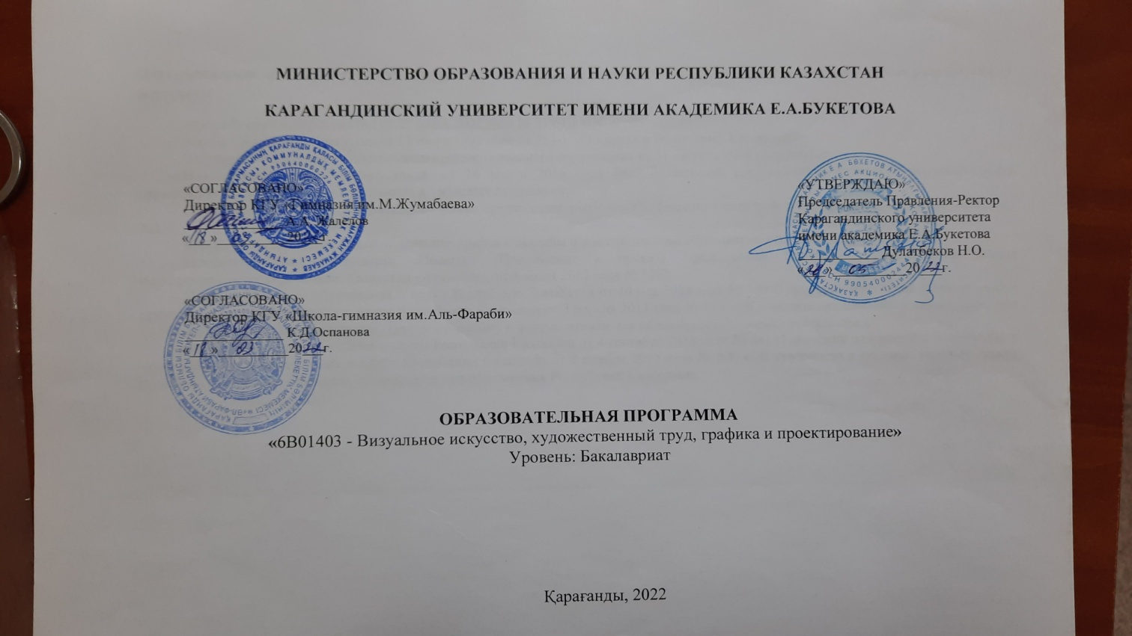

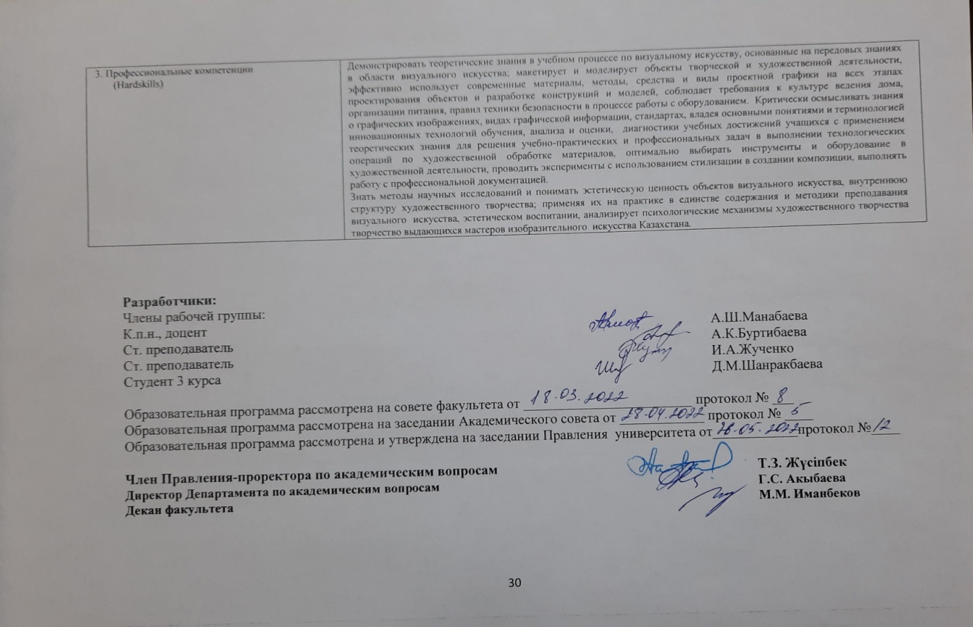

Appendix В1
Reference data on students

General contingent of students OP6B01406 Visual art, artistic work,
graphics and design
Table 1. Total contingent of students OP6B01471 Artistic work, graphics and design

Academy  year* |  | Form of training |  | Number of students in the courses |  |  |  |  | Number of translated from others.universities | Number of deducted | Total for all courses
 |  |  |  | I | II | III | IV | V
September  2019/2020 |  | Full - time | based on an educational grant | 7 |  |  |  |  |  |  | 7
 |  |  | On a paid basis | 8 |  |  |  |  |  |  | 8
 |  | Correspondence
 |  | Evening
 |  | External study
 |  | Distance learning technologies |  | 16 |  |  |  |  |  |  | 16
September  2020/2021 |  | Full - time | based on an educational grant |  | 1 | 7 |  |  |  |  | 8
 |  |  | On a paid basis | 12 | 6 | 8 |  |  |  | 1 | 26
 |  | Correspondence
 |  | Evening
 |  | External study
 |  | Distance learning technologies |  | 17 | 16 |  |  |  |  |  | 33
September  2021/2022 |  | Full - time | based on an educational grant |  |  | 1 | 7 |  |  |  | 8
 |  |  | On a paid basis | 12 | 12 | 6 | 8 |  |  |  | 36
 |  | Correspondence
 |  | Evening
 |  | External study
 |  | Distance learning technologies |  | 13 | 33 | 16 |  |  |  |  | 62
September  2022/2023 |  | Full - time | based on an educational grant |  |  | 1 | 7 |  |  |  | 8
 |  |  | On a paid basis | 21 | 12 | 6 | 8 |  |  |  | 47
 |  | Correspondence
 |  | Evening
 |  | External study
 |  | Distance learning technologies |  | 22 | 13 | 17 |  |  |  | 2 | 52

Table 3. Graduates

№ | Academic | Number of graduates | Of them were employed in the first year of graduation
1 | 2020/2021 | 3 | 3
In just 1 year |  | 3 | 3

Application В2

Material and technical base of the OOI student support system
Table 1. Availability of information and communication equipment
№ | Name | Quantity
1 | Number of personal computers, including | 154
1.1 | Having access to the Internet | 154
2 | Number of projectors | 15
3 | Number of interactive whiteboards | 15

Table 2. Type of Internet connection

1 | Modem connection via a dial-up telephone line; | no
2 | ISDN connection; | no
3 | Digital subscriber line; | no
4 | Fiber-optic communication | yes

Table 3. Maximum data transmission over the Internet

1 | Below 128 Kbit/s: | no
2 | 128-255 Kbit/s: | no
3 | 256-511 Kbit/s: | no
4 | 512Kbit/s– 1.9 Mbit/s: | no
5 | 2 Mbit/sec and above: | yes

Table 4. Availability of special software tools

№ | Name | Quantity
1 | Educational computer programs on individual subjects or topics | -
2 | Computer testing programs | 2
3 | Electronic versions of reference books, encyclopedias and dictionaries | 3
4 | Electronic versions of textbooks on individual subjects and topics | 8
5 | Electronic library systems | 2
6 | Other software tools | -
7 | Electronic system of teachers' relationship with students (portal) | 2

Table 5. Availability of a website

1 | - email address: | office@buketov.edu.kz
2 | - internet website: | www.buketov.kz
3 | -the frequency of updating information on the site: | as new information becomes available

Table 6. Availability of information on the website describing the activities of the educational program

№ | Name | Availability (available/absent)
1 | Implemented educational programs | available
2 | Information about the administration | available
3 | Report on educational activities | available
4 | Information about employment and adaptation of graduates | available
5 | Summary of teachers | available
6 | Information about graduates | available
7 | History of the department | available
8 | Reference guide of the incoming | available

Table 7. Purchase of new books

2019-2020 years . | 2020-2021 years . | 2021-2022 years .
4 352 ex . | 5186 ex . | 10 557 ex .

Table 8. Access to information and technical resources

№ | Information and technical resources | Access |  | Свободность доступа
 |  | There are | No | Free | At certain hours
Teachers' access to:
1 | computers | There are |  | Free
2 | Internet networks | There are |  | Free
3 | Using the necessary software | There are |  | Free
Students' access to:
1 | computers | There are |  | Free
2 | Internet networks | There are |  | Free
3 | Using the necessary software | There are |  | Free
Employees' access to:
1 | computers | There are |  | Free
2 | Internet networks | There are |  | Free
3 | Using the necessary software | There are |  | Free

Table 9. Library resources

Staff (people)
Square | Total (m2) |  | 4440 m2
 | For storing books (m 2) |  | 2893
 | Number of seats in the reading room |  | 1078
Book Fund | Scientific literature | In Kazakh | 81199
 |  | In Russian | 442744
 |  | In English | 6005
 | Periodicals | In Kazakh | 52588
 |  | In Russian | 142598
 |  | In English | 1838
 | Textbooks | In Kazakh. | 428490
 |  | In Russian | 529673
 |  | На англ.яз. | 31935
 |  | In Kazakh | 24157
 | Electronic publications | In Russian | 34256
 |  | In English | 2831
Activity | The average number of readers on a reader's ticket for the year | students | 8846
 |  | Teaching | 430
 |  | staff | 27
 | Average number of books issued per year | students | 464039
 |  | Teaching
 |  | staff
 | Average number of visits per year | students | 139374
 |  | Teaching
 |  | staff

Table 10. Student dormitories

Number / name of the hostel | Total  area (m²) | Year of commissioning | Type of building | Year of repair
 |  |  |  | Capital | cosmetic
Students' House No. 4, block A | 3076 м² | 1987 | standard | 2012 | annually

Table 11. Canteens

Total area(m²) | Year of commissioning | Type of building | Year of repair
 |  |  | capital | cosmetic
122,4 м² | 1974 | standard | 2014 | annually

Table 12. Sports and cultural and recreational infrastructure

Number / name of the hostel | Total  area (m²) | Year of commissioning | Type of building | Year of repair
 |  |  |  | Capital | cosmetic
Спортивныйзал | 298 м² | 1974 | standard | 2014 |  | annually

Table 13.Medical center

Total  area (m²) | Year of repair |  | Number of seats
 | Capital | cosmetic
31,5 | 2020 | - | 1

Table 14. Receipt of fixed assets to the faculty

№ | Component | 2020 year |  | 2021 year
 |  | Initial cost | Quantity | Initial cost | Quantity
1 | Printing on automatic snap-in | 5500,00 | 1
2 | System block |  |  | 161280,00 | 2
3 | Sand Therapy Kit |  |  | 200000,00 | 1
4 | WiFi Router |  |  | 48628,00 | 4
5 | Screen |  |  | 52080,00 | 2
6 | TV |  |  | 244042,0 | 2

Appendix В3

Human resources DETERMINE

Table 1. Basic information about the PPP in the framework of the OP
 |  | Main staff | Freelance  part-time) | Total  (total. state)
Type of employment (rate) | 1,0 | 25 |  | 25
 | 0,5 |  | 3
 | 0,25
Middle age |  | 55,7 |  | 55,7
Degree availability | Master of Science | 7 |  | 7
 | Candidate of Sciences | 10 |  | 10
 | Doctor of Science | 3 |  | 3
 | PhD | 0 |  | 0
Availability of titles | Assistant Professor | 1 |  | 1
 | Associate Professor | 7 |  | 7
 | Professor | 5 |  | 5
 | Academician | 0 |  | 0
Ratio  Teaching staff with academic degree/title (% of total number) |  | 52,0% |  | 52,0%
Fellows, prize winners, etc. |  | 4 |  | 4
Members of public academies, unions, associations |  | 11 |  | 11

Table 4. Information on professional development of teaching staff
(for the last 5 years, including the current one)

№ | 2019 year |  |  |  |  |  | 2020 year
 | Total | including professional development organizations |  |  |  |  | Total | including professional development organizations
 |  | Institute for Advanced Training | universities | --- | --- | --- |  | Institute for Advanced Training | universities | --- | --- | ---
15 |  |  | 15 |  |  |  | 5 |  | 5

продолжение таблицы
№ | 2021 year |  |  |  |  |  | 2022 year
 | Total | including professional development organizations |  |  |  |  | Total | including professional development organizations
 |  | Institute for Advanced Training | universities | --- | --- | --- |  | Institute for Advanced Training | universities | --- | --- | ---
16 |  |  |  | 16 |  |  | 2 |  | 2

2. Partnership
Partnership with schools and universities

№ | Name of organizations | The direction of cooperation | Results  of cooperation | Further
1 | KGKP "Aubakir Ismailov Children's Art School" (branch of the departme | career guidance, advisory | Informing about the educational programs of the department | opportunities
2 | KSU "Gymnasium No. 66" (branch of the Department of Psychology) | research, educational and methodological, organizational and methodological directions | joint scientific and practical conferences, seminars of various levels, exchange of scientific materials | Further expansion of the contingent of applicants of the OP department
3 | KSU "Secondary school No. 86" (branch of the Department of Psychology) | career guidance, advisory, training | Informing about the educational programs of the department | Further expansion of the contingent of applicants of the OP department, implementation of joint research projects

Application G-1
Questionnaire of students' satisfaction with the quality of the educational program

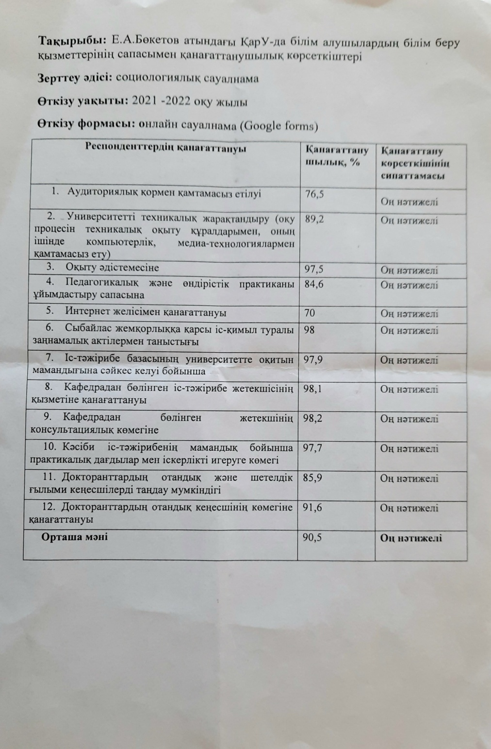

Application G-2

Questionnaire of employers' satisfaction with the quality of graduate training

САУАЛНАМА
«Жұмыс берушілердің педагогикалық мамандықтар бойынша ҚарУ түлектерінің дайындық сапасымен қанағаттануы»

Құрметті жұмыс беруші!

Сізден ұйымдастырылып отырған сауалнамаға қатысып, сауалнаманың сұрақтарына жауап беруіңізді сұраймыз. Сауалнаманың мақсаты - тиімділігін арттыру мақсатында ҚарМУ түлектерінің дайындық деңгейінің түрлі аспектілеріне деген көзқарасыңызды білу. Сауалнаманың әр сұрағына жауап түрлері беріледі. Сіздің пікіріңізге сәйкес келетін жауап түрін таңдап, оған тиісті санды айналдыра сызыңыз. Егер ұсынылған жауаптың бір де біреуі Сізді қанағаттандырмаған болса, белгіленген орынға өз жауабыңызды жазыңыз. Зерттеудің құндылығы Сіздің сұрақтарға толық және шын жауап беруіңізге байланысты болады.

- Сіздің мекемеде Е.А.Букетов атындағы КарУ түлектері жұмыс жасай ма?
- ия
- жоқ

2.Сіздің мекемеде жұмыс жасайтынЕ.А.Бөкетоватындағы ҚарУ түлектерін төменде көрсетілген кесте бойынша жалпы бағалап көріңіз. 5-балдық шкала бойынша әрбір сипаттама бойынша "1" – ең төмен баға ("өте қанағаттанарлықсыз"), ал "5" – ең жоғары баға ("өте жақсы").

№  р\с | Критерий | Баға
1 | Оқу және оқу-әдістемелік жұмысты ұйымдастырады және өткізеді;
2 | Сабақтың мақсатына және міндетіне, күтілетін нәтижелеріне сәйкес пәнді оқытудың теориялық негіздерін қолданады;
3 | Оқытудың тиімді әдістері мен құралдарын, жаңа педагогикалық технологияларды қолданады;
4 | Сыныптаоқу процесін жоспарлайды және ұйымдастырады (сабаққа дайындық, оқушыларды бағалау, олардың жұмысын тексеру);
5 | Оқушылардың жалпы оқу іскерлігі мен дағыдысын қалыптастырады; оқушылармен жеке жұмысты, емтиханға, олимпиадаларға, өз бейіні бойынша конкурстарға дайындықты ұйымдастырады;
6 | Сабақтар, элективті сағаттар, үйірмелер өткізеді;
7 | Оқу процесіне талдау жасайды, өзінің дербес оқыту практикасына өзгерістер енгізеді;
8 | Оқушылардың оқу жетістіктерін критериалды бағалауды іске асырады;
9. | Оқушылардың жеке қабілеттерін және академиялық адалдығын дамытуға көмек көрсетеді;
10. | Оқушылармен сапалы кері байланысты жүзеге асырады;
11. | Оқыту процесінде сараландыру әдістерін қолданады;
12. | Оқушы тұлғасының жалпы мәдениетін қалыптастыруға және оның әлеуметтенуіне ықпал етеді;
13. | Мектепішілік, ішкі желілік іс-шараларды ұйымдастыруға және өткізуге қатысады;
14. | Оқушылардың ата-аналарымен және өзге де заңды өкілдерімен оқыту және тәрбиелеу мәселелері бойынша өзара іс-қимыл жүргізеді;
15. | Мектеп клубтарының, шығармашылық топтарының әдістемелік бірлестіктерінің, педагогикалық және әдістемелік кеңестерінің жұмысына, сонымен қатар әріптестермен бірлесе сабақтарды жоспарлауға қатысады;
16. | Оқытуда және сабақ беруде ақпараттық-коммуникациялық технологияларды қолданады;
17. | Интернет көздерден ақпаратты таңдайды, оқушыларға компьютерлік презентациялар мен ресурстарды  дайындайды;
18. | Оқушылардың бойында ақпаратпен жұмыс істеу дағдыларын қалыптастырады (дереккөздерді таңдай алу, ақпаратты сақтау, өңдеу)
19. | Өз өкілеттігі шеңберінде мектепте қолданылатын компьютерлік ресурстарды (бағдарламалық қамтамасыз етуді) қолдана отырып, белгіленген тәртіппен есептерді сапалы және уақытылы жасауды, дұрыстығы мен тапсыруды қамтамасыз етеді;
20. | Оқупроцесі кезінде оқушылардың өмірі мен денсаулығын сақтау үшін қажетті жағдайлар жасауды қамтамасыз етеді;
21. | Құқықтық,адамгершілік, этикалық корпоративтік мәдениет нормаларын сақтайды, оқушылар мен әріптестер үшін үлгі болып табылады;
22. | Еңбекті қорғау, қауіпсіздік және өрттен қорғау техникаларының қағидалары мен нормаларын және мекеменің ішкі құқықтық актілерімен және Қазақстан Республикасының заңнамасымен айқындалған өзге де функцияларды орындайды.

- Түлек сіздің ұйымыңызда жұмыс істеуі үшін қандай білім мен тәжірибелік дағдыларды игеруі керек?
Критерий |  | Өте маңызды | Иә | Жоқ | Мүлдем маңызды емес
1. | Аналитикалық қабілеттер
2. | Орыс тілін білу мемлекеттік тілді білу
3. | Шет тілдерін білу
4. | Ғылыми жұмыс тәжірибесі

4. Мамандарды даярлау кезінде сіз ЖОО-мен қандай нысанда серіктестіңіз?
1. Мастер-класс өткізу
2. Қосымша жұмыс жағдайында оқыту
3. Студент-практиканттарды ұйым базасында оқыту
4. Бітіру жұмыстарына пікір жазу
5. Түлектерді Бағалау жөніндегі мемлекеттік комиссияға мүшелік
6.Басқа (көрсетіңіз)__________________
7. Серіктеспейміз

5. ЖОО сайтындағы мамандықтар мен түлектер туралы ақпараттың толықтығы сізді қанағаттандырады ма?
1. Қанағаттандырады
2. Қанағаттандырмайды (түсіндіріңіз, неге)

6. Сіздің мекемеңізден ҚарУ студенттері кәсіби практикадан өтеді ме?
1.ия, жыл сайын
2. ия, кейде
3. жоқ, ешқашан өтпеді
4. жоқ, бірақ біз оны қызықтырар едік

7. Сіз практика аяқталғаннан кейін студент-практикантқа жұмыс ұсындыңыз ба?
1. Иә
2. Жоқ (себебін түсіндіріңіз)

8. Сіз түлектерді жұмысқа орналастыру бойынша біздің ЖОО бағдарламасына қатысуға өз дәрежеңізді қалай бағалар едіңіз?
1. өте жоғары
3. жақсы
2. қанағаттанарлық
4. төмен

9. Біздің университеттегі түлектердің кәсіби дайындығын жетілдіру үшін қандай ұсыныстар айтар едіңіз?
1. Жаңа технологияларға сай оқу бағдарламаларын жасау
2. ОПҚ кәсібилік деңгейін арттыру
3. Оқу ордасының материалды-техникалық базасын жақсарту
4. Өндірістік тәжірибелер ұйымдастыру
5. Біліктілікті арттыру бойынша жүйелі түрде қысқа мерзімді курстар өткізу
6. Теориялық және тәжірибелік дәрістер өткізу мақсатында қызмет етіп жүрген мамандарды шақыру
7. Жұмыс беруші мекемелермен тығыз байланыс орнату
8. Басқа (көрсетіңіз)__________________

10. Келісімшарт негізінде біздің университетпен бірлестікте мамандар дайындау жайлы жоспарыңыз бар ма?
1. Иә
2. Жоқ

11. Ұйымның толық аты ___________________________________________________________________________

12. Сіздің аты-жөніңіз және лауазымыңыз __________________________________________________________________________

Зерттеуге қатысқаныңыз үшін алғыс білдіреміз!
Application G-3

Teacher Satisfaction Questionnaire

Сауалнама

«Профессор-оқытушылар құрамының
ЖОО-да еңбекті басқару және ұйымдастыру жүйесіменқанағаттанушылығы»

Құрметті әріптес!
Сізден сауалнамаға қатысуыңызды және сауалнама сұрақтарына жауап беруіңізді сұраймыз. Сауалнаманың мақсаты-университеттегі еңбекті басқару жүйесі мен ұйымдастыруға байланысты әртүрлі әлеуметтік факторлардың әсерін зерттеу. Сауалнаманың әрбір сұрағына жауаптардың ықтимал нұсқалары беріледі. Сіздің пікіріңізге сәйкес келетінін таңдауыңызды сұраймыз. Сауалнама анонимді болып табылады, зерттеу нәтижелері жалпыланған түрде ұсынылады. Зерттеудің құныдылығы сіздің жауаптарыңыздың толықтығы мен шынайылығына байланысты.
Зерттеуге қатысқаныңыз үшін рахмет!

1.Сіздің ойыңызша, қазіргі қазақстандық қоғамдағы ЖОО оқытушысы кәсібінің беделі қандай дәрежеде?
1. Өте жоғары
2. Жоғары
3. Орташа
4. Төмен
5. Өте төмен

2.Сіздің өз жұмысыңызға жалпы көңіліңіз тола ма?
1. Әбден көңілім толады
2. Көңілім толады
3. Соншалықты көңілім толмайды
4. Көңілім толмайды
5. Жауап беруге қиналамын

3.Төменде көрсетілген жағдайлар сіздің еңбек ұжымында қаншалықты дамығанын бағалаңыз: (әр жол бойынша жауап қажет):

 |  | өте жақсы  дамыған | жақсы дамыған | орташа дамыған | нашар дамыған | мүлдем жоқ
1 | Өзара жауапкершілік
2 | Өзара талап қою
3 | Ынтымақтастық, өзара көмек
4 | Бәсекелестік
5 | Бір-біріне деген құрмет
6 | Өзара тілектестік
7 | Корпоративтік рух

4.Сіз қаншалықты қанағаттанасыз (әр жол бойынша жауап):
 |  | Иа,  толығымен қанағаттанамын | Қанағат  танамын | Қанағаттан  дырлықтай | Жалпы қанағаттан  баймын | Толығымен қанағат  танбадым
1 | Жұмыстың сипатына
2 | Басқару жүйесіне
3 | Еңбекті ұйымдастыру жағдайларымен және жұмыс орындарының жабдықталуы
4 | Оқытушы қызметінің нәтижелерін бағалау
5 | Өз мамандығымен
6 | Мансаптық өсу келешегімен
7 | Еңбекақы төлеу және көтермелеу жүйесі
8 | Әлеуметтік қорғау жүйесімен
9 | Кафедра меңгерушісімен қарым-қатынасқа
10 | Жұмыс жөніндегі әріптестермен қарым-қатынасқа
11 | Білім алушылармен қарым-қатынасқа
12 | Өзін-өзі дамыту мүмкіндіктеріне
13 | Ғылыми қызметпен айналысуға арналған
14 | Оқу процесін техникалық жарақтандыру
15 | Кітапхананың оқу және ғылыми әдебиеттермен қамтамасыз етілуіне
16 | Факультеттегі моральдық – психологиялық ахуалға

5. Егер мүмкіндік болса, сіз өзіңіздің кәсіби қызметіңіздің саласын өзгертер ма едіңіз?
1. Ия
2. Иядан гөрі жоқ
3. Жоқтан гөрі ия
4. Жоқ
5. Жауап беруге қиналамын

6.Сіздің ойыңызша, оқытушыларды жұмысқа конкурстық қабылдау және оларды аттестаттау жүйесі ЖОО-ның кадрлық әлеуетін арттыруға ықпал ете ме?
1. Ия
2. Иядан гөрі жоқ
3. Жоқтан гөрі ия
4. Жоқ
5. Жауап беруге қиналамын

7.Сіз келесі құрылымдардың шешімдерң туралы жеткілікті білесіз бе... (әр жол бойынша жауап):
 |  | Ия | Иядан гөрі жоқ | Жоқтан гөрі ия | Жоқ | Жауап беруге қиналамын
1 | ФакультетКеңесі
2 | Деканат
3 | Академиялық Кеңес
4 | Ғылыми-техникалық Кеңес
5 | Басқарма Отырысы
6 | Ғылыми Кеңес

8. Сіздде келесі мүмкіндіктер бар ма .....? (әр жол бойынша жауап)
 |  | иә | иә қарағанда жоқ | жоқ қарағанда иә | жоқ | Жауап беруге қиналамын
1 | ... қажет болған жағдайда факультет деканына тікелей хабарласуға
2 | ... қажет болған жағдайда тікелей университет ректорына хабарласуға
3 | ... қажет болған жағдайда университет проректорына тікелей хабарласуға
4 | ... факультеттің алқалы органдарының жұмысына қатысуға (Сапаны қамтамасыз ету жөніндегі комиссия, факультет кеңесі)
5 | ... жыл ішінде кафедра отырыстарыстарында қарастырылатын жоспарлы мәселелерді қарауға қатысуға
6 | ... кафедра шешімдерін қабылдауға қатысу

9.Сіздің факультеттің алқалы органдарына қатысу құқығыңыз шектеулі деп ойлайсыз ба?
1. Ия
2. Иядан гөрі жоқ
3. Жоқтан гөрі ия
4. Жоқ
5. Жауап беруге қиналамын

10.Сіз жұмыс істейтін кафедраның отырыстары қаншалықты жиі өткізіледі?
1. Әр ай сайын
2. Әр тоқсан сайын
3. Әр семестр сайын
4. Жылына бір рет
5. Отырыстар өткізілмейді

11.Күнделікті кәсіби қызметіңізде келесі ресурстардың қол жетімділік дәрежесін бағалаңыз:
 |  | Иә, толығымен қанағаттанамын | Қанағаттанамын | Қанағаттандырлықтай | Қанағаттанбаймын | Толығымен қанағаттанбаймын
1 | Компьютерлік техника
2 | Көшіру-көбейту техникасы
3 | Кітапхана ресурстары
4 | Интернет-ресурстар

12.Сабақ кестесі сізді қанағаттандырады ма?
1. Ия
2. Иядан гөрі жоқ
3. Жоқтан гөрі ия
4. Жоқ
5. Жауап беруге қиналамын
13.Сіз университеттің сапа саласындағы саясатымен таныссыз ба?
1. Ия
2. Иядан гөрі жоқ
3. Жоқтан гөрі ия
4. Жоқ
5. Жауап беруге қиналамын

14.Сіз өз университетіңіздің даму стратегиясымен келісесіз бе?
1. Ия
2. Иядан гөрі жоқ
3. Жоқтан гөрі ия
4. Жоқ
5. Жауап беруге қиналамын

15.Университетте сіздің кәсіби өсуіңізге кедергі келтіретін факторлар бар ма?
1. Ия
2. Иядан гөрі жоқ
3. Жоқтан гөрі ия
4. Жоқ
5. Жауап беруге қиналамын

16.Сіздің ЖОО-дағы педагогикалық жұмысыңыздың жалпы өтіліңізді көрсетіңіз:
1. 3 жылға дейін
2. 3 жылдан 7 жылға дейін
3. 7 жылдан 15 жылға дейін
4. 15 жылдан 20 жылға дейін
5. 20 жылдан астам

17.Ғылыми немесе академиялық дәрежеңіз:
1. Ғылым докторы
2. Ғылым кандидаты
3. PhD Докторы
4. Магистр
5. Ғылыми немесе академиялық дәрежесіз

18.Сіздің лауазымыңыз:
1.Еңбек сіңірген профессор
2.Профессор-зерттеуші
3.Профессор
4.Қауымдастырылған профессор
5. Профессордың ассистенті
6. Аға оқытушы
7. Оқытушы

19.Факультет:
1.Биология-география
2.Шет тілдер
3.Тарих
4.Математика және ақпараттық технологиялар
5.Педагогика
6.Физика-техникалық
7.Дене шынықтыру және спорт
8.Филология
9.Философия және психология
10.Химия
11.Экономика
12.Заң

Зерттеуге қатысқаныңыз үшін рахмет!

Application G 4

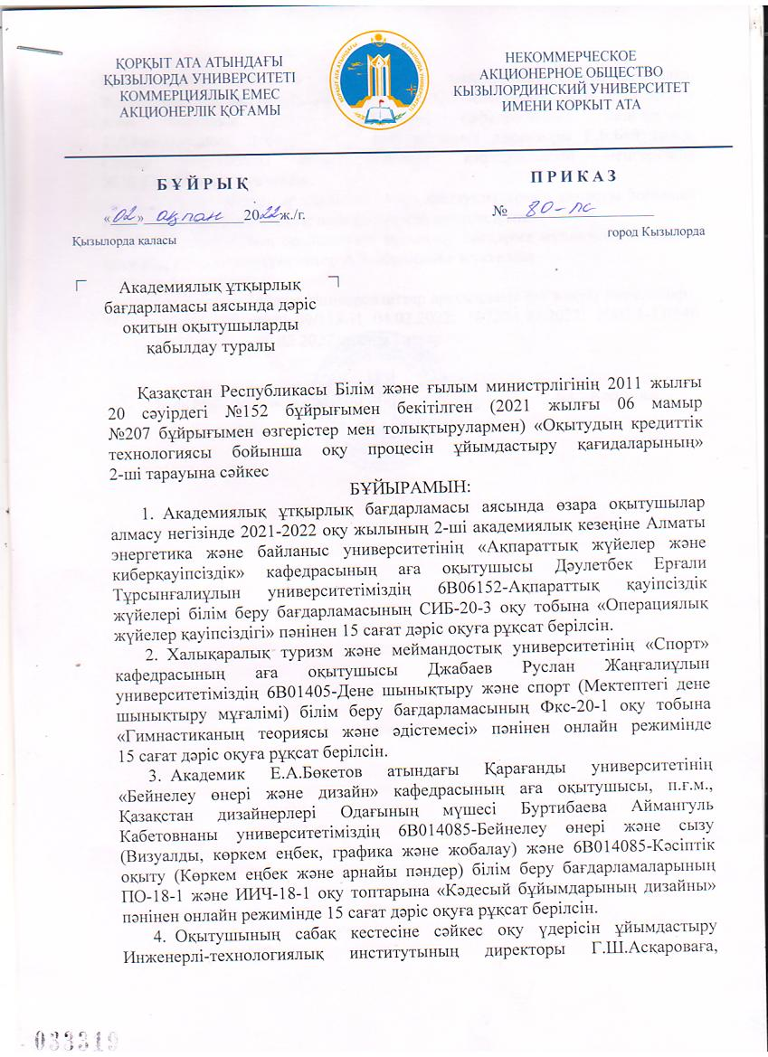

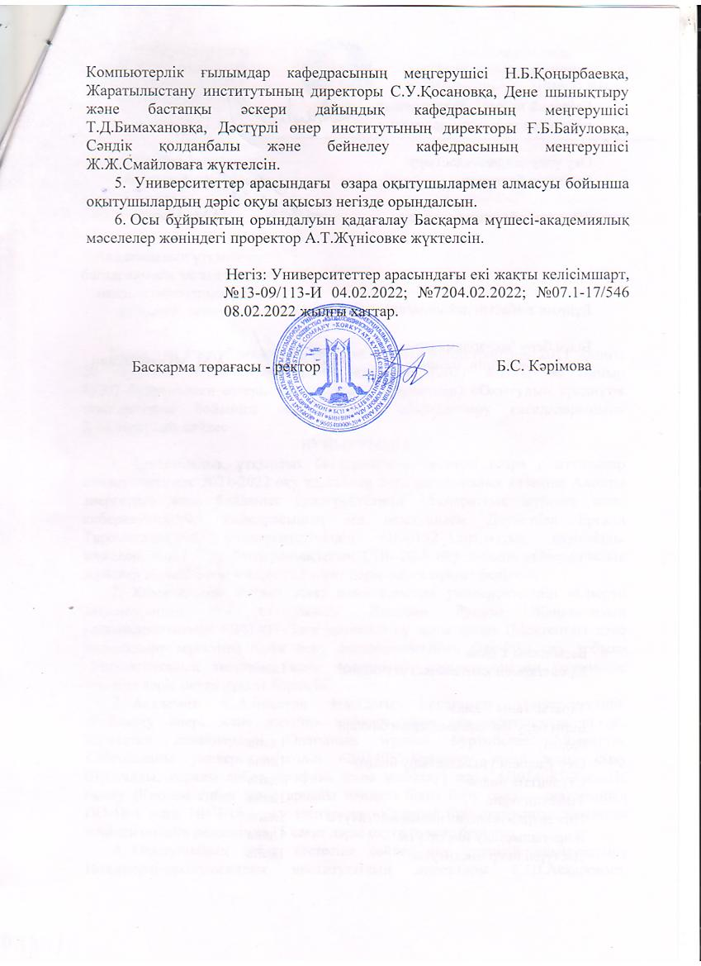

Application Д1

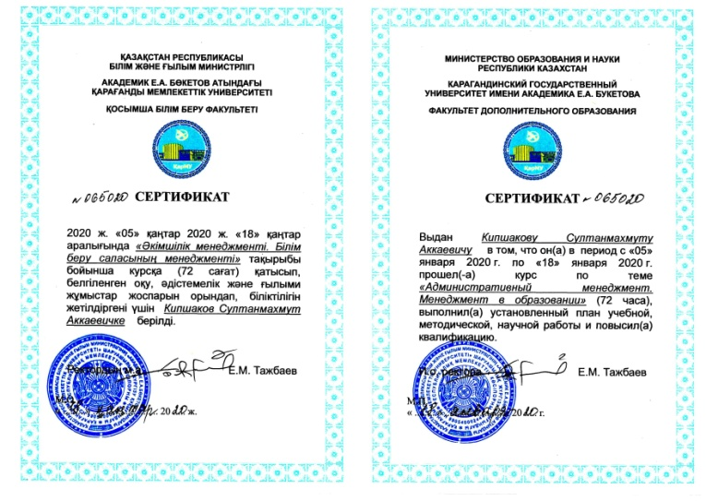
Application Д2

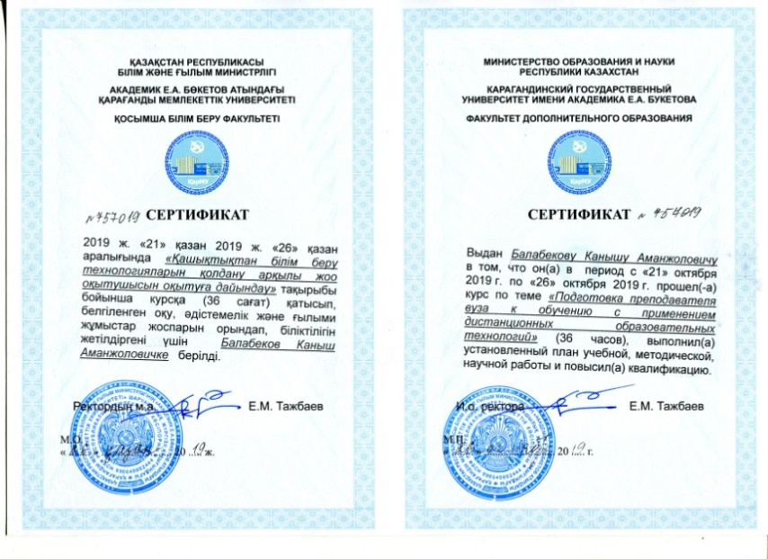

Application Д3
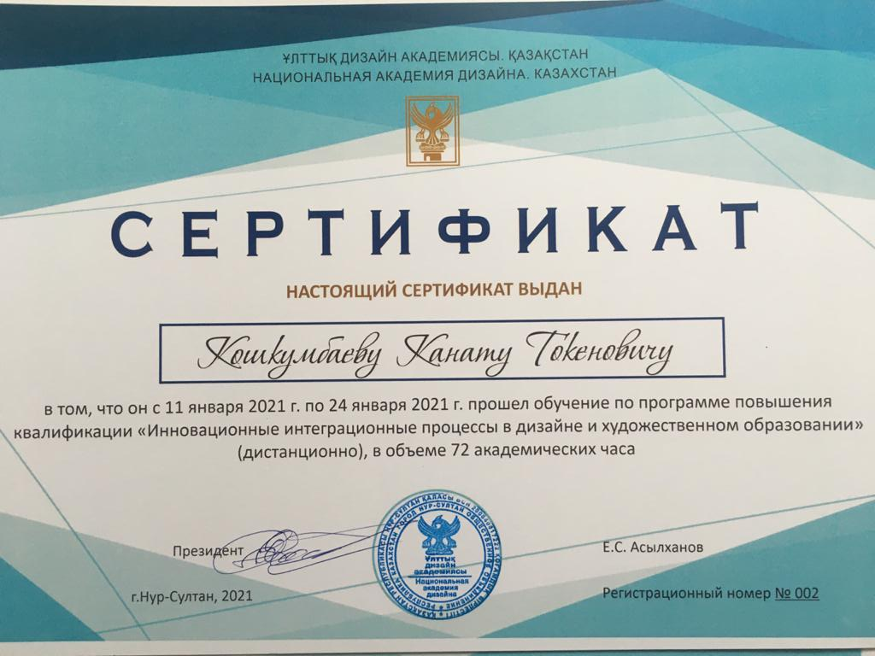

Application Д4

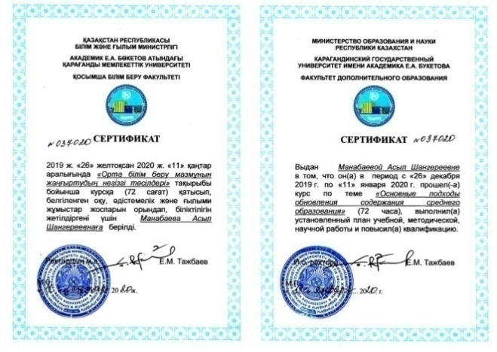

Application Д5

Application Д6
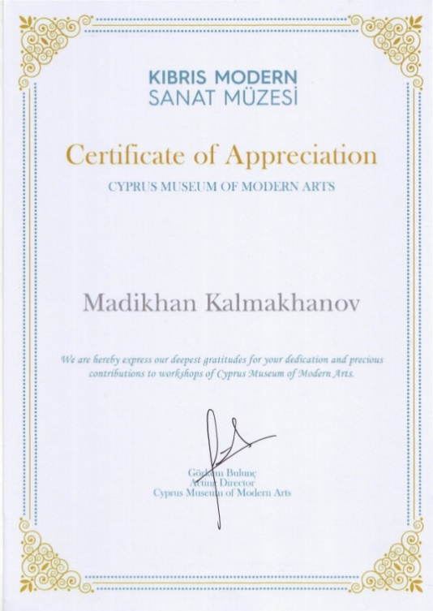

Application Д7
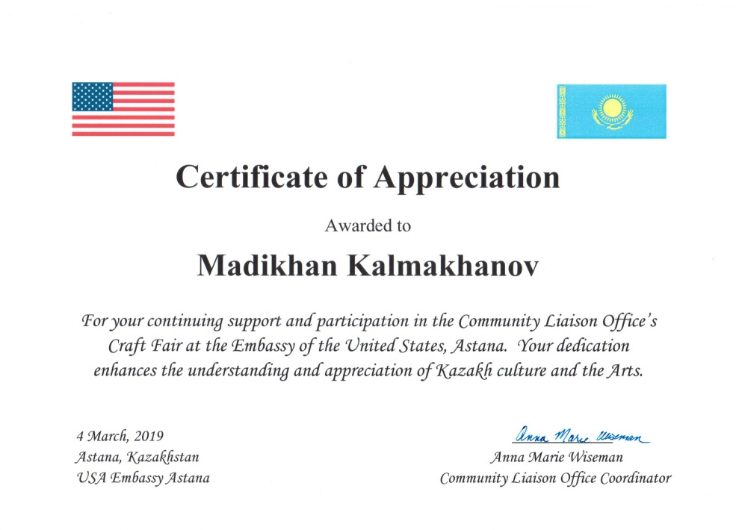

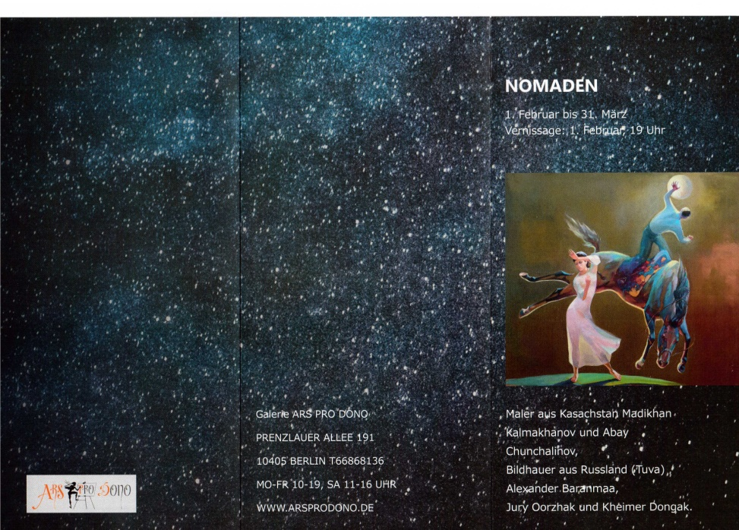

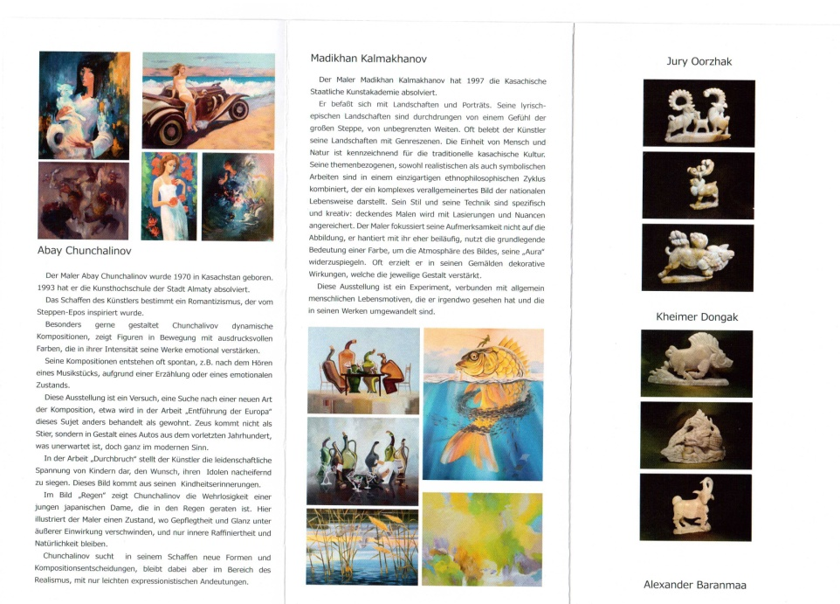

Application Д8

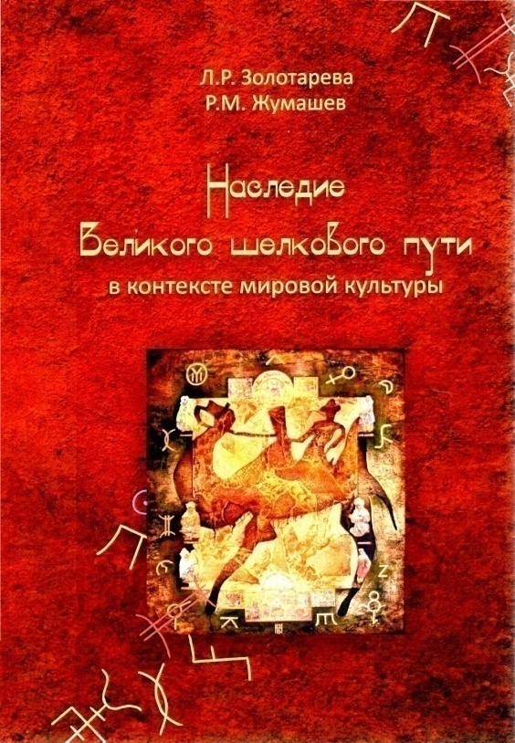

Application Д9

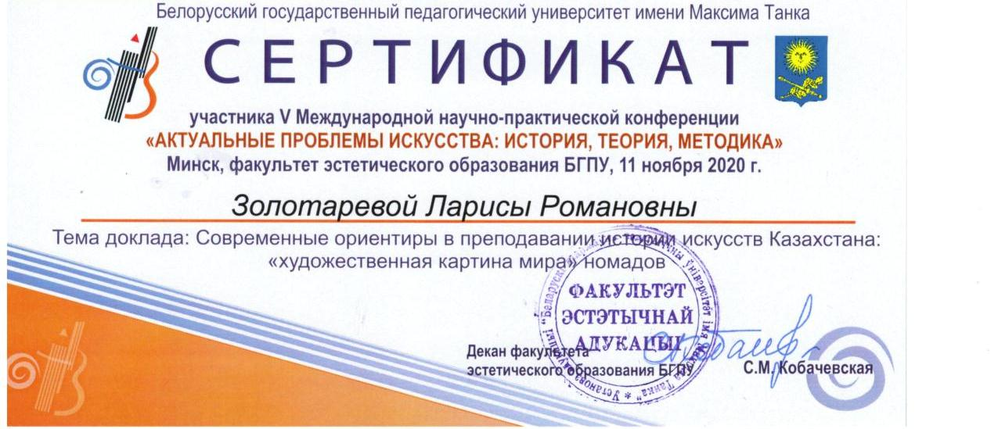

Application Д10

Application Д11
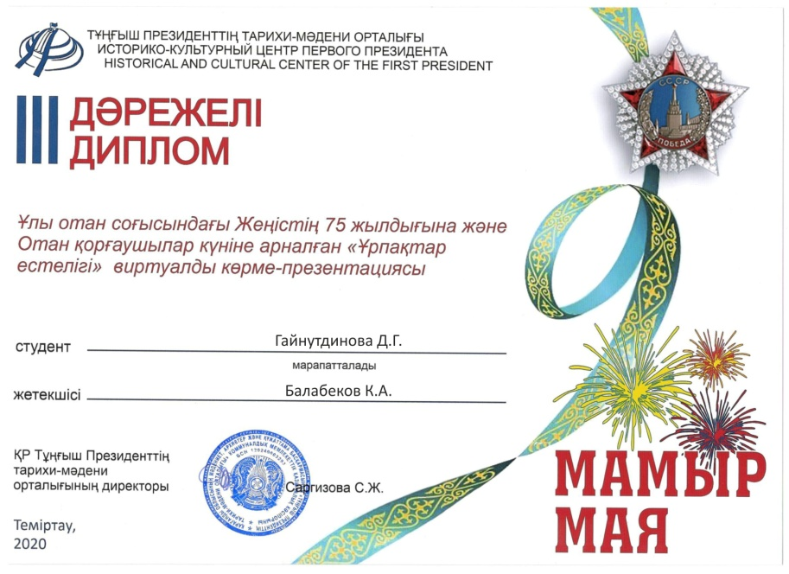

Application Д12

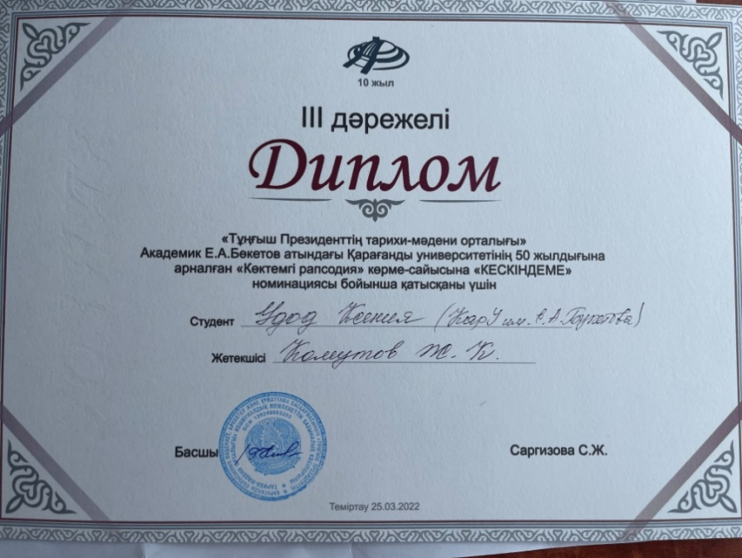

Application Д12

The material and technical base of the NGO and the student support system

Table 2. Availability of information on the website describing the activities of the NGO

№ | Name | Availability (available/absent)
1 | Implemented educational programs | available
2 | Information about the administration | available
3 | Admission Information | available
4 | Information about education (college, Bachelor's degree, Master's degree, doctoral degree) | available
5 | Information about employment | available
6 | Youth policy | available
7 | International cooperation | available
8 | Scientific activity | available
9 | Online services | available
10 | Call-centre | available

Application Д13

Digitalization of education
Name of the university: Karaganda University
named after E.A. Buketov
OP Name: 6B01406 – Visual art, artistic work, graphics and design
№ | Наименование | да/нет | ссылка
1 | Availability of student-teacher feedback on the university portal (text or video) | да | https://idl.buketov.edu.kz/
2 | The possibility of attaching a file (tasks, answers) directly on the portal | да | https://idl.buketov.edu.kz/
3 | Availability of lectures on OP (audio, video, text) on the portal | да | https://idl.buketov.edu.kz/
4 | Availability of an electronic library for CERTAIN | да | https://webirbis.ksu.kz/
5 | Availability of the anti-plagiarism system 1 | да | -
6 | Availability of an examination process tracking system | да | -

Access to the educational portal or information systems of the university (https://idl.buketov.edu.kz ):
login: Kargu_admin пароль: !wev!2323

For information:
According to the first 4 points, it is necessary to insert valid links when clicking on which, rating managers will be able to check the validity of the data.
The supporting document is the contract/act of system implementation.
*1,2 –according to the sub-criteria "Availability of an anti-plagiarism system"/"Availability of an examination process tracking system", the presence of supporting documents is mandatory.

Responsible person for filling out:Zhetimekova Gauhar Zhenisovna
Phone: +7 77018954530
Application Д14

Certificates, certificates, orders, diplomas, copyright certificates

№ | Development with participation | Name of the association or employer | Name of the agreed document | Date of approval | Type of supporting document
1 | Municipal state institution | "Gymnasium No.39 named after M.Zhumabayev | Modular educational program | 23.02.2021г. | Approval sheet for a modular educational program
2 | Municipal state institution | "Secondary school No. 23" | Modular educational program | 23.02.2021г | Approval sheet for a modular educational program

Application Д15

Investments in the development of OP (for 2019-2022)

Name of the university: Karaganda University
named after E.A. Buketov
OP name: 6B01406-Visual art, artistic work, graphics and design

Investments in the development of a computer park
№ p/p | Name | the amount | year of purchase | Used for teaching by an educational program (number) | Used for the contingent of students (number)
1 |  |  | 2018
2 |  |  | 2019
3 | Computers included | 164 3785.9 | 2020 | 3 | 46
4 |  |  | 2021
 | total | 164 3785.9 |  | 3 | 46
Investing in software
№ p/p | Name | the amount | year of purchase | Used for teaching by an educational program (number) | Used for the contingent of students (number)
1 | Subscription by paragraph | 1489800,00 | 2019  2021 | 3 | 46
2 | Domain Support Services |  | 2019
3 | Domain name registration |  | 2020
4 | Antivirus license |  | 2021
 | total | 1489800,00 |  | 3 | 46
Investments in the development of the department's laboratory
№ p/p | Name | the amount | year of purchase | Used for teaching by an educational program (number) | Used for the contingent of students (number)
1 | Multifunctional device | 13 809,6 | 2019 | 3 | 46
2 | Nidec Potter's Wheel(Shimpo) | 39 133,26 | 2020 | 3 | 46
3 | Bookbinding Machine Office Kit B3432E | 330 000,00 | 2021 | 3 | 46
4 | Angle grinder Bosch GWS 24-180 H | 76 000,00 | 2021 | 3 | 46
4.2 | Hammer drill SDS-plus Bosch GBH 240 F | 55 000,00 | 2021 | 3 | 46
4.3 | Electric Drill | 35 000,00 | 2021 | 3 | 46
4.4 | Cordless drill-screwdriver Bosch GSR 180-LI | 130 000,00 | 2021 | 3 | 46
4.5 | Miter saw "Zubr" | 65 000,00 | 2021 | 3 | 46
4.6 | Tool set "STELS" | 115 000,00 | 2021 | 3 | 46
4.7 | Potter's Wheel iMjld Basic | 1305774,95 | 2021 | 3 | 46
4.8 | Drill Kernel 400-1/45 (engraver) | 350 000 | 2021 | 3 | 46
4.9 | total | 2514717,81 |  | 3 | 46
Investments in the library fund
№ p/p | Name | the amount | year of purchase | Used for teaching by an educational program (number) | Used for the contingent of students (number)
1 | Periodicals | 160511.08  611219.12 | 2019  2020  2021  2022 | 3 | 46
2 | Literature |  | 2019
3 | Library and information services | 1907873,83 | 2021 | 3 | 46
4 | Literature | 102 190 | 2021 | 3 | 46
 | total | 2781 794,03

Application Д16

